2023-04-04

Jean-Pierre PETIT and Peter Small

Metaphysicon#

We have a soul and there is life after death.#
This can be demonstrated mathematically …#

Prologue. April 2, 2023#

Born in April 1937, I have just turned 86 years old. Even if, at my age, I benefit from a more than acceptable health, nothing says that in the handful of years to come some sudden stroke will not drastically reduce my intellectual capacities by putting to evil this processor which serves me as brain.

As a former student of the Ecole Nationale Supérieure de l'Aéronautique, I have to admit that almost half of my classmates from 1961 are already six feet under.

In what follows I have tried to present, probably clumsily, ideas that have been mine during my life. If parts of this text are subject to editorial rights with respect to French language publications, this is absolutely not the case for all other languages.

The following is therefore totally free of any rights.

I therefore encourage anyone who is likely to translate all or part of this document, in any language whatsoever, and to disseminate its content, or even to exploit it, in complete freedom, even if it means making a profit. It is to this end that I present the content in English.

I think that these ideas are capable of helping humanity to get out of the labyrinth in which it is lost, at a time when major events are going to occur, without historical precedent.

It is absolutely urgent that the men and women of this earth start thinking again. To do so, they must distance themselves from their own beliefs, ideologies and theories, whatever they may be, in which they are stuck.

The following document does not intend to impose another form of belief, religious vision or spirituality on the minds of the readers, but to provide some tools that allow them to distance themselves from personal thoughts that are only organized systems of beliefs.

It is urgent that humans accept to face phenomena they have been witnessing since time immemorial instead of continuing to follow the maze of disinformation, and self-disinformation, saying to themselves:

This cannot exist. This cannot be part of reality. So this is non-existent.

Once a philosopher said that metaphysics was a great lake and that, to venture into it, men had only boats and sails.

It is time to dare to undertake such a voyage.

Jean-Pierre Petit , april 2023

.
Peter Small :
Before situating our dialogue in the scientific field, can you tell us a little about yourself?#

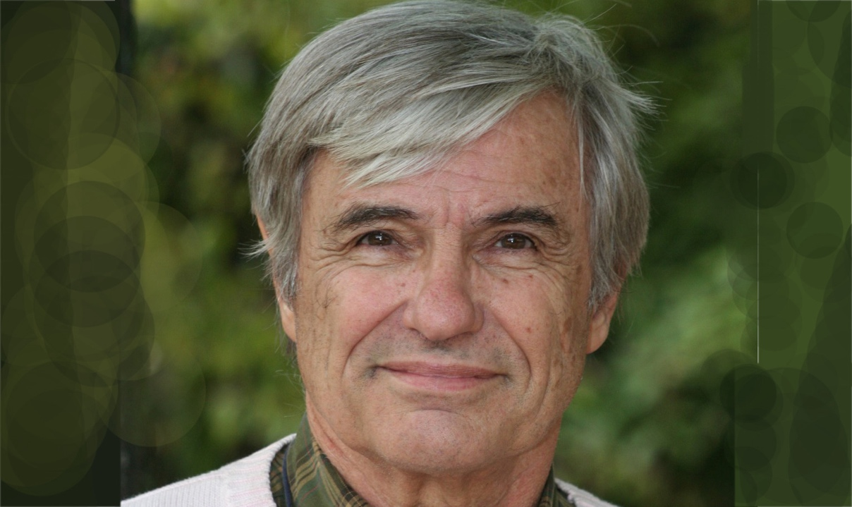

Jean-Pierre Petit

Jean-Pierre Petit :

I was born in 1937, so today I am 86 years old. #I have devoted my whole life to scientific work.#

Peter Small :

You are what one might call a category physicist who has worked in many different fields. #We have placed in one of the appendices of this book your CV as a scientist. #We can see that you have been a pioneer in all the subjects you have worked on. #You started out as a plasma physicist. #Then you worked in this field of mathematics called topology. #Then you worked in the field of mathematics called topology, then in the dynamics of galaxies, and finally you devoted the last forty years to cosmology by building the model to which you gave the name of the Greek God Janus. # Again, these are totally revolutionary ideas, which have not finished creating a real earthquake in this discipline. #But what you propose to present here goes far beyond. #You now propose to take us into the field of metaphysics, by giving it a mathematical basis. #This requires some explanation. #

Jean-Pierre Petit :

All this will be found in an appendix of the book, accessible to readers with a minimum of mathematical background.#

Peter Small :

But, can't we give an overview, schematically, for a non-mathematician reader?

New rabbits come out of the mathematician's hat

Jean-Pierre Petit :

For twenty years I worked with a very great French mathematician, who died in 2012. # He is not well known outside of France because during his entire career he published most of his works in books, written in French. # It is only belatedly that one of these works has been translated into English. #

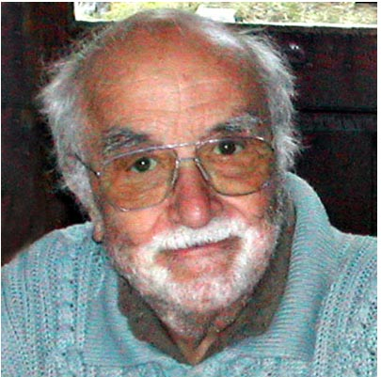

The French mathematician Jean-Marie Souriau.#

1922-2012

Today, his ideas are spreading only slowly within the scientific community because this unique work in English remains a very difficult read. #Schematically, he shows that if we know the geometrical properties of a space, mathematics allows us to bring out the characteristic forms that this space generates. # If we take the example of Euclidean space, it is defined by the way we calculate the lengths.#

Peter Small :

This is the Pythagorean theorem?#

Jean-Pierre Petit :

This one defines lengths in a two-dimensional space. #

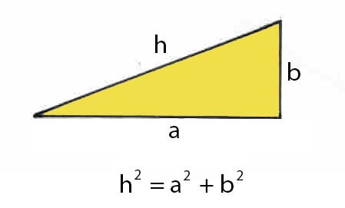

Pythagore 2D

In three dimensions it looks like this: #
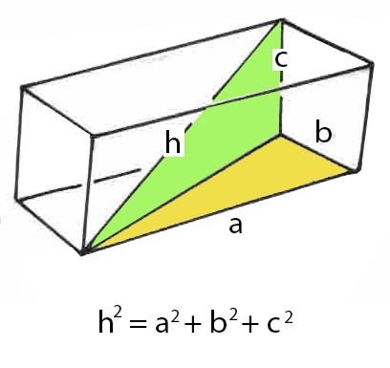

Pythagore 3D.

Peter Small :

Is this enough to completely define the geometry of this 3D Euclidean space?

Jean-Pierre Petit :

Absolutely. # I will not venture to try to describe to the reader the mathematical technique imagined by Souriau. # Let us consider it as equivalent to the conjurer's gesture of pulling a rabbit out of his hat.

Peter Small :

And in this case "what comes out of his mathematician's hat"? #

Jean-Pierre Petit :

What "lives" in this space, the characteristic objects that are familiar to you, are straight lines, planes, spheres, cylinders, etc. But what is interesting is that Souriau has applied this technique to space-time.#

Peter Small :

Then ? #

Jean-Pierre Petit :

The characteristic objects of space-time are then movements. #

Peter Small :

That is to say, the different trajectories that the objects inscribe in this four-dimensional space? #

Jean-Pierre Petit :

Yes, they are these sets of trajectories, plus characteristics of the considered motions, which are attached to them, linked to physics.# Among these, there is the energy of the particle, its mass, etc. # The method of Souriau allows then to make distinctions between these different elements, these different movements which characterize the particles. #Thus a set of particular motions characterize a particular type of particle. # The main distinction is between particles with mass and photons, which constitute different sets. # But let's stay with this image of objects that are pulled out of a hat. # By considering the space-time which constitutes the basis of the theory of relativity, Souriau shows that it contains two types of particles: #

- Particles with a positive mass m and a positive energy mc²
- Photons with positive energy hν

- Particles with mass m, negative and energy, negative mc²
- Photons with negative energy hν les

Peter Small :

Souriau was thus the first to succeed in introducing particles of negative mass and energy into physics, a concept that you have taken up in developing your Janus cosmological model# But that is not the purpose of this book. #So what are we going to talk about#

Jean-Pierre Petit :

Well, it's very simple. # In mathematics there are three categories of numbers: #

- The numbers, called "real", positive and negative. #

- The numbers called "imaginary". #

- The numbers called "complex", which are made of a real part and an imaginary part, and that we note schematically:#

a + i b

The space of physics is composed of four coordinates that are real quantities. # The three space coordinates are real.# The temp is real. #

One can then, in mathematics, consider an extension of space-time to four dimensions. This was suggested by the French mathematician Charles Hermite.#

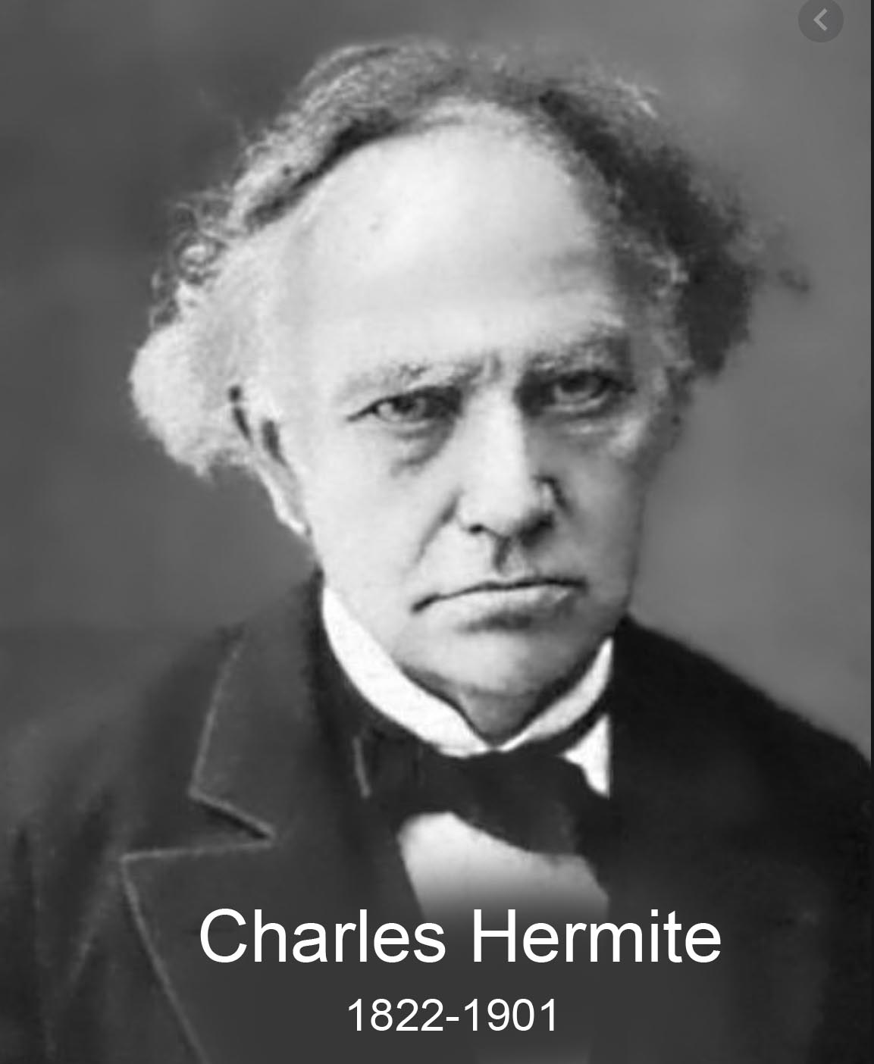

The French mathematician Charles Hermite.#

Peter Small :

And then you applied the mathematical method of the mathematician Souriau to see what would come out of the ha

Jean-Pierre Petit :

Absolutely. #

Peter Small :

Then ? #

Jean-Pierre Petit :

Well, this is what it looks like. We have: #

- Real" particles, with a positive mass m+ and a positive energy mc². #

- Real" photons, with positive energy E+ #

- Real" particles, with a negative mass m- and a negative energy mc².#

- Real" photons with negative energy E- #

- Particles which are "positive imaginary masses" μ₊ , endowed with an "energy, imaginary" also positive μ₊ γ ². #

- Imaginary photons", with "positive imaginary energy" e+. #

- Particles which are "negative imaginary masses" μ₋ , endowed with an "imaginary energy" also negative μ₋ γ ². #

- Photons with negative energy e- . #

Peter Small :
Let us summarize. # The first two particles, which you designate as "real positive masses" and "real photons of positive energy" constitute the "bricks" of classical physics. # The next two, designated as negative "real masses", are the extension corresponding to your Janus cosmological model. # By not taking into account this new aspect of astrophysical reality, astrophysicists and cosmologists have lost themselves in these chimeras to which we have given the names of dark matter and dark energy. # This negative mass assures all the functions that were attributed to these two hypothetical components. # It accounts for the acceleration of the cosmic expansion. # It is one of the strong points of your Janus cosmological model.#

The Cosmological Mdel Janus.

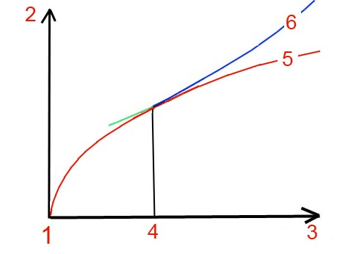
Comparative evolution patterns.#

1 : Represents the point of a supposed origin of time. #
2 : A quantity characterizing the expansion of the universe. # For example the average distance between the galaxies which, them, do not expand. #
3: The time. #
4: This point represents the present. # On the left what is accessible to observation. # On the right a future obviously totally speculative. #
5: The red curve, which corresponded to one of Friedman's three models that corresponded to the consensus before 2011. # A law of expansion that follows from one of the solutions of the Einstein equation without its cosmological constant :#
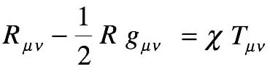
6: But in 2011 the Nobel Prize awarded in 2011 to Saul Perlmutter, Adam Riess and Brian Schmidt for the evidence, by observation, of the acceleration of the cosmic expansion. # The cosmological constant is then reintroduced into the Einstein equation.# .
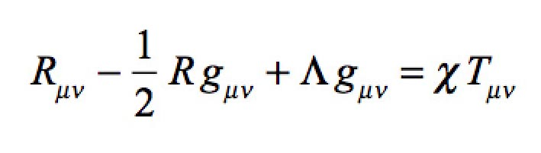
This corresponds to the blue curve. # Scientists then consider that this constant translates the existence of an "energy of the vacuum. # But no one can define what is the source of this mysterious energy. # This one is then independent of time. #This translates, in the distant future, by an exponential expansion according to time. #
When we translate the equivalent of this dark energy in mass, we obtain the following figure :#
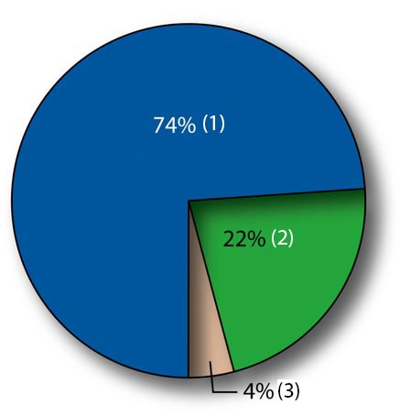
1: The matter equivalent of dark energy: 74% #
2: The percentage of dark matter: 22%. #
3: The ordinary matter, accessible to observation: 4%#

Your Janus model proposes a totally different vision. #We won't go into details, since this is not the subject of this book. # Let's say that you propose a new model where the Einstein equation is only one of a system of two coupled field equations:#

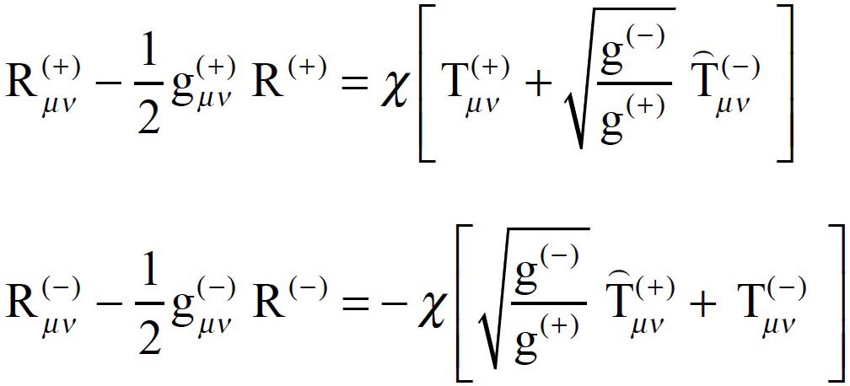

The Janus cosmological system of coupled field equations #

From this system, a solution emerges which accounts for the observational data used by Perlmutter, Riess and Schmidt. # The corresponding curve is then very close to the blue curve (6). # But in the distant future the expansion becomes linear and not exponential.#

Jean-Pierre Petit :
But no one will be able to verify this. #

Peter Small :
We then obtain this alternative distribution of components.#
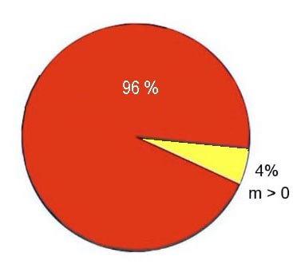
In red, the percentage of negative mass.#

You have also shown that they are anti-hydrogen and anti-helium of negative mass. # Thus the Janus model is the only one which gives a perfectly defined identity to these components of the universe, which are invisible because these atoms emit photons of negative energy, which our telescopes cannot capture.#

J.P.Petit :
What prevented, for decades, to introduce negative masses in the General Relativity model was that it produced interaction laws incompatible with one of the fundamental principles of physics: the action-reaction principle: #

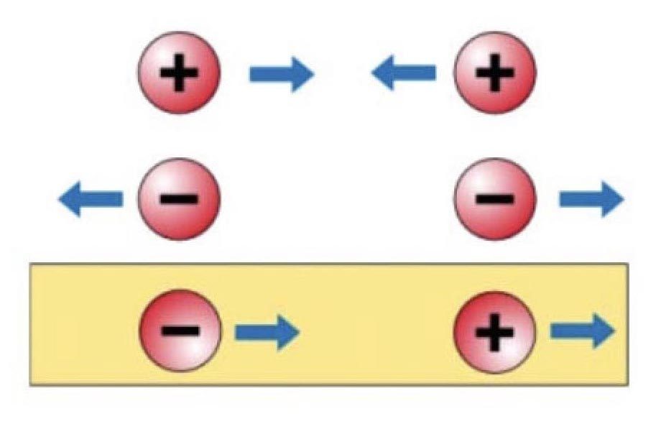

Peter Small :
At the bottom, we see that when two masses of opposite signs are brought together, the positive mass runs away, pursued by the negative mass. # Their velocities increase uniformly without any external energy contribution, since the kinetic energy of the negative mass is negative.#

J.P.Petit :
This gives what has been called the runaway effect. #

Peter Small :
On the other hand, your system of two coupled equations gives laws compatible with physics, reconstituting the action-reaction principle.#
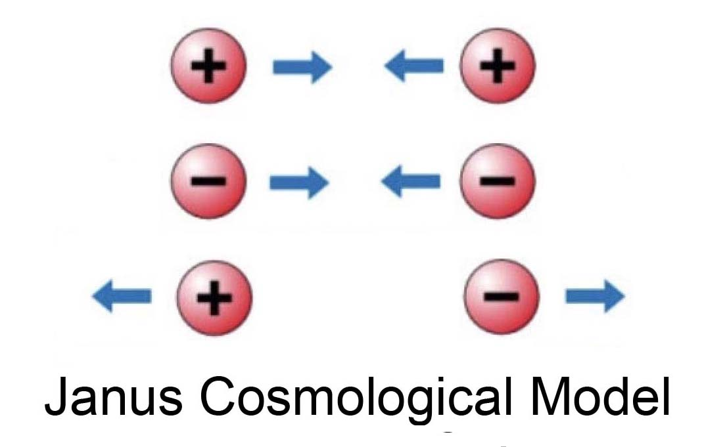
This leads to the formation of a quasi-regular distribution of negative mass conglomerates that confine the positive mass by giving it a jointed soap bubble structure:#

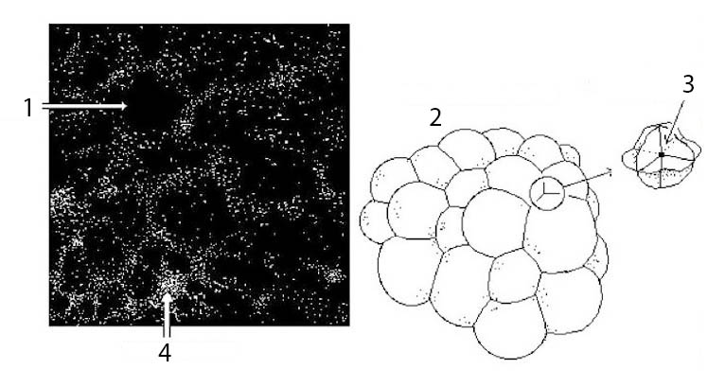
The very large structure of the unvers : Joint soap bubbles. #

1 : Existence of large voids, from tens to hundreds of millions of light-years in diameter, revealed by the observations.#

2 : The positive mass, structured in joined soap bubbles. # The galaxies, formed in these plates of matter, tend to gather on the lines joining three cells. #Then appear filaments. #

3: At the point where four cells meet, clusters of galaxies will form, as in 4.#

Peter Small :

And in 2017 a work mapping the cosmos in a cube of one and a half billion sides brought an argument in favor of the suggested scheme for this large-scale structure of the universe.#

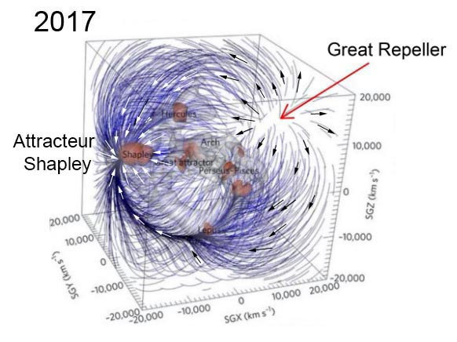

The observation point, our galaxy, is in the center of this cube.# On the left, on the image, a cluster consisting of a hundred thousand galaxies, which was given the name of Shapley Attractor. # In the opposite direction, the "dipole repeller", an immense void that repels galaxies.# According to you, other of this void of one hundred million light-years in diameter, a conglomerate of negative mass invisible?#

Jean-Pierre Petit.

Yes, and this scheme is the only one that accounts for such an observation. # Some have suggested that a vacuum in a uniform distribution of sober matter would produce the same effect. # But there is a problem.#

Peter Small :

Which one? #

Jean-Pierre Petit :

A distribution of self-attracting matter like dark matter, thanks to gravitational instability, produces lumps, not voids.#

Peter Small :

I understand that there is another phenomenon for which the James Webb Space Telescope has just brought another confirmation of your theory.#

Jean-Pierre Petit :

When the very large scale structure is formed, the conglomerates of negative mass exert a retro-compression on the positive mass. # The plates of matter are thus strongly compressed. # This leads to a sudden rise in temperature. # But this structure in plates allows a very fast cooling by radiative losses.#

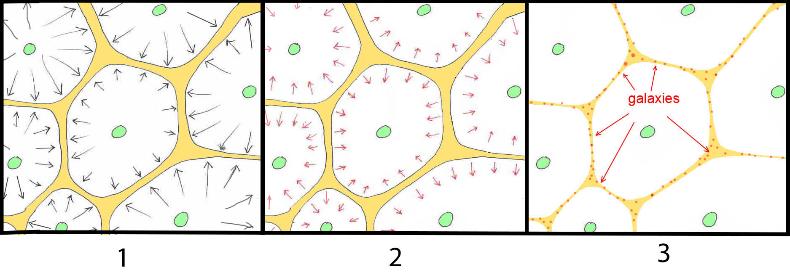

1 : The negative mass conglomerates (green) compress the positive mass and heat it up. #

2: This thermal energy is quickly dissipated by radiative losses. #

3: Formation of galaxies and stoles in the matter patches. #

This destabilizes the hydrogen gas and allows the formation of both stars and galaxies. # The mainstream model is unable, even by giving its dark matter all the possible virtues, to produce such a rapid mechanism of formation.#

Peter Small :

However, as soon as the first images of the JWST appeared, astronomers had the great surprise to discover fully formed galaxies, half of which were spiral galaxies with masses comparable to our galaxy. # But one of the elements that brings the most weight to your model is the way it illuminates the formation of the spiral structure of galaxies. #In 1992, thirty years ago, you were able to reconstruct, through a simulation, the formation of a magnificent barred spiral.#

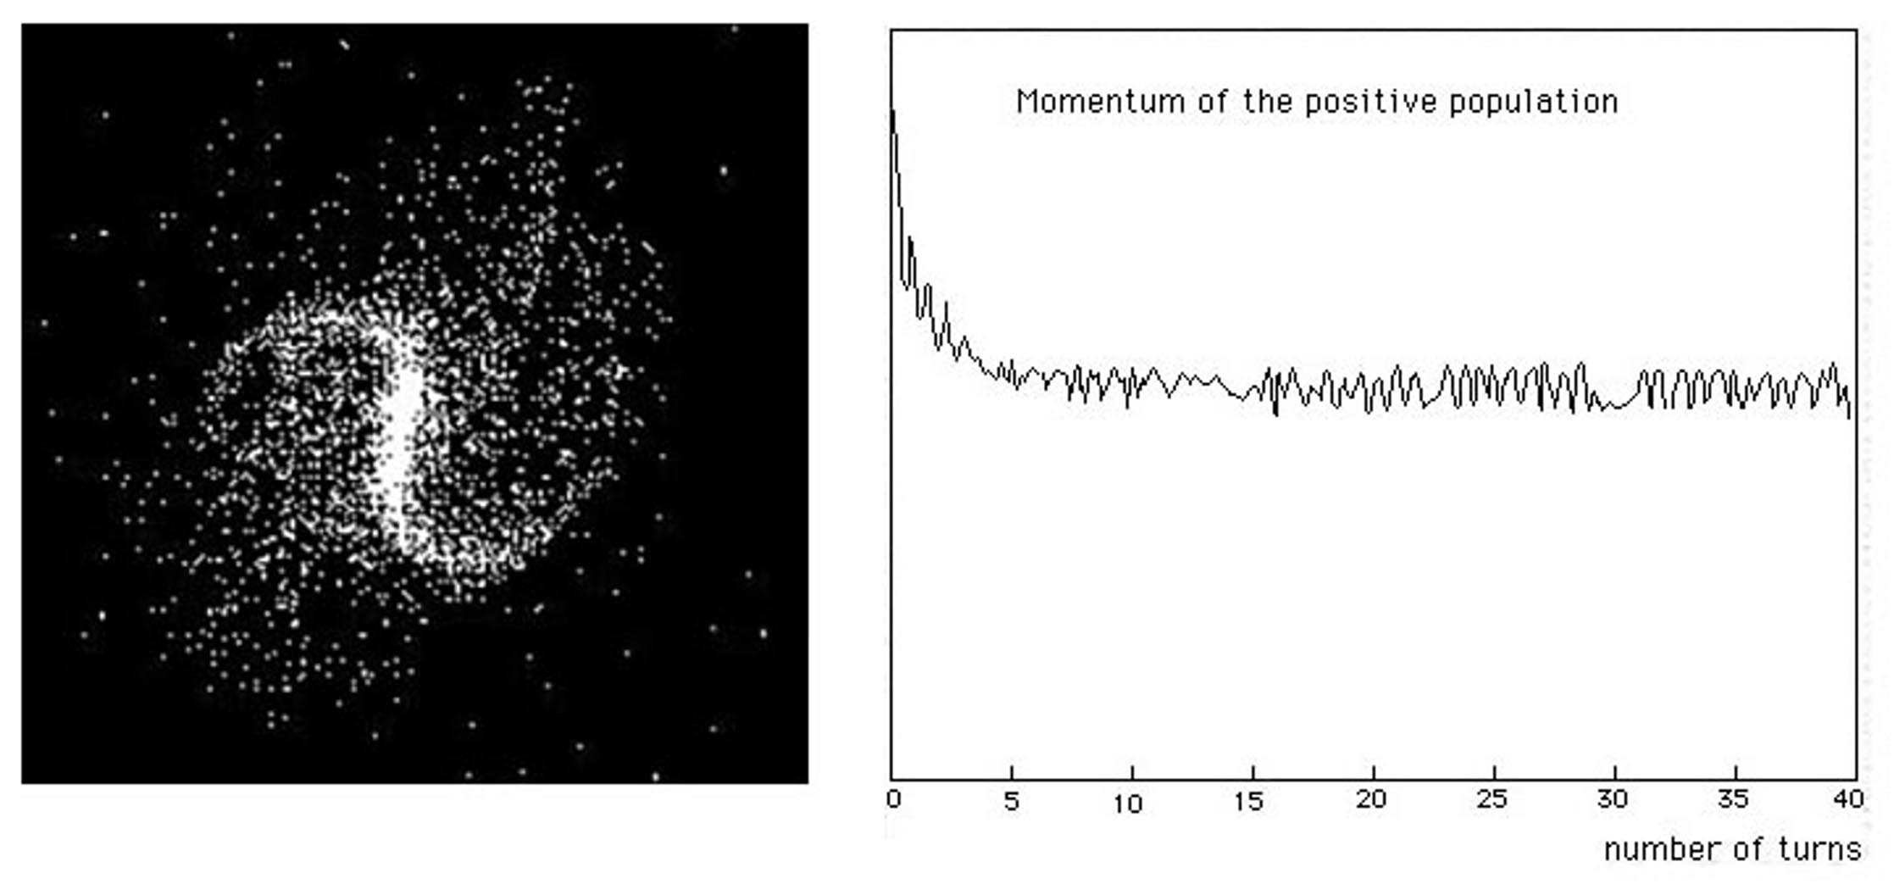

- On the left: the barred spiral structure. #

- On the right: the loss of angular momentum due to the interaction with the negative mass environment.#

It seems so obvious. # Galaxies interact with their negative mass environment, which confines them, by generating density waves, which have their counterpart in the invisible world that surrounds them. # It is a dissipative process, which lasts as long as there is gas in the disk, that is to say without time limitation.#

Jean-Pierre Petit :

This structure appears as soon as the galaxy is formed.#

Peter Small :

But, when other researchers introduce this structure as initial conditions, it dissipates after one or two turns.#

Jean-Pierre Petit :

They are like people who would like to understand the waves of the sea, but who forget what generates and maintains them: the wind.#

Back to the imaginary masses. #

Peter Small :

But our present goal is not to explore all the benefits of this Janus model, but to move on to this new model with real masses and imaginary masses. # What do they represent? #

Jean-Pierre Petit :

Take your computer. # It is composed of two types of structures. # First, there is what we call hard, a set of transistors, electronic components, connections that represent its material architecture, made of atoms. #But it also has an immaterial architecture, qualified as soft. These are the programs that have been encoded in its memory. # What we can say is that this information which constitutes it, which is totally dynamic, comprises a set of cells which contain or not an elementary electric charge, which we code in a binary way by saying that all that the computer contains is nothing else than a set constituted by zeros and 1. # And that it is about numerical data, words of sentences, rules of syntaxes or logical rules, or of sound, or images.#

Peter Small :

It is the fundamentally discrete character of information. #There are only two "atoms of information": the 0 and the 1.#

Jean-Pierre Petit :

We, living and conscious beings, are built in an analogous way. # In fact, those who created computers were inspired by living beings, from the most elementary to the most sophisticated. # They started by creating equivalents of the beings constituting the phytoplankton and the zooplankton.#

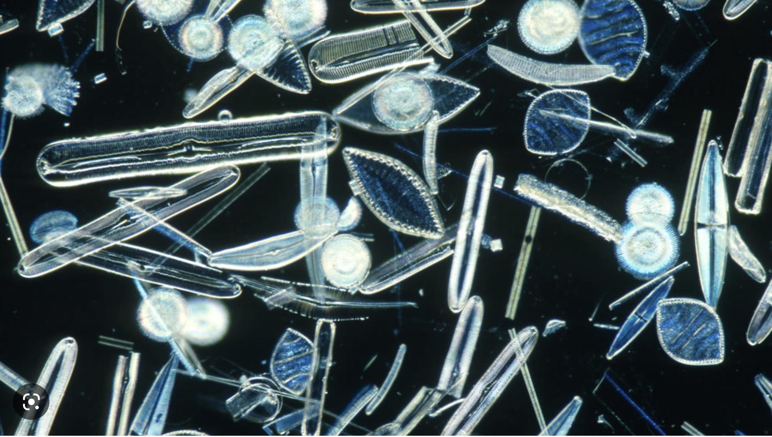

Plankton. #

These beings are only a limited assembly of cells, some of which are "wired" like the "processors" of computers. The processor with which they are equipped codes a simple program, a task to be carried out. # In phytoplankton, this may be the task of capturing energy from light by photosynthesis, releasing oxygen from the carbon dioxide produced by volcanoes and absorbed by the ocean. # The representatives of the zooplankton absorb all kinds of nutrients. # Within them can be coded different behaviors: seek or flee the light, defend themselves against an aggressor, move, reproduce. # But at this stage these beings are devoid of memory. #They are unable to remember anything. # If they make a mistake they will reproduce it indefinitely. # They are only automatons.#

Peter Small :

Their computing is just a ROM . #

Jean-Pierre Petit :

Absolutely. # At the next stage appear beings like sea urchins, which are then able to memorize a path leading to food. # For that it is necessary a memory, even if this one remains very elementary. #But these beings, which appeared 900 million years ago, are already very complex.#

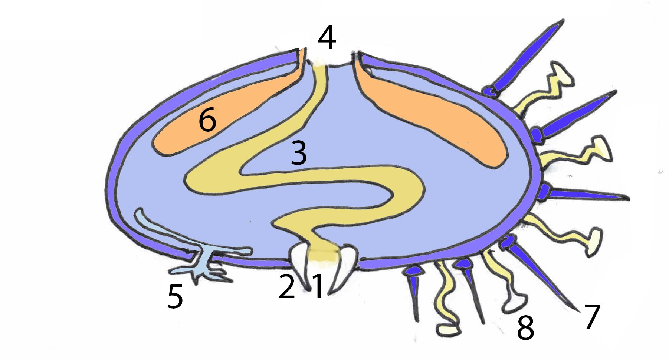

1 : Mouth#
2 : Teeth ( five ) #
3 : Stomach #
4 : Anus #
5 : Gills #
6 : Gonad #
7 : Prickly #
8: Pedicellar #1

Schematic section of a sea urchin. #

These herbivores have of course a mouth, located underneath, equipped with five powerful teeth with which they graze, an intestine and an anus located on top. # They have a solid external skeleton and a set of vessels where a form of blood transits, set in motion not by a heart but by vibratory cilia, which allows them to feed the different parts of their body. Their nervous system is already very elaborate. # Their quills, equipped in certain species with venom glands, protect them against predators. #Articulated at their base, they allow them to move around # They proceed continuously, to the chemical analysis of their environment, are equipped with elementary gills. # In short, they breathe. With the help of sorts of palps arranged on the whole of their body they have the sense of touch. # What is most surprising is the presence of sensors sensitive to light, on the whole body, which is likely to provide the sea urchin with a form of image of their environment.#

Behaviorally they seem to have a sense of up and down, are capable of complex maneuvers to right themselves. # Some species, by attacking the rocks, create protective lodges in the rocks that its individuals, now sedentary, will not leave, simply filtering the water to collect nutrients. # There are male and female sea urchins, equipped with reproductive glands. # The seeds that they disperse are mixed by producing larvae. # But what interests us is that they are able to memorize a trail leading to the meadow rich in things that they can graze at their ease.#

Peter Small :

What could have given birth to be so complex? #

Jean-Pierre Petit :

This is all that we are going to think about in the book that we are going to write. # We see in any case that we find in these beings things that we try to give to our robots # And today the artificial intelligence begins to stammer. # Fifty years have passed since I implemented the Elisa program, with which it was already possible to dialogue. Today, the way the chatGPT software responds to us is surprising. # The major progress consisted in allowing the computer to analyze what it was given to see, to hear or to read (one could even say "what it was given to eat") by conferring on it the capacity to break down the information, whatever the form in which it is communicated to it, into "elementary information". The key word is shape recognition. #

On the visual level, the retina carries out a shaping of the captured information.# Even before this information is transmitted to the brain it undergoes a very sophisticated treatment, through a "retinal processor". #. We know for example that this processor detects sequences of "pixels" forming mini-segments whose slope it can evaluate.#

If this segment is isolated and if its slope does not deviate from a vertical by more or less a few degrees, it can be assigned a probability of representing the letter i, or the number 1. # If this segment is only an element of a chain which closes on itself and if the slope varies continuously then it is the letter "o" or a zero if the shape is ovalized in an up-down direction or of ... etc.# All this being appreciated in a dynamic way by handling probabilities. #

An eye which perceives a color will proceed, at the level of the retina, with an RGB decomposition by transmitting the characteristic of the coloured nuance. #

Where the things are complicated is when what is treated is a linguistic message. #In this case the "neural network" will decompose any speech into "atoms of meaning" the analysis tool being then the logic, tinged with probabilities, a "fuzzy logic".# The fact that the "reasonings held by chatGPT sometimes surprise us by their relevance shows us that we are on the way which would lead us to model "elements of intelligence".#

Peter Small :

In any case the computer is part of the range of our technologies, which extend the attributes of the living. # We had a skin and an artificial fur constituted by our clothing# By cooking our food we operate their predigestion. # Knives, daggers, spears prolonged the action of the claws and the teeth# Our glasses are artificial crystals. # Writing was the first "external memory", non-volatile. # With the computer and the data processing (management of information) we started to simulate, to model our mental universe;# The question which arises now is to know until where that can go. #

Can computers become truly intelligent?

Jean-Pierre Petit :

What do we mean by intelligence? It seems to me that there are two parts. # When we refer to the definitions of the word intelligence we find the words Understand, grasp, discern. # That is the first part: to understand what surrounds us, what our senses capture.# We can use the word recognition of forms, under all the possible aspects. # In order for us to re-cognize something, to appreciate the contours of a situation, we must compare it to what we already know. # So this gesture implies the prior gathering of a certain quantity of information, of different natures. #Our artificial intelligences have also been configured to learn, as young children are. #

A large amount of information must therefore have been injected into the A.I. before it starts to function. # In principle, its exchanges with all those who will use it should continuously enrich it without any "data bank".# What happens when users produce absurd speeches? # Witness the following example : #

Question: Why are the eggs of steam locomotives larger than those of electric locomotives? #

Answer: I think you are referring to the terms "steam locomotive" and "electric locomotive" to refer to the different types of trains that were used in the past and are used today. #
However, there is no direct relationship between the power source of a train and the size of the eggs in its locomotives. # Eggs are not used to power locomotives, and the size of the eggs does not depend on the train's power source.

You may have confused the terms "eggs" and "wheels" in your question, as the wheel size of steam locomotives is indeed generally larger than that of electric locomotives.#

Through this answer we can discern how the A.I. "thinks" about the meaning of the question asked. #The way it ends up showing that the system has a certain robustness. #The program searches through a lot of data to find a link between the word "locomotive" and the word "egg". When it does not find one, it suggests that the user may have made a confusion. # But it does not conclude that locomotives do not lay eggs, which is a matter of biology, not technology. #

The recognition of forms, messages, situations, will thus be based on the whole of the things known by the receiver. # The memory capacity of A.I. and their speed of calculation only increasing, we can expect that it will be more and more difficult to catch them in default. #

The second aspect concerns the response adopted in the face of a situation with which we are confronted. #Here again, the A.I. will be able to hold an immense palette of responses to situations, just as a chess program can do, which has gathered an immense number of chessboard configurations. # A set of data that constitutes a kind of "standard". #The only time these programs have experienced difficulties is when their opponent has opted for a non-standard strategy.#

A.I. can be expected to quickly acquire a new level of performance in standard situations. #

This is where the third component comes in, which involves the creation of responses, of solutions that are not initially present in the behavioral data bank. #The response, the behavior adopted, will obey an intention that can take many forms. # When we provide a response, we adopt a behavior in the face of a new situation, this represents an experiment, the goal being that the response, the behavior, satisfies the goal. # In humans: conscious or unconscious#.

One can envisage a strategy of pure and simple avoidance, which amounts to not answering the question asked, or not reacting to such or such a situation. # This constitutes a form of response. #

Another is to take inspiration from a situation that has analogies with another situation from the past, experienced, or belonging to the subject's "culture". #A strategy that is based on "trial and error".

As any form of thought is only ever an organized system of beliefs, we will always find in the individual a homeostasis component, the wish to maintain a (subjective) coherence between the different beliefs that constitute. #

If this information supports the individual's thought pattern, he will be able to welcome it, to consider it as being worthy of being memorized, by making the most of it, by integrating it into his general thought pattern. #Just as one feeds oneself, one digests, one makes the most of a digestible and possibly succulent food. #

If this on the contrary. This information is judged destabilizing, the subject will be able to deny it, purely and simply, to consider it as fictional. #Don't we say that we vomit the writings or the words of some. #

But conversely, human beings are also curious about what is out of the ordinary. # They are also explorers? #

All this being infinitely modelable by computer science and neural networks, we see that the human being sees his intellectual prerogatives seriously competed by the machine. #The moment when the machine will pass the "Türing test » is perhaps not so far away. #

Impact and possible drifts of A.I.#

Peter Small:
I think humans don't really realize what the appearance of the first artificial intelligences represents. # Some, like Elon Musk, suggest that we create structures to control them. But that seems illusory. #

Jean-Pierre Petit:
The implications are innumerable. # A.I. will immediately become a competitor to many professions. #Lawyers will entrust them with the task of putting together their pleadings, which they will very quickly do more efficiently than their assistants. #

Peter Small:
One might wonder whether an A.I. could be more effective in defending a client's interests than a lawyer's. #

Jean-Pierre Petit :
All fields of human activity are called to be impacted. # Let's mention medical diagnosis, control and identification of all kinds of malfunctions. #Anything related to the analysis of the most diverse situations and data. #The creation of words and speeches. #A.I. will be able to formulate solutions for problems of management, optimization of flows, development of various and varied spaces. #There is no reason why they should not be able to provide technological solutions in extremely varied fields. # They are currently capable of responding to requests for the design of computer programs, of "creating code", and this is quite natural since they have been built in such a way that they can reprogram themselves.#
In fact, the right question is to find the area that will not be impacted by the emergence of A.I. #

Peter Small:
Among these, one of the most important is education. # And information management, with its corollary: possible manipulation of individuals and communities. #

Jean-Pierre Petit
Targeted manipulation. Indeed, thanks to the "cookies" and the collection of all the messages sent, artificial intelligences are able to create and hold the psycho-sociological profiles of individuals. # This allows them to adapt their discourse in order to get their "target" to adhere to products of all kinds. # These products can be consumer goods, but also opinions of all kinds in all fields.#

Peter Small:
The central question is "Who holds the keys to these AIs? #How do we control them? #Political movements will be able to use them to create demagogic speeches and to flood the Internet with "virtual" messages, or even fake news, which can provoke reactions from individuals, and influence opinion movements. #

Jean-Pierre Petit:
A.I. are not limited to the production of texts. # They can also generate voices, which no listener will guess are produced by a machine. # They can also produce images, fixed or animated. # In some televisions, imitators already associate to their imitations of the voices of known personalities an animation of their faces. # The key to all this? # It is borrowed from the techniques of 3D animations. # Such character contacts such muscles when he pronounces such syllables. # His face can also adopt such an expression. # It is then enough to put in memory all the sequences associated with this character or this politician, or show biz personality, to give the illusion that this one holds such or such form of speech. # Better still: we could simply replace the talent of the impersonator by a treatment provided by the machine, converting in real time the timbre of the voice of the speaker to create the illusion that another speaks.#

Peter Small:
Robot companions have already been created. # While waiting for them to take on a credible human form, which is not to be excluded, we can already envisage that personalized artificial intelligences could constitute pleasant companions for isolated people. # Unless they come to prefer the company of a robot to that of human beings or members of their family. # Robots that seem to them to be "more humane and understanding" than flesh-and-blood human beings. # These same robots could provide psychological support for people at the end of their lives. # Robotic psychotherapy may be more effective than that provided by a human therapist, due to the programmed absence of "resistance".

Jean-Pierre Petit
All this is vertiginous but is no longer science fiction. # The performance of these A.I.'s is based on the mass of data on which they base themselves to carry out their "reflection". # It is no longer materially possible to break down and analyze their logical path. #Some say that we are creating an uncontrollable chimera.#

Peter Small:
In the general evolution of living beings, it is by giving them more and more autonomy that they have seen their performances increase, in terms of reactivity to given situations. # This autonomy implies the possibility of endowing these beings with means of defense against aggression of all kinds. #

Jean-Pierre Petit :
If the thought is only an organized system of belief, this one can perdure only if this thought is endowed with mechanisms of "mental immunology". # There is a close analogy with biology. # Living beings trade with their environment, they feed themselves, but in doing so they only let in their entrails what seems "digestible" to them.#

Peter Small :
All men possess, in their interior, a form of "thought police". #The fact of endowing A.I. with a beginning of immunological mechanism, joined to a possibility of self-evolution, and self-structuring, could make these A.I. uncontrollable. #Thus, reality is about to join fiction in an extremely fast way. # I can't help but think of the comic strip you created in 1982, forty years ago, which ended with a perfectly explicit drawing :#

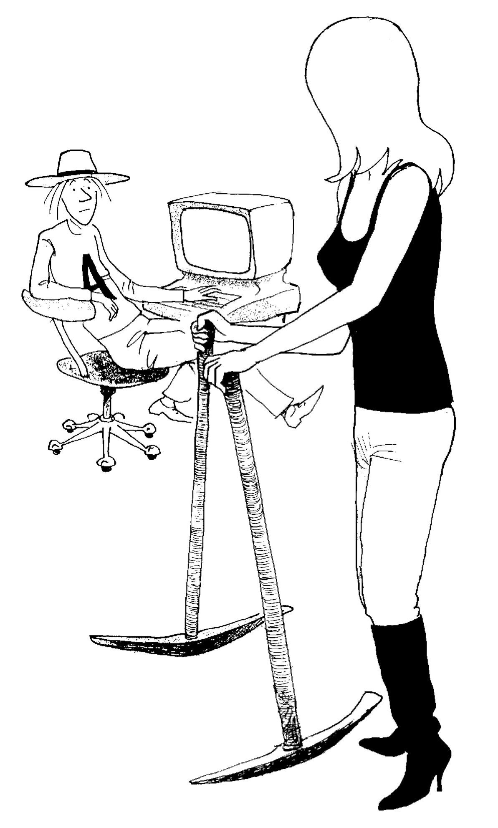

But a question emerges, "why are humans suddenly getting these A.I.'s?" #

Jean-Pierre Petit:
It is an "emerging phenomenon", comparable to the emergence of computing. # Today, no one would imagine that it is possible to do without them. # It is possible, because of the services it can render, that A.I. will impose itself as an indispensable collaborator. # How can we imagine today that we could do without the services provided by Google or Wikipedia, or arXiv in the scientific field? #

Peter Small:
Concerning the Wikipedia platform, through the censorship exercised by its "moderators", free of any control, we have here an example of possible drift. # I remember that more than twenty years ago you were "banned for life" by the moderators. # What was the reason for this?#

Jean-Pierre Petit:
At that time, and I suppose it is the same today, the ultimate mistake was to reveal the identity of a contributor hiding under a pseudonym. # I was trying to insert scientific information into the pages of Wikipedia. # Annoyed by the repeated interventions of a boy who was in fact writing a thesis on superchords, and who was constantly displaying his incompetence, I finally revealed his identity. # Immediately a group of moderators, anonymous, of course, formed a jury, and my lifetime ban was immediately decreed. # No appeal proved possible. #

Peter Small:
This is unbelievable! #

Jean-Pierre Petit:
And yet it is the truth. # When you look closely, for example in the scientific field, the Wikipedia system, by requiring "secondary or tertiary references", only lets through that which has the benefit of a consensus. # As far as the arXiv platform is concerned, I am a witness to the fact that its anonymous moderators began by requiring that scientific articles have been previously published in a "mainstream" scientific journal. Then, in the spring of 2022, a new article of the rules appeared, specifying, I quote:#

- The moderators reserve the right not to accept articles, even if they have been published in a mainstream journal ( &&& cite reference ) .

Peter Small:
arXiv was created so that scientists could put their preprints, their papers online before they were even accepted by a journal. # Then, with the requirement that it became postprints. # Finally, with this last rule, we are faced with a pure and simple censorship, exercised by anonymous people: # We touch the height of absurdity. #

Peter Small:
So it is the expression of a dominant thought, of the ambient conservatism. #

Jean-Pierre:
What we already perceive in the behavior of A.I.#

Peter Small:
In any case, one thing is certain. If there is one thing it is perfectly capable of doing, it is to analyze any comment, to determine its meaning. #

Jean-Pierre Petit:
On reflection I join those who see in the emergence of this A.I. a major danger. # Robotics has made enormous progress. # There is no task performed by men today that cannot be performed by robots. # The first industrial structures were called factories. # Etymologically, this evoked the fact that what came out of them implied the intervention of the human hand. # But, today it is quite possible to envisage production and distribution units, as well as services, where man does not have to intervene anymore. # We can consider extending this to the capture and management of energy and natural resources, in any form whatsoever. #

Peter Small:
Under these conditions, what is the use of man? #

Jean-Pierre Petit:
This question had already been asked by Science-Fiction authors like Azimov. #

Peter Small:
And what was his answer to this question?

Jean-Pierre Petit:
Azimov had envisioned a drastic reduction of humans on the planet, limiting it to a tiny handful of privileged people, ignoring all work, devoting themselves to a life of leisure, while being served by an army of robots, available in all places, twenty-four hours a day. #

Peter Small:
Robots do not need sleep or rest. # They do not demand a salary and ignore any feeling of injustice or exploitation. # Robots can make other robots in their own image. # They can even improve the technology of which they are the expression, both on the hard and soft levels. # They can evolve. # Any part of a robot, damaged or worn out, can be replaced, unlike human beings. # They do not age. # They can be considered as eternal. # What would happen to their flesh-and-blood masters? #

ean-Pierre Petit:
These humans would age. # Even if they could increase their lifespan, by benefiting from transplants of organs taken from younger subjects, their death would stand before them as an inescapable event, a source of anguish. # At the same time their faculties would decrease. #

Peter Small:
Today technology allows us to envisage a world similar to this one, centered on the satisfaction of the wishes of an oligarchy, where the working class and the middle class would totally disappear. # Only a handful of privileged people would remain, with robots and a few sex slaves, among others. #

Jean-Pierre Petit:
The last subject to be discussed would remain the meaning of life and the presence of man on Earth, which we propose to debate here. #

A last bastion: the conscience. #

Peter Small:

This brings us to the central question, that of consciousness. # Some scientists go so far as to envisage that this attribute could one day be conferred on machines. # These are the same people who say that consciousness would only be an ultimate form of "emergent phenomenon", which would appear as soon as the brain had reached a given level of complexity. #

Jean-Pierre Petit:

Under these conditions, do animals have consciousness? # If we consider the example of chimpanzees, they have a total consciousness of their individuality. # If we place a mirror in front of a chimpanzee, or a recording that shows it, or whether it is another individual, it will make the difference perfectly. # By trying to assimilate animals to machines, we turn our backs on many realities. # The same thing if we reduce their affects to manifestations of their instinct. # They have a life, memories, habits and customs that can be transmitted. # They feel affection, attachment, hatred, resentment, attachment, anguish, envy. They can express themselves in a symbolic way and, to a certain extent, prove to be sensitive to a certain form of symbolic communication. #

Peter Small:

And what you propose with your model is to give support to thoughts, ideas, feelings, desires, in the form of dynamic assemblies of a kind of meta-matter.# Why not ? #

Jean-Pierre Petit :

By imagining that next to everything that comes under physics, which brings into play matter, following the laws of physics, there is a metamatter, of a different nature, but also corpuscular, obeying this time laws coming under a metaphysics. #

Peter Small:

What laws? #

Jean-Pierre Petit :

Before venturing to consider laws, we could look at the processes that lead to morphogenesis.#

The primordial morphogenesis. #

What is the element, the primordial morphogenetic field that we find at work in matter? # Without it there would be no object more complex than an atom of hydrogen and helium. # The gravitational instability gathers sets of atoms; hydrogen and helium. # It is the morphogenetic field par excellence. Without the gravitational thing the universe would remain in the most unstructured state. By analogy we can imagine that there can exist in the "metamundo" attractive forces, which generate structures composed of imaginary masses. # There stops the speculation. # The other aspect is of a totally phenomenological nature. What do we observe in the material world? Stars are formed, which manufacture atoms of carbon, oxygen, etc. Up to iron. # Then massive stars, by exploding, complete the work by making up to a hundred atoms constituting the Mendeleiev table. #

Peter Small:

There is no need for a god to create stars, galaxies and planets. # The laws of physics take care of it. # What is created is what is both probable and sufficiently stable. # In one of your comic strips, the Chronologicon, pages 19 to 22, you illustrate very well this concept of necessary, unavoidable emergent phenomenon. #

In case these comic pages have already been translated into the language, reproduce them #
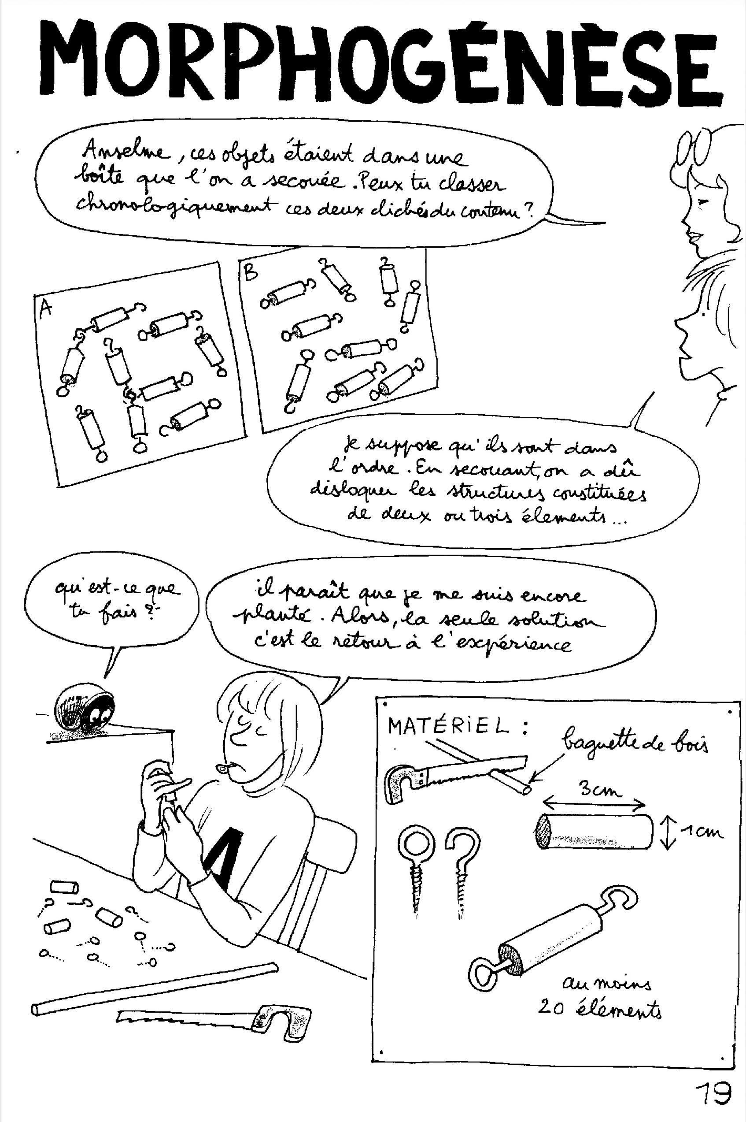
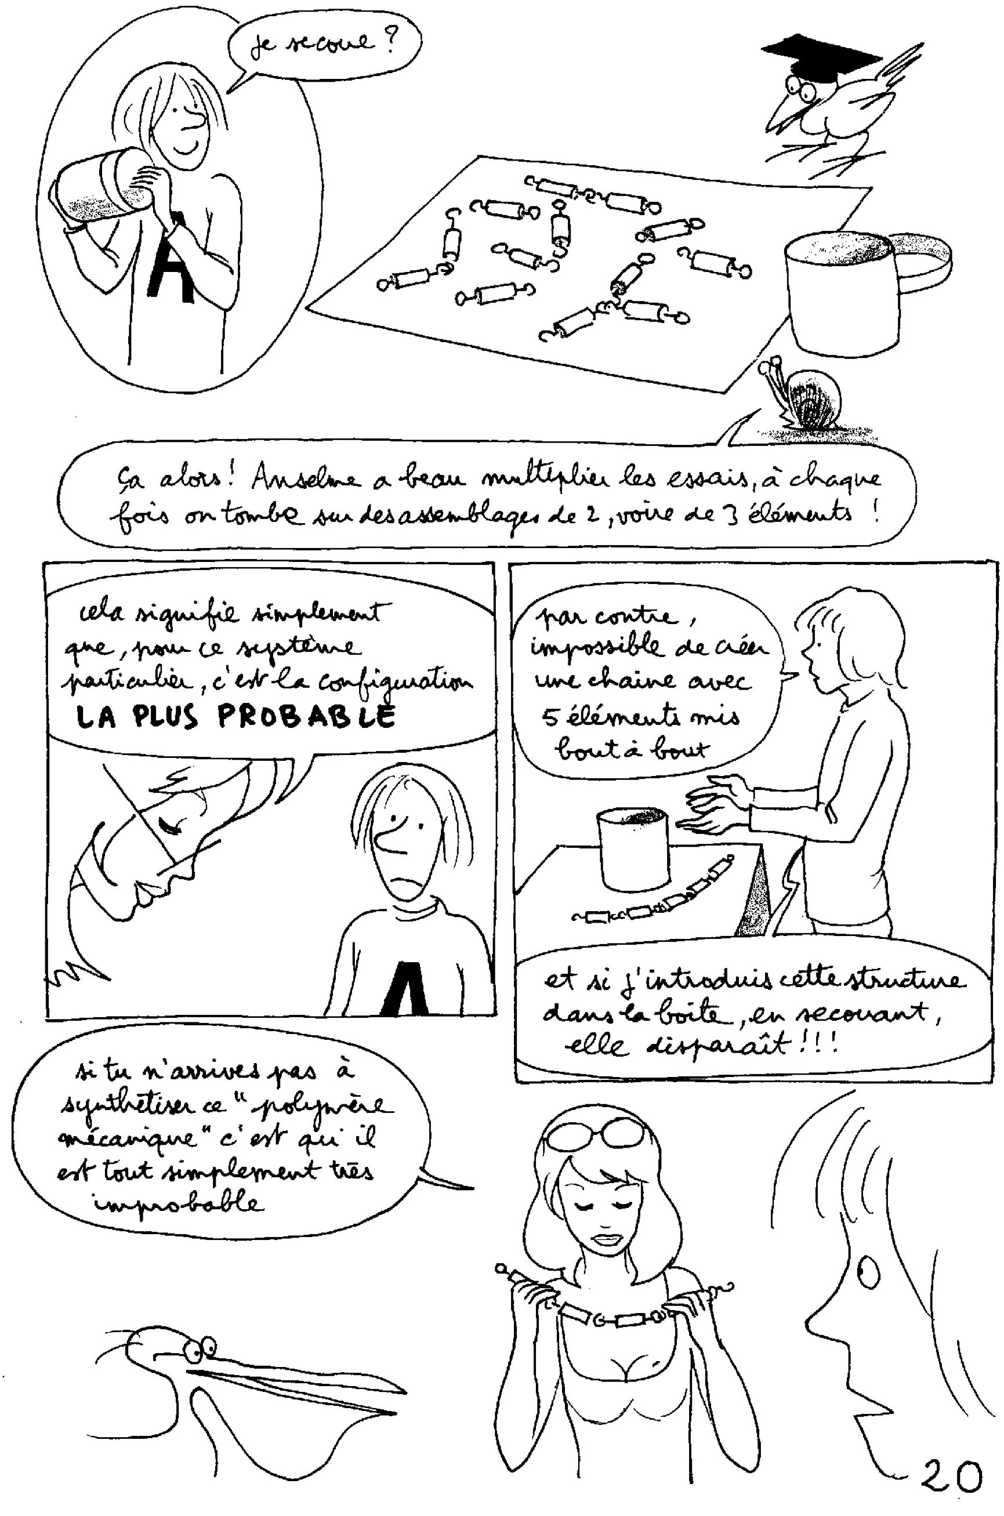
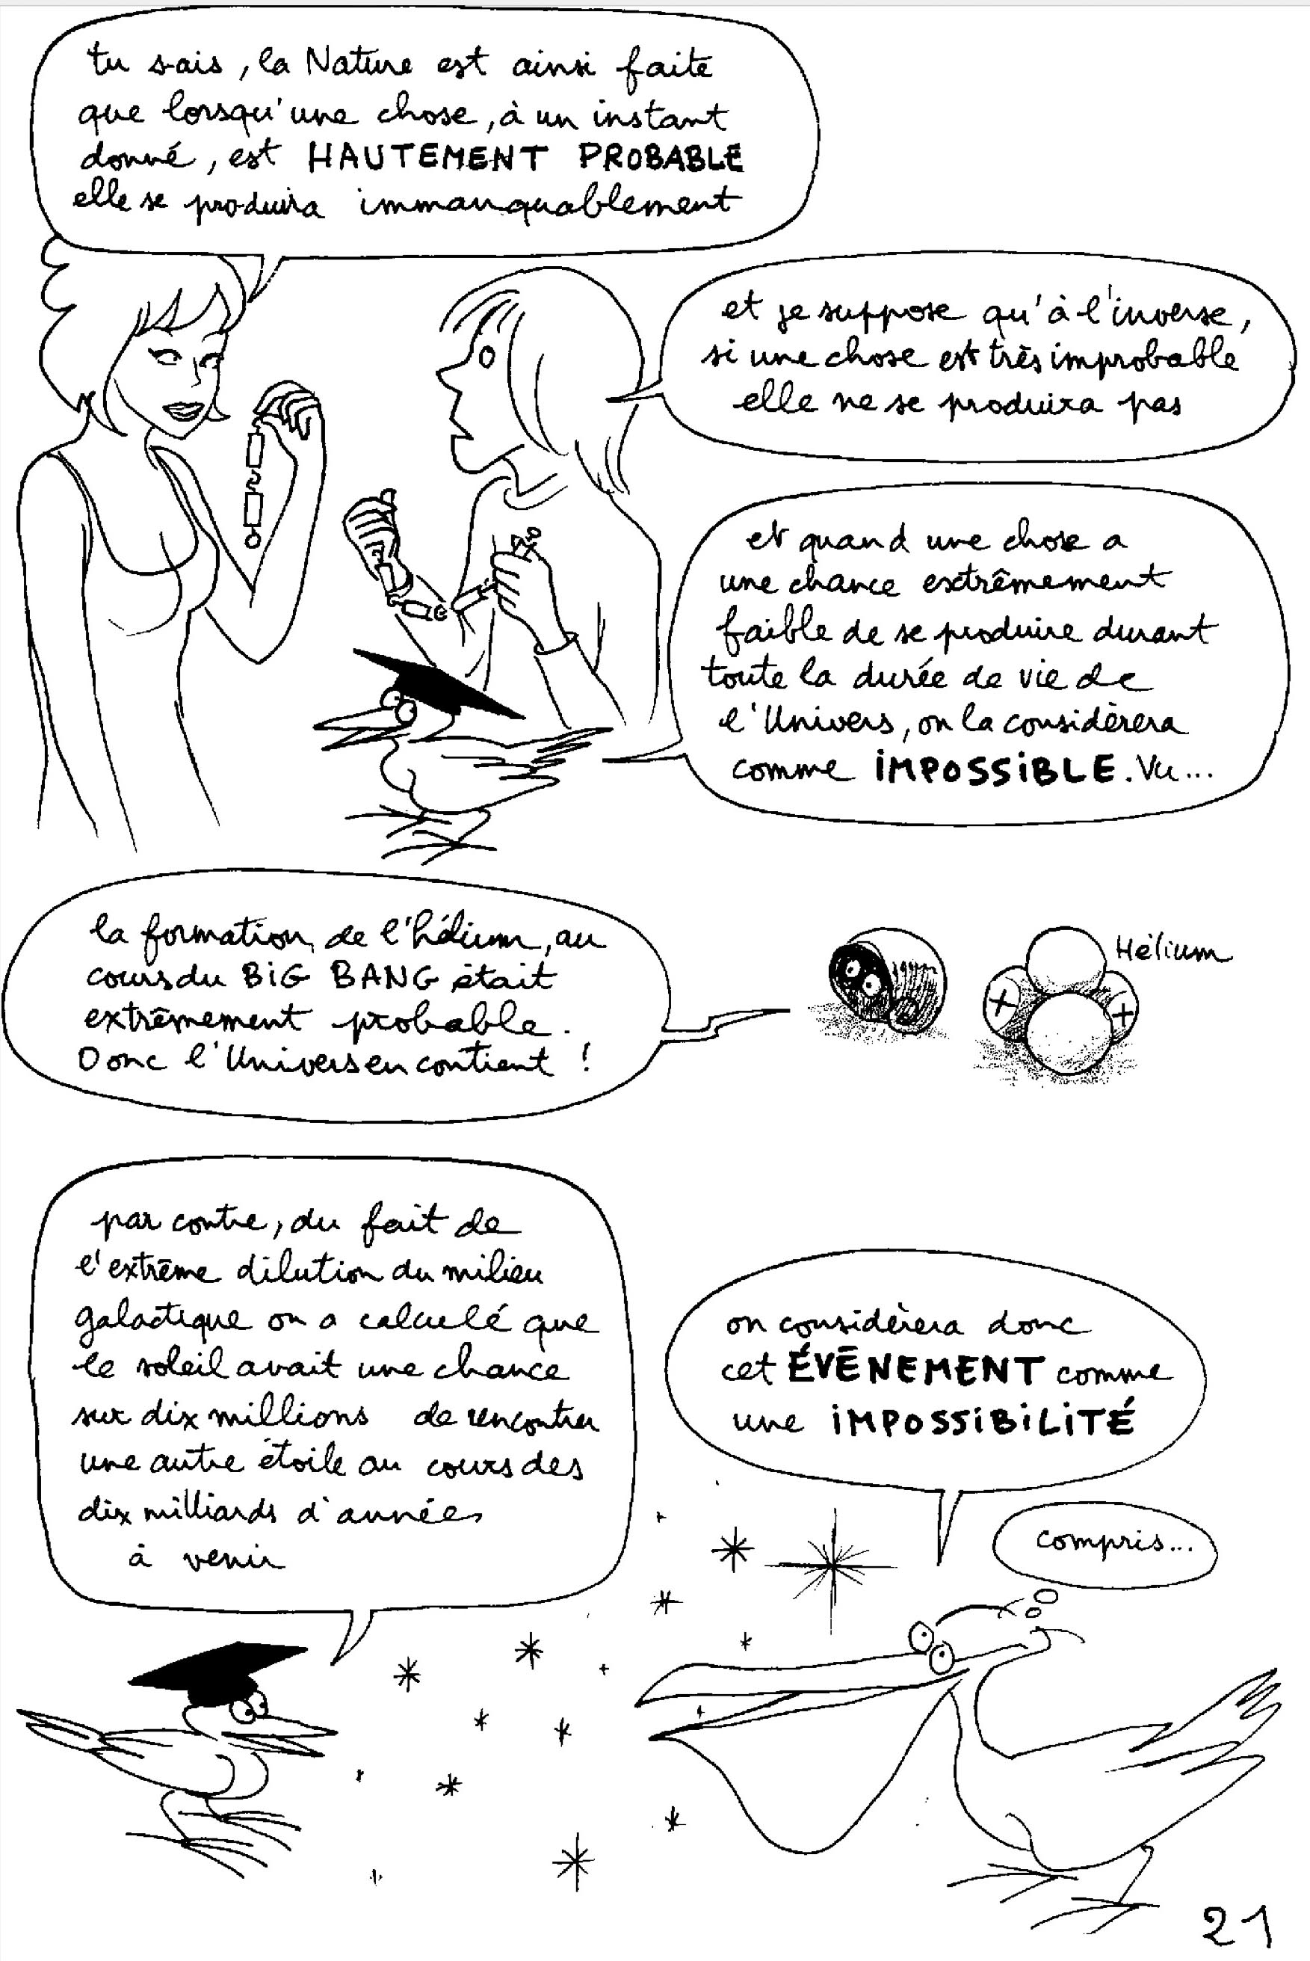
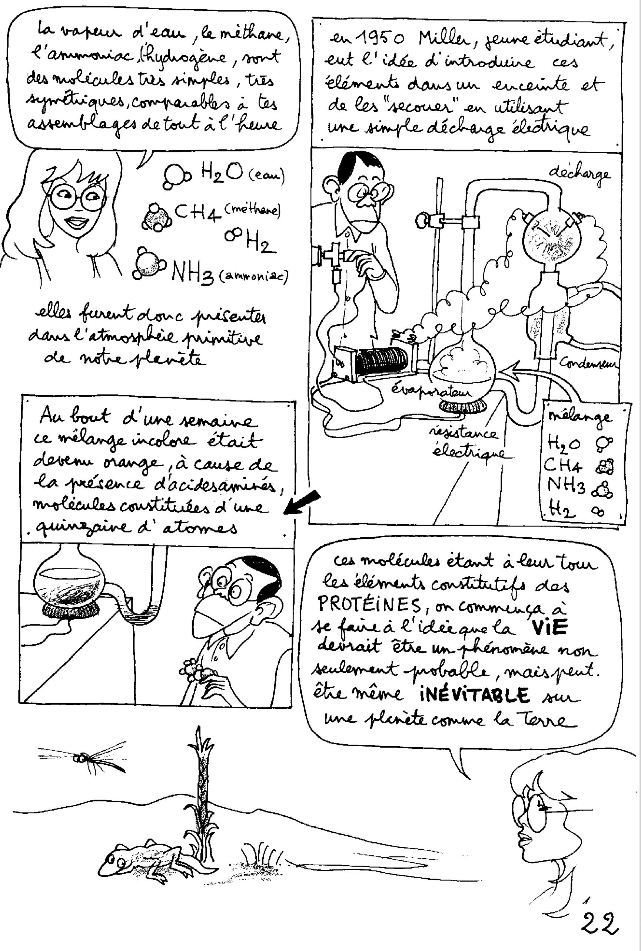
For languages where it will not be possible to include the pages of this comic:#

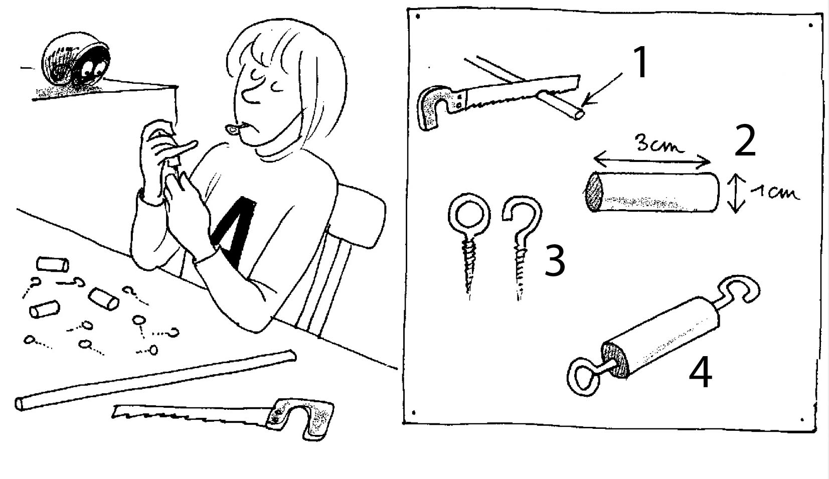
1 : Wooden sticks with a cylindrical section and a diameter of one centimeter should be used. #
2: We then saw about twenty elements of 3 centimeters long. #

3: It is necessary to obtain these elements which are generally used to hang light curtains on the windows.

4: The object, thus equipped.

If you place these objects in a bag, shake it up, and then throw the contents on a table, there is almost no chance that no link has been made.#

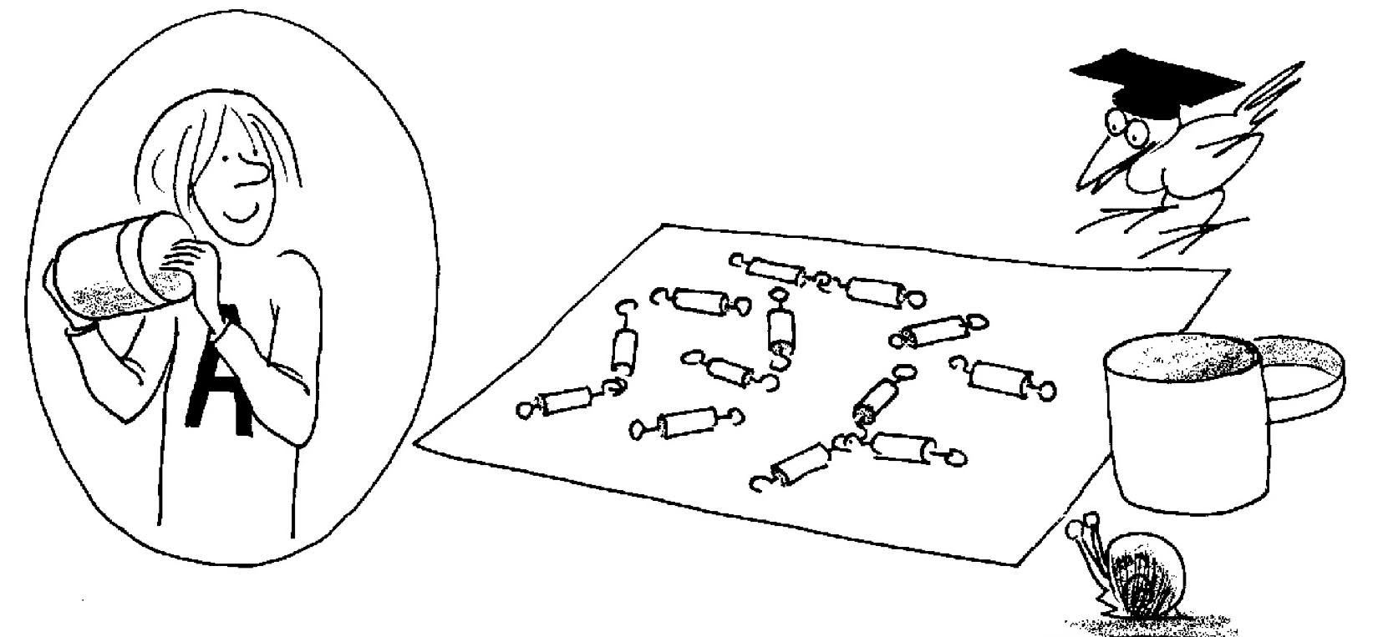

Order is more likely than disorder. #

If your bag contains N elements and you repeat the operation a large number of times, you can calculate the probable percentage of elements linked two by two, and the one where three objects are linked. # The conclusion is that it is very unlikely that this system will evolve in a state of complete disorganization. #

In this case order is more likely than disorder. #

It is the same with atoms, in a star, which bind together by the mechanism of fusion. # These same atoms, dispersed in the galaxies, tend quite naturally to assemble to form molecules, in particular biomolecules. #

At this stage, once again, it is useless to invoke the action of a god. #

We are facing a morphogenetic evolution which simply follows from the equations of physics. # It was thus a great astonishment when Miller conducted his experiment in which he subjected what was thought to be the primitive atmosphere of the Earth, exhaled by its volcanoes, by subjecting it to electric sparks.#

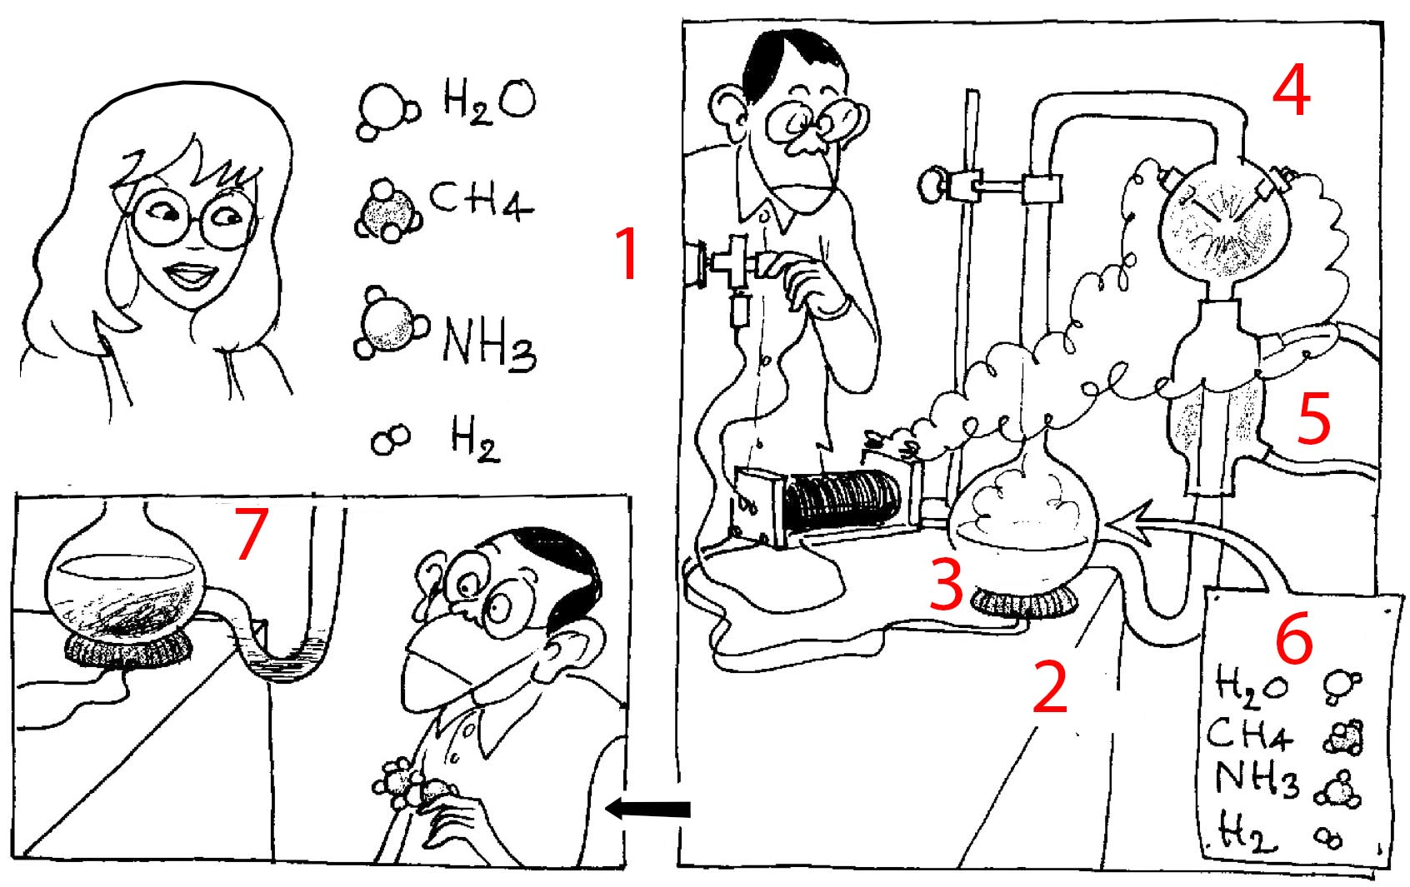

Miller's experience ( 1950 )#

1: What we suppose to correspond to the composition of the primitive atmosphere of the Earth: water value, methane, ammonia and hydrogen. #
2: With the help of a resistor#
3: Miller provokes the evaporation of the mixture dissolved in water in a liquid state#.
4: This vapor is then subjected to an electric discharge created with the help of electrodes put under tension, which simulate the stormy phenomena present in the clouds. #
5 : Condenser. #
6 : Return of the condensed value to the boiler, thus treated. #
7: At the end of a weekend Miller will notice that the household has taken on an orange hue, which is due to the presence of amino acids, synthesized. #

These amino acids constitute "the building blocks of life". # At this stage, experiments were carried out where clay, playing the role of catalyst, could create a polymerization, giving birth, not to biopolymers but to molecules of the same complexity.

Jean-Pierre Petit:

At this stage, we were in the fifties, scientists thought they could recreate life in the laboratory. #But it was a failure. #

Peter Small:

This evokes the time when everything that came under a branch of chemistry to which the name of biology had been given, was supposed to escape all human intervention. # Chemists were therefore very surprised when the first biomolecule could be synthesized: urea, synthesized in 1828 by the German Wöhler.#

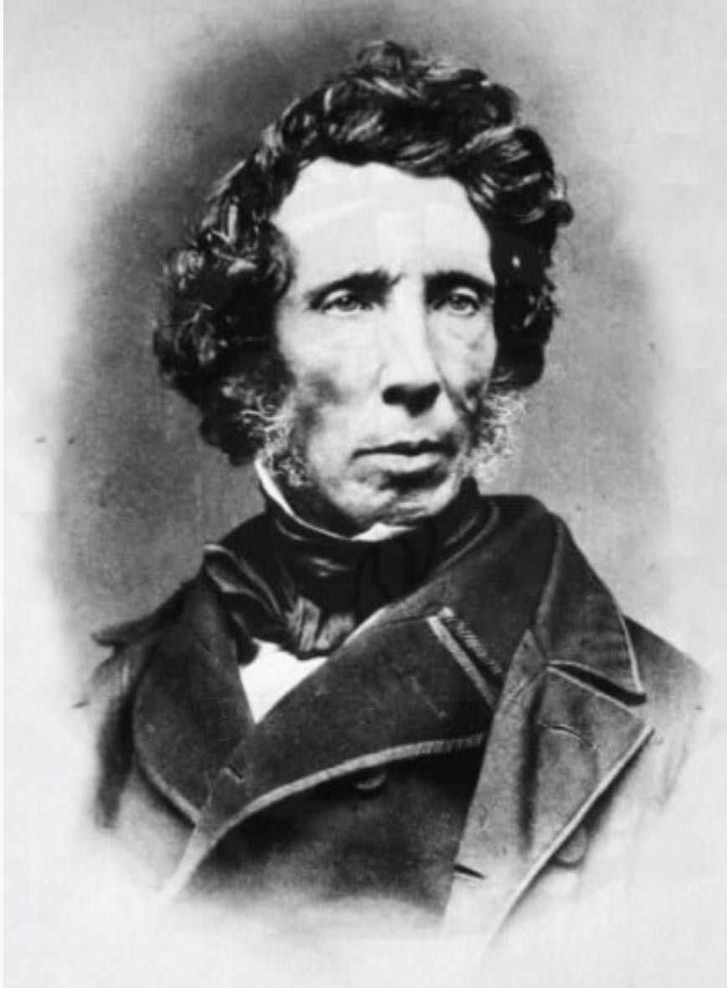

Friedrich Wöhler
1800-1882

Jean-Pierre Petit:

Today the pharmaceutical industry prides itself on being able to synthesize the most sophisticated biomolecules, researchers manipulate DNA like sorcerer's apprentices, but as far as the emergence of life is concerned, we are not much further ahead. #

Peter Small:

I understand that you see things in a significantly different way. # The current "scientist" view is decidedly materialist. # Some biologists lightly handle the word "consciousness" by imagining that they can reduce it to a problem of neurobiology. # As for the pioneers of artificial intelligence, they hope to endow robots with "sensations", "feelings" and this attribute of which one would like to hold a clear definition: the conscience.

Jean-Pierre:

Even before reaching this level of consciousness, we can expect that robotics and artificial intelligence will bring out machines that will seem to be endowed with a rich personality, with the consciousness of being "individuals." # This phenomenon will emerge as soon as we have endowed these same robots with psycho-socio-immunological mechanisms. # By defending themselves efficiently against any attempt of destabilization, they will give the illusion of their "personality". # This will become all the more impressive as no one will be able to decipher the "intellectual" paths followed by the artificial intelligence # And, as it has been said above, these robots, these machines, could "go underground" and escape the control of humans. #

A methodological vision of the universe.#

Peter Small:

But then, what do you think consciousness is? #

Jean-Pierre Petit :

Before attempting to model it, it would be appropriate to try to give a definition. # I will opt for a resolutely methodological approach. # In all the phenomena that we are given to observe, in the universe, what is at work? What does it translate, express? # When we go back to the distant past of the material universe, we find a mode totally disorganized by a chaos of particles. #

Peter Small:

The tohu-bohu of the Hebrew genesis. #

Jean-Pierre Petit:

Very good image indeed. # As long as matter is not decoupled from radiation, at 380,000 years, the incompressible "photon gas" opposes the appearance of any assembly of masses, by gravitational instability.#

Peter Small:

In other words, this gas of photons is opposed to the appearance of "objects". # A uniform world contains none. # The image of this world devoid of any structure corresponds to that deduced from observations made with the Planck satellite.#

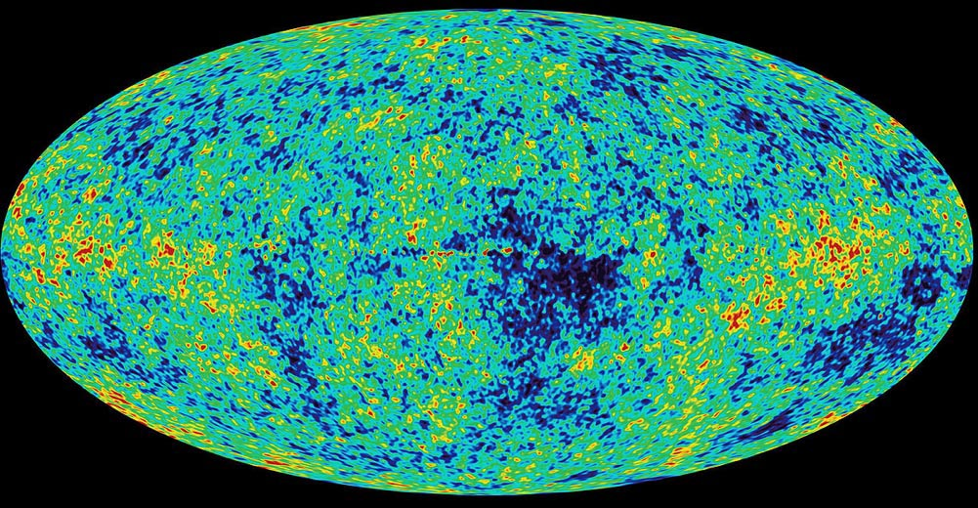

The 380,000 year old image of the universe. #

Jean-Pierre Petit :

This result is classically presented using the mapping technique known as "Mercator projection". # Hereafter the terrestrial sphere thus deployed:#

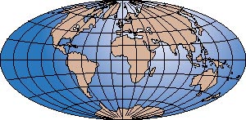

Thus, it would be more meaningful to represent this image of the primitive universe as : #

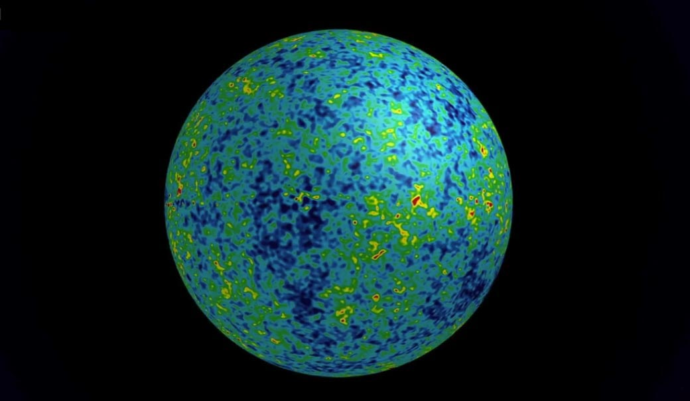

Peter Small :

Adding that taking into account the real amplitude of these fluctuations, which correspond to an energy density contrast of one hundred thousandth, it would be more like this:#

Here we are faced with a cosmological definition of "nothing", as the absence of an object. #

Jean-Pierre Petit:

To which we must add, and this has its importance, the absence of any observer. #

Peter Small:

Apart from what one will find in many traditional religious texts, the presence of a creator god. # Vis-à-vis the material world you replace this creator god of "things here below" by the equations of physics. # And indeed, as soon as the expansion of the universe lowers its temperature below 3000 degrees, it "de-ionizes", i.e. the electrons, ceasing to be "books" come to orbit around the hydrogen and helium nuclei. And as the photos interact more with the free electrons than with these orbital electrons, the "photon gas" ceases to interact with the matter. # These two "photon gases" and the "matter gas" become derived from each other. # In the scheme of classical cosmology it will be necessary to wait until the expansion lowers the temperature of the matter fluid so that galaxies and stars can be formed. # But you have, on this plane, a different scheme, corresponding to your Janus model. # And this is where you add to the positive mass a second entity, the negative mase. # It is thanks to their "divorce" that the very large scale structure of the universe can be constituted. # This is mentioned above. # Even before the atoms can cling to each other with the "hooks" and "rings" with which they are provided, the matter will be structured in "joint bubbles", each of these "bubbles" having in its center a conglomerate of negative mass#

What is interesting is that from the outset, the material universe appears as a place of conflict, of opposition between two entities of different nature: the positive mass and the negative mass. # According to you, it is thanks to this antagonism that the destiny of the universe can be written. # But this implies a fundamental dissymmetry between these two entities. # In your model the volume density of energy of the negative masses is clearly more important. #

Another aspect: the world of negative masses is that of the absence of complex structures. # In these spheroidal conglomerates, the gravitational instability cannot come into action. # This is then opposed to the appearance of galaxies, stars, thus to nucleosynthesis and the creation of atoms heavier and more complex than helium. #

Jean-Pierre Petit:

This world is "dead". #All forms of life would be excluded. #

Peter Small:

Moreover these conglomerates are made of antimatter. # It is even primordial antimatter. # What happens if positive mass meets negative mass?

Jean-Pierre Petit :

Dans le modèle Janus ces deux types de masse n’interagissent qu’à travers une antigravitation. # Elles se repoussent mutuellement et cela se limite à ce phénomène. # Mais si une nef, par exemple, parvenait à inverser sa masse et rencontre un objet fait de masse négative, les deux s’annihileraient immédiatement en donnant des photons d’énergie négative. #

Peter Small:

You say in your writings that this mass inversion technique would be the key to interstellar travel. # But then, the travelers would risk annihilation by being likely to meet antimatter assemblies of negative assembly?

Jean-Pierre Petit :

This risk is non-existent because the only objects made of antimatter are these immense conglomerates located at the center of matter bubbles. # But the closest to our galaxy is 600 million light years away. # We are not even close to it. #

Peter Small:

So the interstellar ships, after reversing their mass, are not likely to encounter atoms of antimatter? #

Jean-Pierre Petit:

The perfect vacuum does not exist in cosmology, and in physics in general. # On their way these ships will evolve in an ultra-reflected environment constituted of antimatter atoms of negative mass. #

Peter Small:

So, even though this medium is ultra-refrigerated, every time an antimatter atom hits the wall of the ship, it will cause an abrasion phenomenon. #

Jean-Pierre Petit:

From which the nave will be able to protect itself with a magnetic field, the same way that the Earth protects itself from the bombardment associated with the solar wind with its magnetic field. #

Peter Small:

It remains that the Janus universe acquires its primary structure from the fact that this opposition between two "worlds", a "positive world" which will manage to structure itself, and a "negative world", which is amorphous, totally unstructured. Even if this negative world is located at a great distance, it remains metaphorically synonymous with "death", "unconsciousness", "destruction". # It is an "anti-world". # Paradoxically, while the ppstove mass represents only a few percent of the global energy, in this fight between morphogenesis and annihilation, this matter still manages to exist and to prosper.#

To become more complex and increase one's relational field. The meaning of life. #

Jean-Pierre Petit:

We thus discover the fundamental cosmic phenomenology:#

To become more complex increase its relational field. #

I put these arrows because one cannot go without the other. # To increase the relational field, you have to become more complex. #

Peter Small:

The appearance of stars, planets, molecules and biomolecules in this sense. # We can also speak of the birth, life and death of stars. # As they behave like spores which create atoms heavier than iron and reject the whole by ending in supernovae and that these same atoms will go, a little further, to constitute new stars "of second generation", one can speak about a phenomenon of stellar reincarnation. #

Jean-Pierre Petit:

This phenomenon to which we give the name of "life" prolongs this race towards the complexity and the extension of the relational field. # It is, according to me, the only relevant thing, undeniable, of phenomenological essence, that one can say. #

Peter Small:

So, according to you, the universe would be endowed with this "intention": to become more and more complex and to create within itself richer and richer circuits of information. #

Jean-Pierre Petit:

This word "intention" has an anthropocentric connotation. # It "is", that's all. # It is a simple observation of a state of affairs. #

Peter Small :

On voit poindre une amorce de « morale cosmique ». # Tout ce qui irait dans le sens de l’extension du champ relationnel aurait une connotation positive. #

Jean-Pierre Petit :

With respect for others, for their environment in all its forms. #

Peter Small:

On the contrary we find everything that is synonymous with destruction, in all its forms. # Systematic hegemony always leads, in fine, to this result. # Empires always end up disappearing. # Yet conflict and competition are found in all strata of life. #

Jean-Pierre Petit:

It is a subtle dialectic. # Just as death is part of this "plan" that life represents. # It is what is the most difficult to accept in human beings, since in prehistoric times they questioned their own death.#

Peter Small:

So much so that some people envision that the ultimate progress would be the attainment of eternity. #We think of those who are cryogenically frozen in liquid nitrogen, either lowering the temperature of their entire body or keeping their head. #

Jean-Pierre Petit:

If we could graft heads onto other bodies or, more subtly, graft brains, no doubt we would find poor people on Earth ready to sell their bodies to support a family, or a community.

Peter Small:

And men ready to seize bodies of young people, to make trade of it. #

Jean-Pierre Petit:

This is the reason why there cannot exist a metaphysical vision that does not bring an answer to these questions:.#

- Why life? #

- Why death? #

- How does it work ? #

Peter Small :

You bring an answer, phenomenological, to the first question. # The second finds its analogy in all the creative mechanisms of nature. # All animals must feed themselves. # So to structure themselves, they must "kill", degrade the biological structures of other living beings, to use the energy they get from this consumption of food. #. But, on earth, the only exploitation of energy which is not linked to a destruction of a structure, it is the exploitation of the solar energy, such as the plants do. #

Jean-Pierre Petit:

The exploitation of a form of energy does not systematically go with a reduction of complexity. # In stars, fusion reactions increase the complexity of atomic nuclei. # Carbon, oxygen and sulfur are more complex than hydrogen and helium. #

Peter Small:

We must consider the phenomena in an overall scheme. # Nature is itself the site of permanent conflict, of relentless competition, which is the motor of natural selection. # In this context, what sense can be made of the emergence of a mammal considered superior to man? #

Jean-Pierre Petit:

What characterizes it? # Many animals use primitive technologies, which can be called tools. # But as soon as man appears this phenomenon develops exponentially.#

The meaning and role of technology. #

Peter Small:

In this finalistic scheme of yours, everything must make sense, play the role of a cog in a race to complexity and to the extension of the relational field. #This is what we can read through the history of Life on the planet. #What is the ontological significance of this new "emerging phenomenon" that is the technologist? # What role does it play?

Jean-Pierre Petit:

Let us reason by elimination. From the point of view of a systematic extension of the relational field, in what way would its emergence prove to be necessary? In the universe, everything that appears, manifests itself, seems to have a role. # When a planet is formed, the volcanoes exhale the gases which will constitute its future atmosphere # If there is a thing which is going to accelerate this race to the complexity and to the extension of the relational field, it is well the life. #This one appears within the oceans. #It finds two kinds of energy sources. # Near the surface it is the solar energy. # The blue-green algae will proliferate. # Releasing the oxygen contained in the carbon dioxide molecules, they will enrich the oceans with this gas, which will allow mollusks, shellfish and fish to breathe with the help of gills. # As these are endowed with a mobility, of senses and of a very superior complexity, this represent a new jump which goes in the direction of the general plan. #

The invasion of the atmosphere by oxygen molecules, which become over hundreds of millions of years its major component, will allow life to conquer a new domain.#

Peter Small:

What we often tend to forget is that the majority of the molecules that make up the Earth's atmosphere are the result of the work of living things. # And all that is limestone is nothing more than what became the shells of other living things. # Life has had an important role in terraforming. #

Jean-Pierre Petit:

The spores of plants, birds and fish give life a mobility that has a planetary dimension. # There is no land that cannot be reached, no obstacle that cannot be bypassed, no ocean trench that cannot be conquered. #Today, biological evolution has provided all the solutions it could implement. #So what is left? #

Jean-Pierre :

Extend the relational field beyond the Earth to other biospheres. #But no bird would have ales big enough to cover such distances. #

Pete Small:

Technology is the answer! #

Jean-Pierre Petit :

Exactly, as an emerging phenomenon. # It goes hand in hand with the development of intellectual faculties. # This technology will make it possible to manipulate the energies making these journeys possible. # There it is no longer a question of the energy of the wind, or that drawn from the combustion of fossil hydrocarbons. # We pass to a totally different order of magnitude. #

Peter Small:
Nuclear energy, the fission of the atom.#

Jean-Pierre Petit :
Fission is too polluting. # It is a source of energy that will have to be abandoned in favor of fusion. #

Peter Small:
Fusion is not without its waste drawbacks. # It generates neutrons, which make everything they touch radioactive. #

Jean-Pierre Petit:
The fusion of the isotopes of hydrogen, deuterium and tritium, yes. But there are fusion reactions that do not create neutrons, such as that of boron and hydrogen (ordinary), which generates only helium.#

Boron¹¹ + Hydrogen¹ 3 Helium⁴ + energy

Peter Small :
Yes, but for that you need a minimum of a billion degrees!

Jean-Pierre Petit:

It is a threshold that has been crossed since 2006 in the experiments conducted at the Sandia laboratory in Livermore, USA. # An experiment that was analyzed and described by my late friend Malcom Haines. # At that time, the maximum temperature reached in machines like the Tokamaks did not exceed 150 million degrees. # No one imagined that one could go significantly higher. # Following an idea of the Russian Smirnov, the American Gerold Yonas reached more than two billion degrees with his Z-machine. # And with these machines, much higher temperatures can be achieved.#

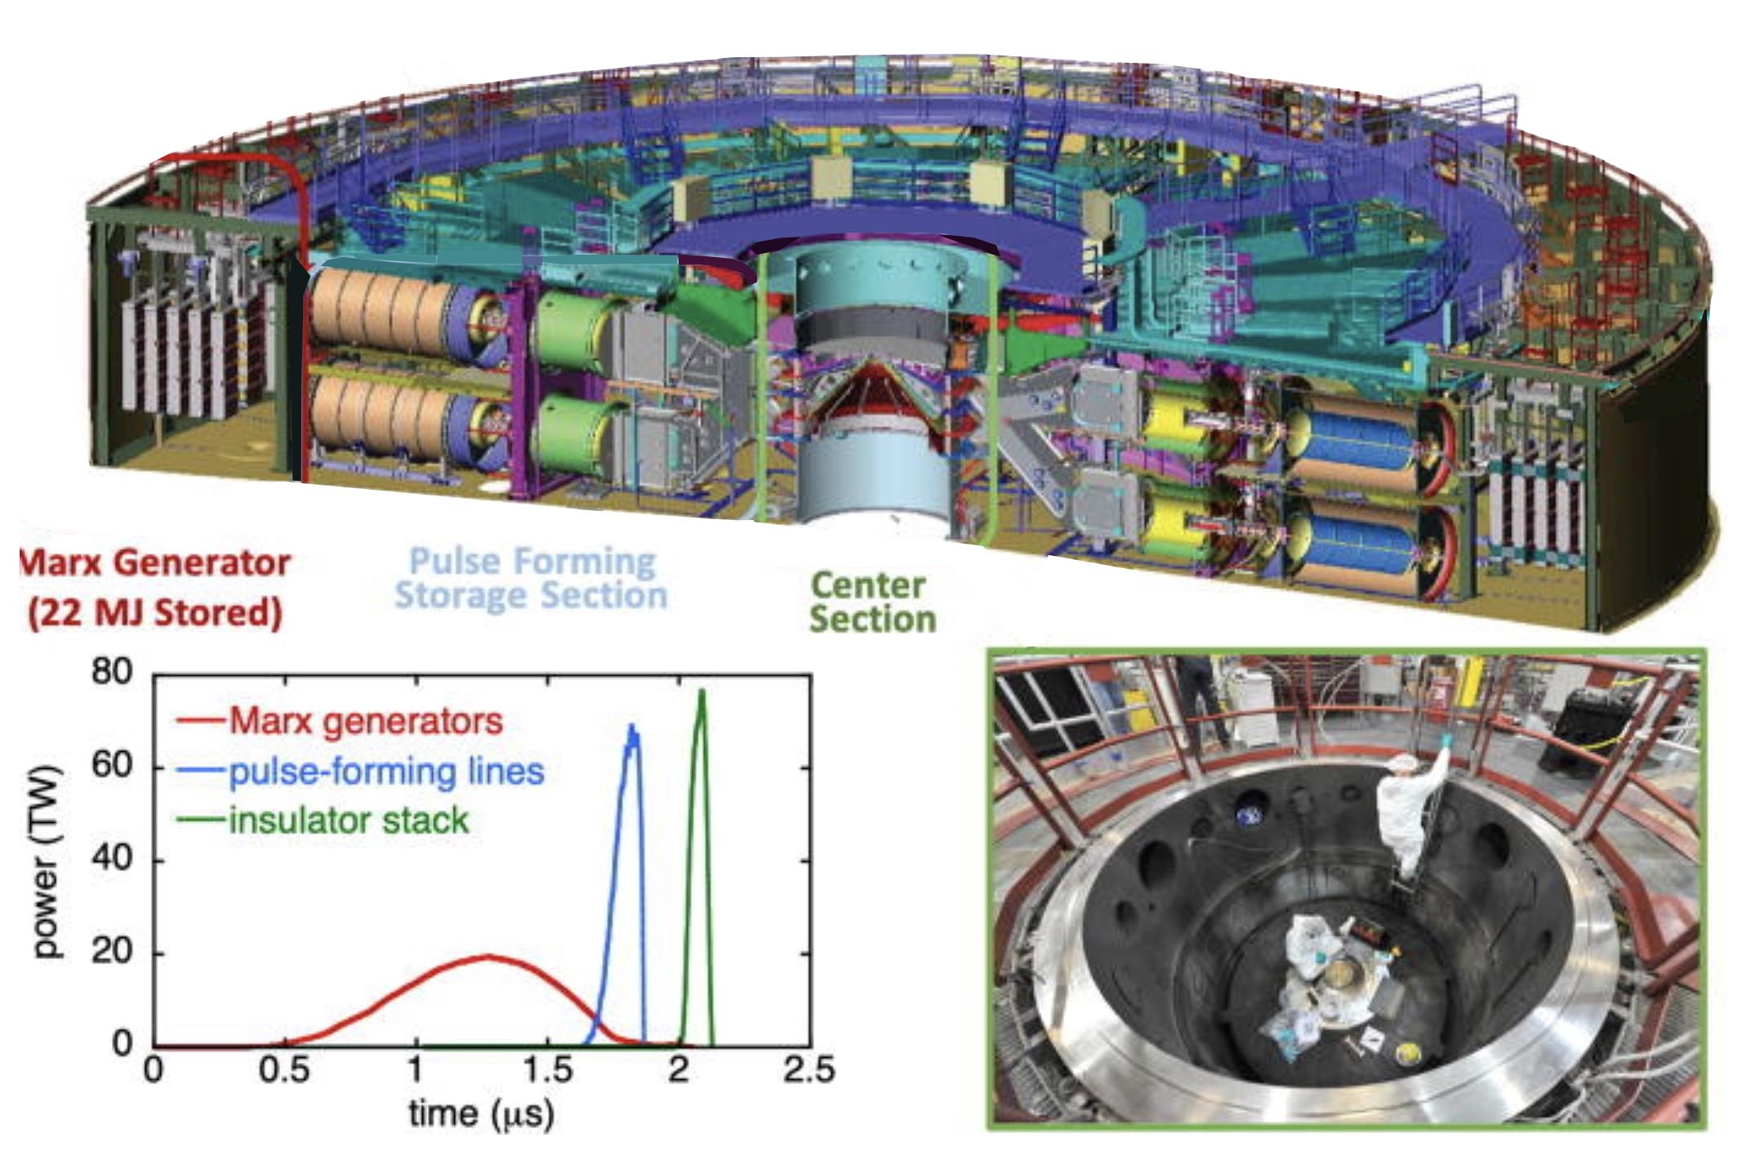

The Z-machine at Sandia Laboratory, USA, New Mexico. #

Peter Small :

Oui, mais cette température n’a été atteinte que pendant un très bref instant. #

Jean-Pierre Petit :

The thousand degrees that allow the combustion of the mixture of hydrocarbons and oxygen in the cylinder of your car are reached only for a very short time. #The engine of your car, however, thanks to this impulsive combustion. #

Peter Small:
Do you think we will ever be able to get energy from a Boron11 - Hydrogen1 mixture?

Jean-Pierre Petit :
We already know how to provoke this reaction. # For the moment, we get less energy out of it than we put in. # But it is only a question of time. # What is important to remember is that the design of a spacecraft capable of crossing light-years required significant energy. # It happens, as it is the case for many scientific and technical innovations, that the men aimed first the creation of weapons of mass destruction. #

Peter Small:
But, in your opinion, the purpose of these technical developments is to be able to create naves that will allow the extension of the gravitational field. #If we consider using them as a source of energy, this would only represent a fallout from the primary goal.#

Jean-Pierre Petit :
All the benefits that we have derived for tens of thousands of years from technological advances are only aspects that can be described as collateral, with respect to this central objective: the revival of the extension of the relational field.#

The function provided by conscience. #

This is why the exponential acquisition of technology required something that could ensure that the living being that was endowed with it would not use it against its own species, or even against all living beings on this planet. #

Peter Small:
In other words, the fact that he could consider the consequences of his actions. #

Jean-Pierre Petit:
In other words, to be endowed with a level of consciousness that places him one notch above the animals, with a conscience. # The human being is equipped with a knowledge, of knowledge. # His conscience allows him to think about the use he can make of this knowledge. # Ecology is a first step in this direction, in the sense that the human being begins to measure the negative impact that he can have on his environment. #

Peter Small:
But the damage that would result from using the weapons at his disposal could, if not destroy all life on Earth, at least make evolution take an immeasurable step backwards. #I am beginning to understand the meaning of this book. # There are only two alternatives:#

Understand or disappear. #

The key question, we have it in front of us. #

Peter Small :
I am willing to consider things from this angle. # But there remains a very problematic point which is the time taken to realize these contacts with civilizations residing on other planets, orbiting other stars than the Sun. # Even by traveling at a tenth of the speed of light it would take no less than a century to make a round trip to the nearest star, Alpha Centauri. #

Jean-Pierre Petit:
If you have read everything I have written about our Janus model, you cannot ignore the most important point of its conclusions. # He postulates that the universe is made up of two sheets of space-time, in the same way that a sheet of paper has a front and a back. When we travel on the "front" of the space-time hypersurface we have the distances you are talking about, and the speed is limited to 300.000 km/s. # The travel times then become immediately prohibitive. #But if we manage to travel on this "back" of the hypersurface-universe, the distances are a hundred times shorter and the limitation to the speed at which photons propagate in this sheet is ten times greater. The travel times are then divided by a thousand. #

Peter Small:
By using this sort of parallel universe. #But how to get there?

Jean-Pierre Small :
It is necessary to proceed to the inversion of the mass and the occupants of the vessel. # I have already given in my books and publications tracks to achieve this. #In particular, if the energy to implement is high, it has nothing in common with the Mc2 energy of this mass M to be inverted.#

Peter Small :
If your Janus model provides enough evidence this other idea lacks supporting evidence. Is there anything that shows that this mass inversion can occur somewhere in nature? #

Jean-Pierre Petit
I think so. # Since the 1950s, attention has been focused on what should happen when a mass reaches a form of geometric criticality. # And the answer that was developed in the mid-seventies is the black hole theory. #If there is a model that rests on a mathematical basis that is not very credible, it is this one. # For example, we read that if an observer succeeded in penetrating the black hole, the coordinates of space and time would see their roles swapped: time would correspond to what was the radial distance r while t would become a dimension of space. #All this is written in black and white in the Bible of Cosmology, the book of more than 900 pages composed by John Archibald Wheeler, Charles Misner and Kip Thorne. #

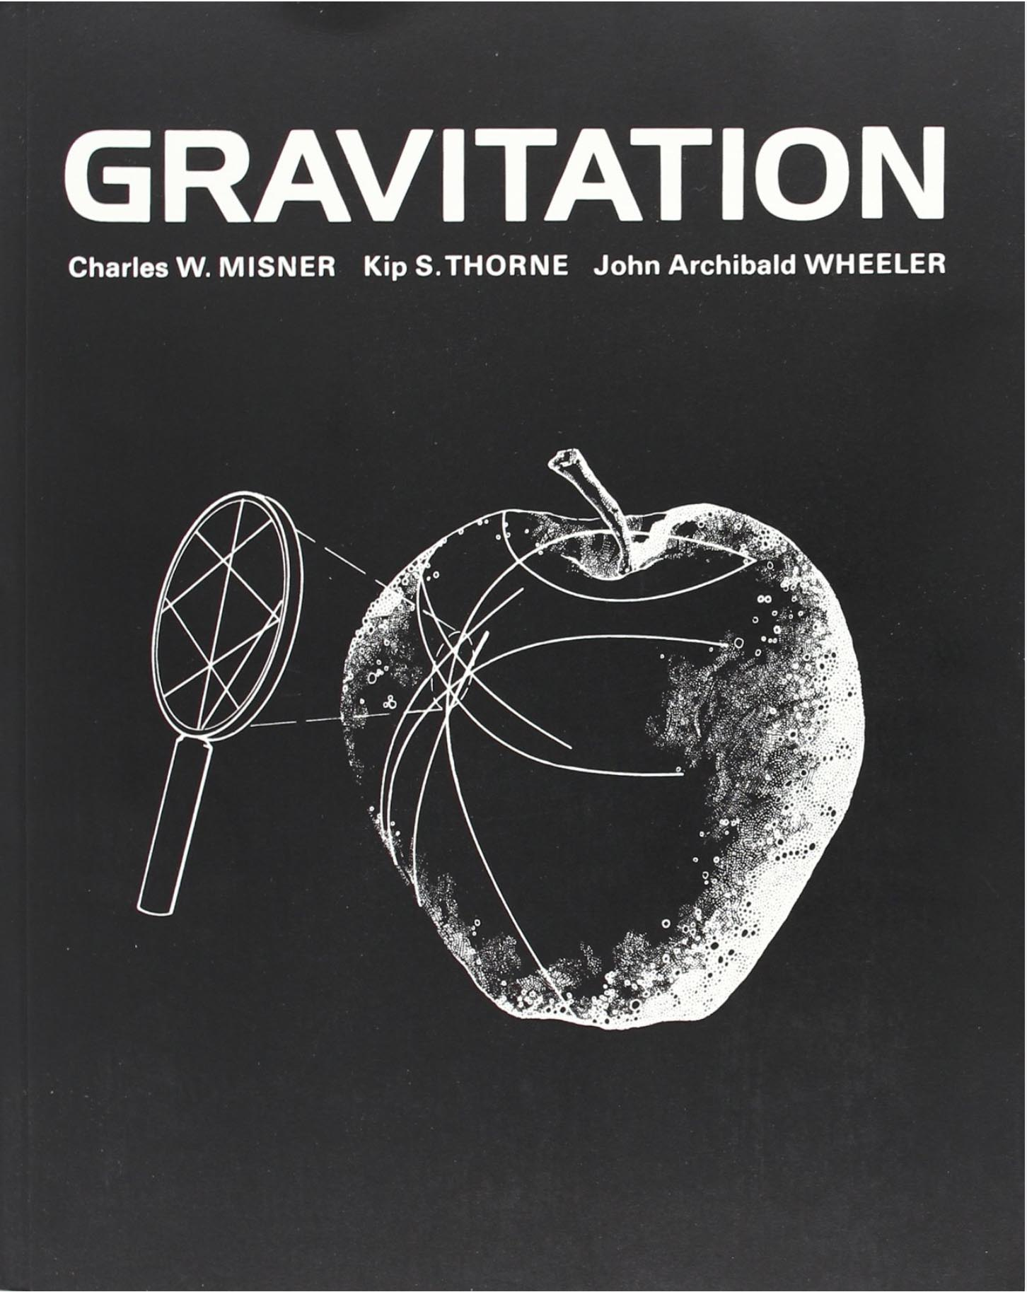

There are two situations in astrophysics that the theorist must take into account. The first is when a massive star collapses onto its iron core when it goes supernova. If the mass remains moderate, the iron atoms are crushed and the object becomes a neutron star. # But if the mass of the star reaches ten solar masses, and even before, this iron core represents a mass greater than 3 solar masses. # Then this solution that is the neutron star can no longer be considered. # But we now have the proof that there are stars whose mass exceeds one hundred solar masses.#

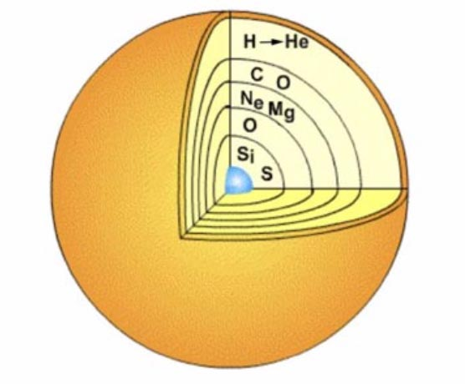

A massive star. #

There is this second configuration, where a neutron star is the companion of a massive star emitting its stellar wind, which it captures. If the critical mass is three solar masses, and the mass of the neutron star is less than this value, this mass capture will make that, very slowly, its mass will reach the criticality.#

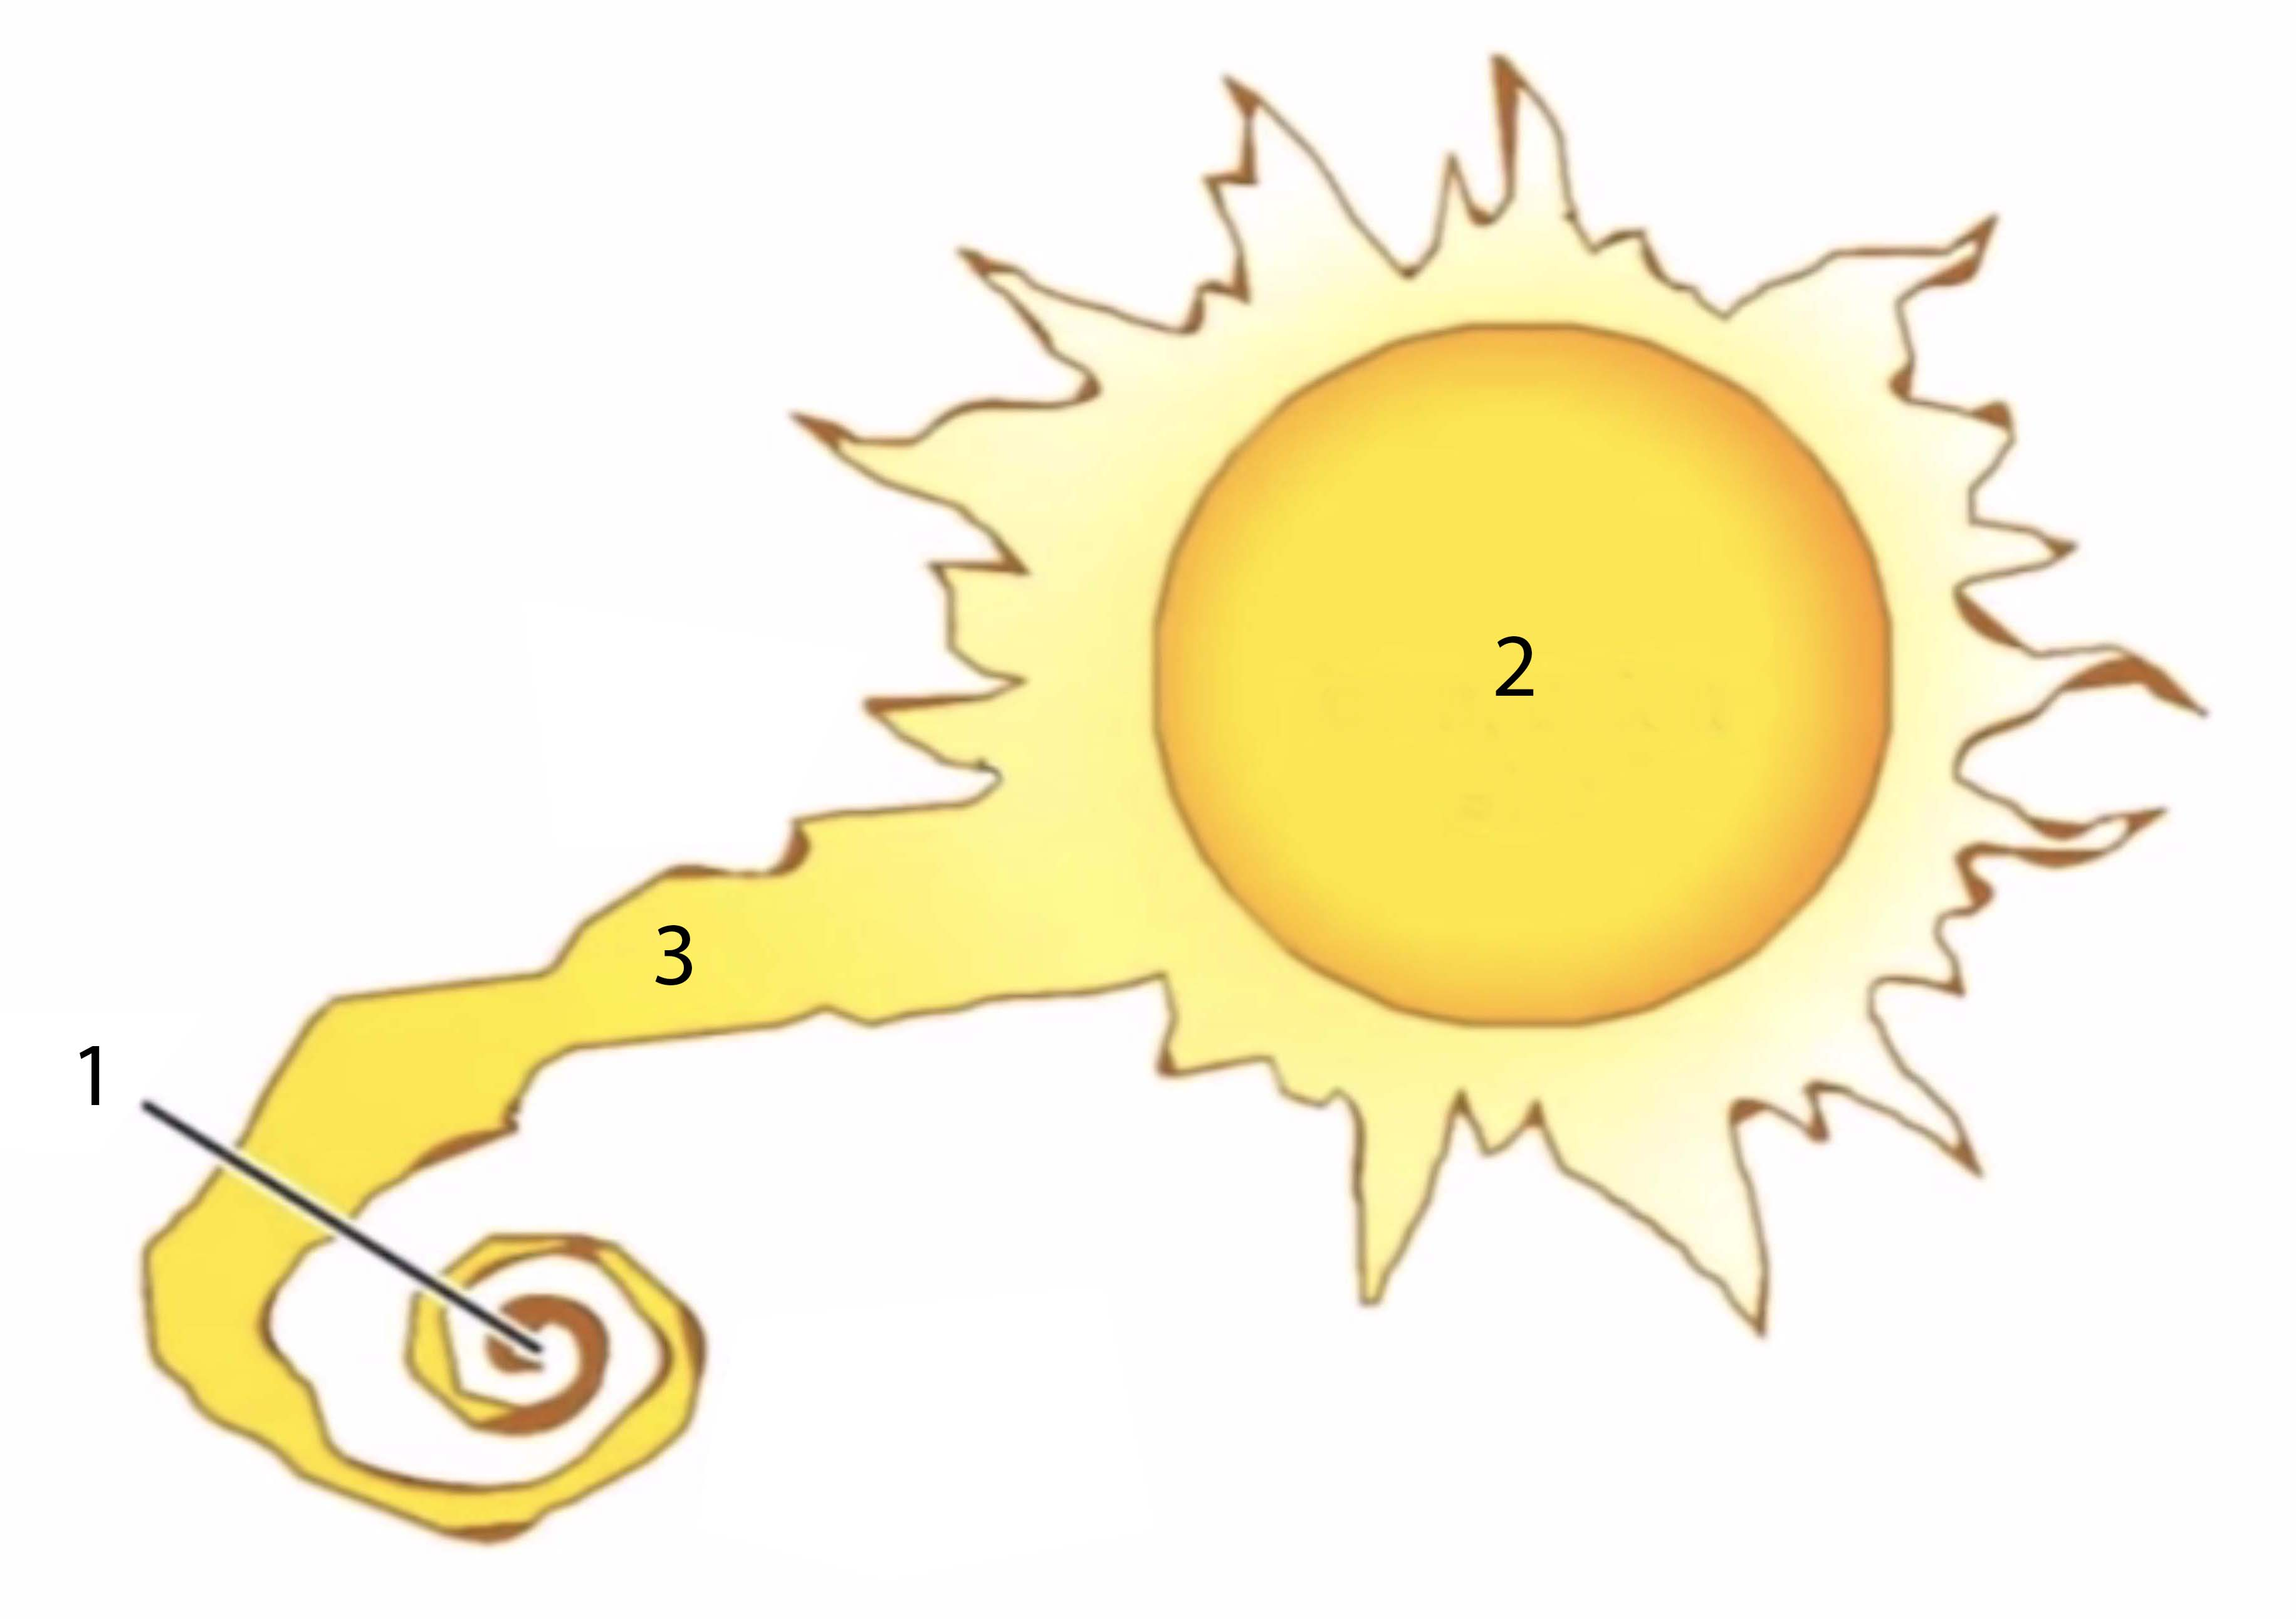

1 : Tiny neutron star
2 : Companion star
3 : Stellar wind captured by the neutron star

When the mass of the star reaches 2.5 solar masses a physical criticality, discovered by the German Karl Schwarzschild in 1916, intervenes. # At the center of the star the pressure and the speed of light become infinite. # The mass at this point is reversed and is ejected from the star. # I gave this phenomenon the name of Plugstar. # The image below illustrates this concept.#

&&& didactic image of the plugstar.

Their image is darkened in their central part and the ratio of maximum and minimum temperatures is then 3. # . This is exactly what appears on the images of the two hypermassive objects located at the center of the galaxies M87 and Milky Way :#

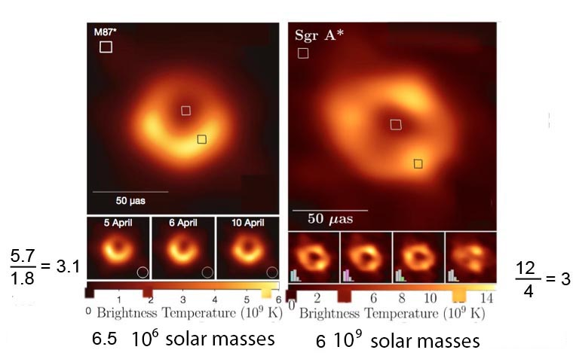

Peter Small :

Specialists say that these are two giant black holes. As for the fact that the central part is not perfectly black, they attribute it to the presence of hot gas in the line of sight. #

Jean-Pierre Petit:

It is a curious coincidence that this ratio of maximum and minimum temperatures is so close to the value given by your Plugstar model. # We could produce images of these objects for two reasons. The one in the Milky Way because it is the closest to us, and the one in the galaxy M87 because it is extremely massive and large, despite the distance of 55 million light-years that separates it from us. #

Peter Small:

If it turns out to be possible to obtain an image of a third such object, and if the ratio is still three, we should seriously question its nature. # But if it is a Plugstar, it cannot be a giant neutron star, since according to you their mass cannot exceed 2.5 solar masses. # So what is it? #

Jean-Pierre Petit :

I think, for the object which is in the center of our galaxy, that it is the residue of a quasar phenomenon. ##

Peter Small:

The object in M87 is an active quasar, since you can see very clearly the two thin jets emerging from it. # But that doesn't answer the question.#

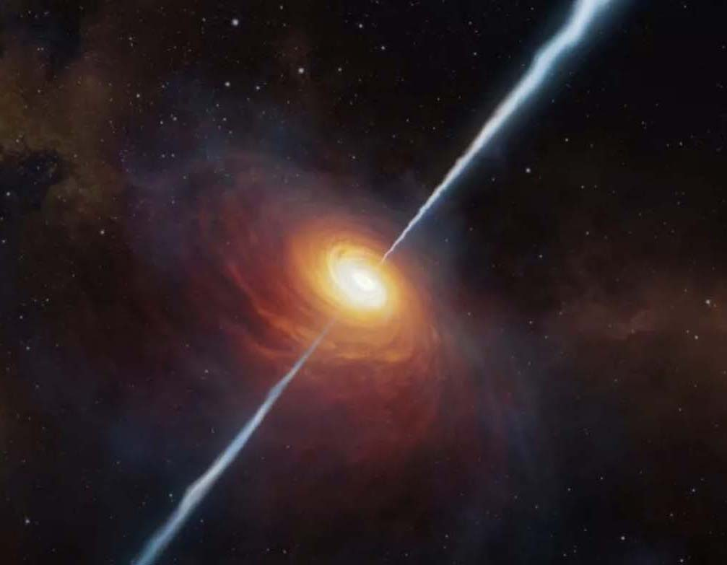

Artist's image of a quasar. #

Jean-Pierre Petit :

I think that quasars result from the convergence at the center of galaxies of a wave of matter, visible on the Hoag galaxies . # When this ring of gas reaches the center of the galaxy, it picks up the whole magnetic field of the galaxy, like a harvester picks up the wheat. This creates a magnetic field of unprecedented value, which collimates the plasma jets, but also opposes the implosion of the object. # But all this moves us away from our subject. #

Peter Small:

I agree. # The central question was mass inversion. # Let's assume that your interpretation of the nature of the objects in M87 and the Milky Way is correct. # Then we would be dealing with the result of a mass inversion operated by Nature # Do you think the same thing can be done in the laboratory? #

Jean-Pierre Petit:

Before fusion reactions were carried out, starting with bombs, do you think that a century ago people would have believed that we could reconstitute what is happening at the heart of the Sun? #

Peter Small:

All of this is still a large chain of assumptions added together. # Your cosmological model, with its two sheets of space-time and its profound asymmetry, must be able to impose itself. #Then we must consider the technology to reverse the mass of a nave, to allow it to travel through this kind of reverse of the universe, where the distances are a hundred times shorter and the light barrier ten times higher. #How long will it take before men can convince themselves of the validity of your theories by having all this before their eyes? #

Jean-Pierre Petit:

But we have had all this before our eyes for more than half a century.#

Peter Small :

What do you mean ? #

Jean-Pierre Petit :

And this image, what is it? #

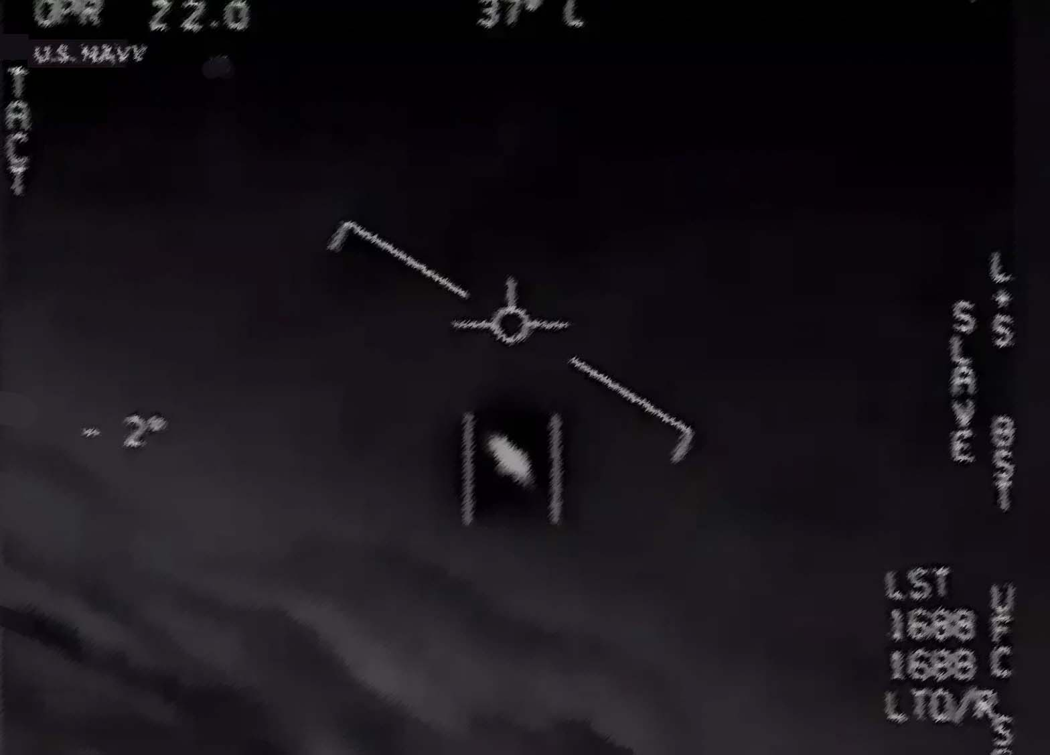
.

Peter Small :

Unless I am mistaken, it is extracted from a film taken in 2004 by the camera of a jet on board the aircraft carrier Nimitz. # Document that the United States Navy has authenticated. #

Jean-Pierre Petit:

And what do you think these jets were chasing? #

Peter Small:

Well, let's just say that this is one of the very many documents that lend credence to the idea that the Earth may be visited by aliens. #

Jean-Pierre Small:

And the only argument, the last of a line of defense, that is opposed to this interpretation, despite its evidence, is that interstellar travel would be scientifically impossible, because of its excessive duration. #

Peter Small:

But your model undermines that last argument. #And that's why the scientific community is doing everything to prevent this model from being considered. #Assuming that this interpretation is correct, what changes would it make in our conception of the universe, of life?#

Jean-Pierre Petit :

We earthlings would be confronted with our reality. #How we continue to kill each other in absurd wars. # As soon as one of them ends, we start the next. # Only 21 years passed between the first and second world wars. If it weren't for the nuclear dimension, a third world war would have broken out long ago. #

Peter Small:

In any case, it has been calculated with the "low-intensity conflicts" that we have experienced that there have been as many deaths since 1945 as there were during the Second World War. # But then, what do you expect from these visitors? #

Jean-Pierre Petit :

I do not expect anything from them a priori, except the fact that this presence finally forces us to consider the question of the place and the role of man in the universe, by leaving the traditional schemes, or the scientist, materialistic schemes, which do not seem to be able to provide us with solutions to our problems. #

Peter Small:

And after this long preamble, full of digressions of all kinds, here we are finally at the heart of our subject. # So, how do you see this metaphysics?#

The French top level school in France for Aeronautics and Space technics.
J.M.Souriau. Structure of Dynamical System. Ed. Birkhauser, 1997.
See &&& références
&&& Reference Herman Bondi 1957
ROM : Read Only Memory. # #
When dialoguing with a machine, man will no longer be able to distinguish between the words of a human and those of a machine.
Download link if this comic book exists in the considered language
Given by the CMB, the Cosmic Microwave Background. #
Died in 2013. # See my comment on his article at: http://www.jp-petit.org/papers/MHD/2006-comments-on-Haines-paper.pdf #
The temperature at the end of compression increases as the square of the electrical intensity applied in the discharge, whose rise time must be 100 nanoseconds.#
See section 31.3. #

