A French academician who doesn't understand the Janus model

The Janus cosmological model represents a profound change in the geometric representation of the universe. Einstein had described it as a "four-dimensional hypersurface". The Janus model extends this geometric vision by endowing this hypersurface with an "underside" where particles of negative energy and mass are located. Mathematically, this implies a "bimetric" description, where the two entities interact, hence the term "bigravity".

It so happens that the first person to propose such a thing was French academician Thibault Damour, in 2002A French academician who understood nothing about the Janus model.

Thibault Damour, academician

The articles, cited in footnotes, are accompanied by an address from which they can be downloaded.

Damour and Kogan attempt to construct a bimetric theory, involving a spectrum of gravitons endowed with masses, but this 40-page article comes to a screeching halt. In passing, they show that such bigravity must obey a system of two coupled field equations :

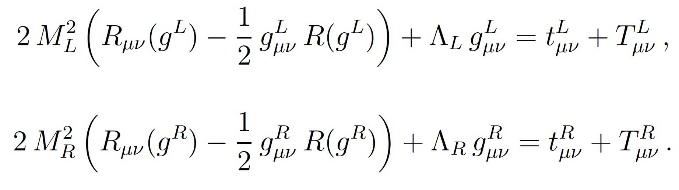

Six years later, Germany's Sabine Hossenfelder (now a science blogger) takes a more precise approach. This time, it's a question of conferring an identity on the inhabitants of this second fold of universe, in the form of negative masses.

In 1957, cosmologist Hermann Bondi attempted to introduce these masses into Albert Einstein's model . But the appearance of the runaway phenomenon (see the album) brings physical contradictions to light (the runaway effect). The model contradicts fundamental principles of physics, such as the action-reaction principle and equivalence. Sabine Hossenfelder also constructs her system of two coupled field equations:

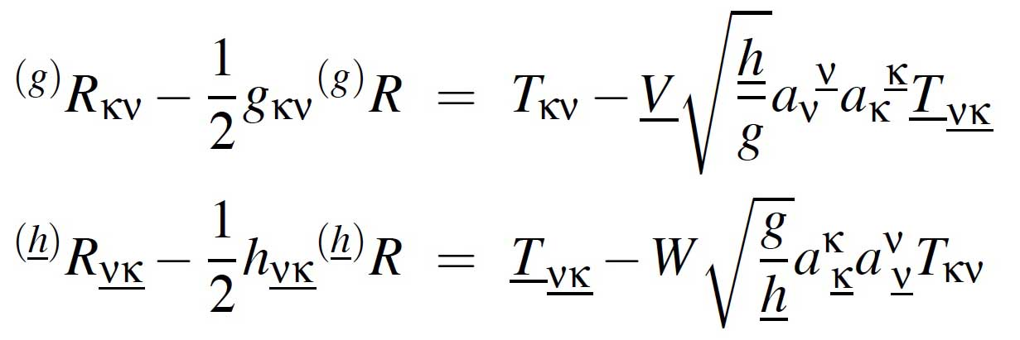

But she can't get rid of the discrepancy with physical principles. Believing that this is inexorably linked to bigravity, she gives up.

In 2014 we publish the first exact solution of our system of coupled field equations, which is physically and mathematically consistent, but which limits the solutions to a description of a homogeneous, unsteady isotropic universe.

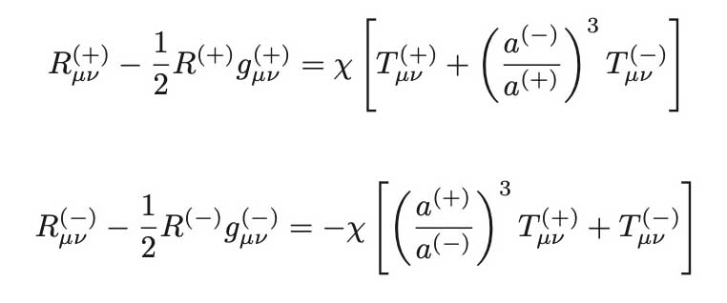
Mathematical consistency translates into a generalized conservation of energy. The exact solution derived from the equations shows that the "dark energy" driving the acceleration of cosmic expansion is none other than that of negative mass, the majority. In 2018 Gilles d’Agostini exploits this exact solution and shows that the model, named Janus, perfectly accounts for the data from type Ia supernovae, which earned S.Perlmutter , A.G. Riess and Schmidt the Nobel Prize for showing that the expansion of the universe, far from slowing down, was actually accelerating. Here's how G.D'Agostini's curve fits perfectly with the data:

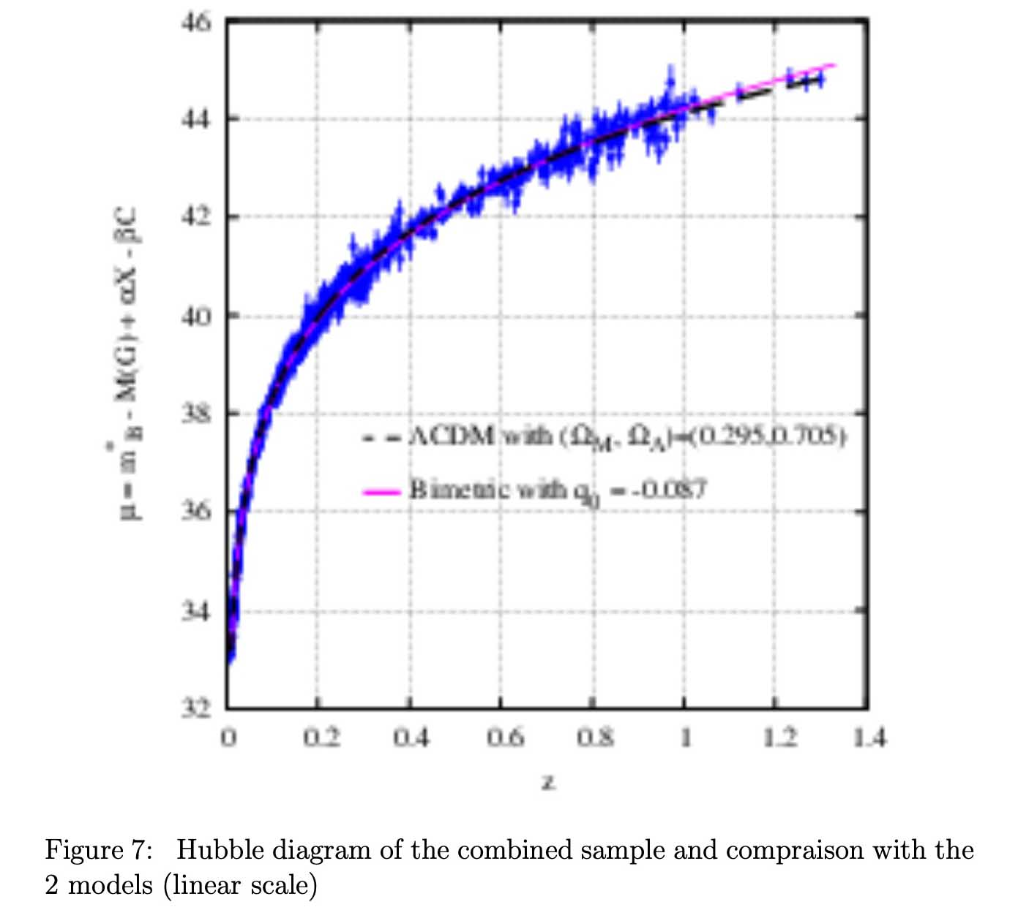

The mathematical consistency of the system of coupled field equations dictates that the terms of both members of the equations must have zero covariant derivatives. This applies to their first members, by construction. In physical terms, this translates into the satisfaction of conservation equations. The Einstein equation provides only two types of solution.

First, there are unsteady solutions under conditions of isotropy and homogeneity. Satisfaction of the condition translates into conservation of energy. We have seen that the same applies to the Janus equations. In the second article of 2014 the extension had been operated with two different light speeds.

The second set of solutions refers to stationarity (invariance by temporal translation), combined with assumptions of spatial symmetry. As in Einstein's model, the Newtonian approximation provides the 1/r² law and the sign of the forces. The forces deduced from the Janus equations (see comic strip) are in line with the principles of action-reaction and equivalence. In a vacuum, the mathematical consistency of the equations poses no problem, since both second members are zero.

But in 2014, when the model was being developed, it was not possible to determine the geometry inside the masses. Indeed, the equation translating the physical and mathematical coherence in this region of space simply translates into the fact that the forces of gravity within the masses must be balanced by the forces of pressure. In 2018, we had finally succeeded in this project and were in dialogue with a peer-reviewed journal to publish a first result, restricted to the conditions of the Newtonian approximation, which accounts for 99% of astrophysical phenomena. The article is published in the early days of January 2019.

At the same time, French academician Thibault Damour, considered the country's foremost expert on cosmology, published an article entitled Sur le Modèle Janus ( About the Janus Model) . He's a member of the Institut des Hautes Études, the French equivalent of Advanced Studies in Princeton, USA. He also sent me a registered letter with acknowledgement of receipt, informing me of the publication of an article which, according to him, put an end to what he considered to be ramblings.

Flabbergasted, we immediately replied, telling him that we had just solved the problem through an article, a copy of which we sent him, and proposing a meeting.

No reply.

Months and years went by without Mr Damour replying to any of our messages. In 2022, three years after his article went on line, we sent a letter to Mr. Damour, detailing the calculations on which our article was based., co-signed by them, demanding a reaction from him.

The reaction was immediate. On December 12, 2022, he published a second article on the IHES website, a veritable act of authority, entitled "Incohérence Physique et Mathématique du Modèle Cosmologique Janus" (Physical and mathematical inconsistency of the Janus cosmological model).

He then bases this new article on the fact that in the Janus model "negative masses attract each other, whereas it is well known that they repel each other". He thus demonstrates that he hasn't actually read our articles, and bases his argument on Herman Bondi's result from 1950. In the Einsteinian model, indeed, these negative masses repel each other. But in the Janus model, they attract. But there's none so deaf as those who don't want to understand.

It's easy to deduce the direction of the forces by constructing geodesics in a vacuum. The result is :
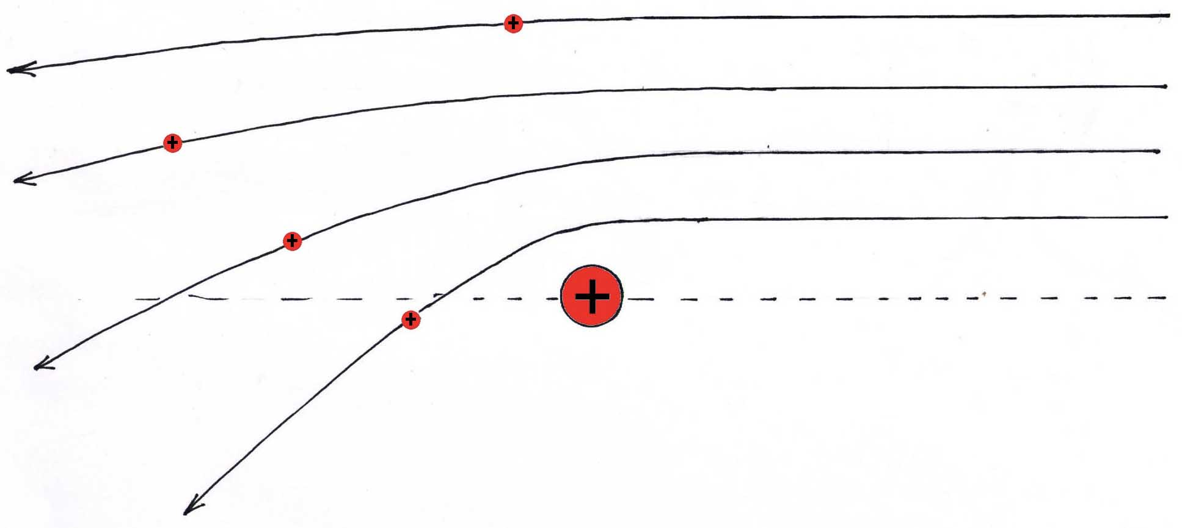

Fig.1 : Positive masses attract each other

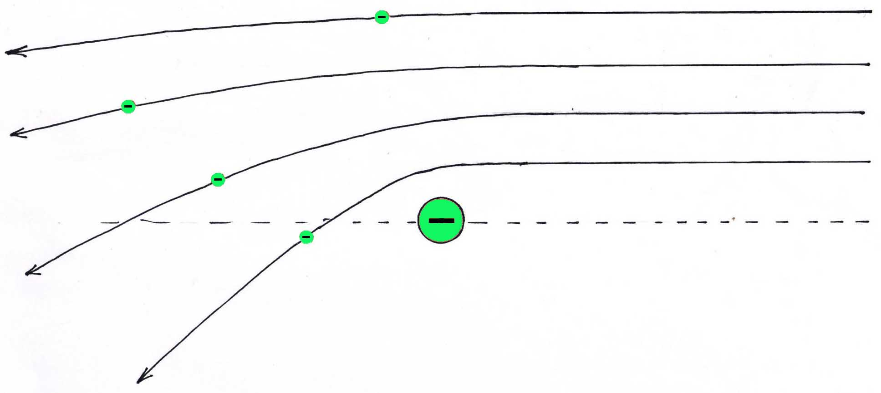

Fig.2 : Negative masses attract each other

Not having read our work and published articles, Damour didn't understand the effect of this "minus" sign in the equations, indicated here in red.:

$${R^{\left(+\right)}}_{μ}^{ν}-\frac{1}{2} R^{+}δ_{μ}^{ν}=χ\left[{T^{\left(+\right)}}_{μ}^{ν}+\sqrt{\frac{g^{-}}{g^{+}}} {{\hat{T}}^{\left(-\right)}}_{μ}^{ν}\right]RRRR$$

$${R^{\left(-\right)}}_{μ}^{ν}-\frac{1}{2} R^{-}δ_{μ}^{ν}=-χ\left[\sqrt{\frac{g^{+}}{g^{-}}} {{\hat{T}}^{\left(+\right)}}_{μ}^{ν}+{T^{\left(-\right)}}_{μ}^{ν}\right]$$

On December 14, 2022, we immediately pointed out his error. .

He then abandons this criticism and replaces this second article with a third one , posted on December 18, 2022, still on his IHES page, and then falls back on the alleged impossibility of integrating the neutron star model.

But here again, this last criticism doesn't hold water.

There is no need to explain the form of the "interaction tensors":
All we need to do is specify that their respective divergences must be zero. This is what Damour says in his 2002 article. But he doesn't know what else to say. In fact, it is this condition of compatibility and coherence that dictates the form of these two tensors. At this point, we should remember that general relativity, which translates into cosmic geometry being based on Albert Einstein's field equation, is in fact based on only two types of solution:

- Unsteady solutions (invariance of the solution by time translation) with isotropy and homogeneity.

- Stationary solutions with invariance under the action of the SO(3) (spherical symmetry) and SO(2) (axisymmetry) groups.

For the moment, the axisymmetric, SO(2)-invariant stationary solution of Einstein's equation is represented by the Kerr exterior metric (1963) (describing geometry in vacuum, outside a field-creating mass). This solution should logically be completed by its complement, the solution expressed in the form of an interior metric. But this has never been produced. The Janus equations provide the joint exterior metrics, two-sheet extensions of this Kerr exterior metric. As these solutions follow from the equations without a second member, their mathematical consistency follows automatically. The system must therefore be physically and mathematically consistent in both configurations;

- Unsteady solutions (invariance of the solution by time translation) with isotropy and homogeneity.

- Stationary solutions with invariance under the action of SO(3) groups (spherical symmetry).

The question has been solved in the first case with our 2014,2015, 2018 papers. The compatibility equation then translates into the generalized conservation of energy:

E = r⁽⁺⁾c⁽⁺⁾²a⁽⁺⁾³ + r⁽⁻⁾c⁽⁻⁾²a⁽⁻⁾³ = Cst

In the second case, as Damour agrees in the article posted on his page of the IHES website on December 18, 2022, these conditions are also fulfilled in the Newtonian approximation (low curvature, low velocities ahead of the speed of light).

This includes the geometric description of the region of space corresponding to the Great Repeller phenomenon, both inside and outside the formation. The geodesics followed by positive-energy photons (which alone lend themselves to confrontation with observation) can be deduced from the pair of inner and outer Schwarzschild metrics generated by a negative-mass source.

This left us with the problem of describing the geometry inside a neutron star, which is based on this Newtonian approximation. Everything that could be done in this direction was fully described in Karl Schwarzschild's two papers of 1916, the equation of state, known as the TOV equation (Tolman-Oppenheimer-Volkoff ) which is simply a reformulation of the 1916 solution in another coordinate system and through a differential equation.

This can be reconciled as a solution of the Janus system, based on the fact that these neutron stars are automatically located (positive and negative masses are mutually exclusive) in a region where negative mass is practically absent, and the system is reduced to equation :

This equation is none other than Einstein's equation, in mixed notations, which explains in particular why the Janus model satisfies all local relativistic data (perigee advance of planetary orbits, deviations of light rays by masses). A more detailed technical description can be found in the reply to T.Damour, in French. .

Conclusion:

The challenge introduced by the Janus model is obviously a major one. We need to consider adopting a geometrical extension of general relativity, replacing the Einstein equation with the system of two coupled field equations of the Janus model:

$${R^{\left(+\right)}}_{μ}^{ν}-\frac{1}{2} R^{+}δ_{μ}^{ν}=χ\left[{T^{\left(+\right)}}_{μ}^{ν}+\sqrt{\frac{g^{-}}{g^{+}}} {{\hat{T}}^{\left(-\right)}}_{μ}^{ν}\right]RRRR$$

$${R^{\left(-\right)}}_{μ}^{ν}-\frac{1}{2} R^{-}δ_{μ}^{ν}=-χ\left[\sqrt{\frac{g^{+}}{g^{-}}} {{\hat{T}}^{\left(+\right)}}_{μ}^{ν}+{T^{\left(-\right)}}_{μ}^{ν}\right]$$

On such an important issue, it is totally anomalous that the French academician Thibault Damour should have contented himself, in the form of an act of authority, with publishing on the website of the institute to which he belongs two articles entitled:

Physical and mathematical inconsistency of the Janus model

Instead of publishing this criticism in due form in a peer-reviewed journal, which would have been an ethical response. On the contrary, he refused any exchange, any debate, any legitimate expression of a scientific right of reply.

J.P.Petit 2023

T.Damour & I.I.Kogan : Effective Lagrangian and Universality classes of Nonlinear Bigravity. Phys. Rev. D 66 (2002). http://www.jp-petit.org/papers/cosmo/2002-Damour-Kogan-bigravity.pdf
S. Hossenfelder : A bimetric Theory with Exchange symmetry Phys. Rev. D78, 044015, 2008 and arXiv : 0807.2838v1 (gr-qc)17 july 2008. http://www.jp-petit.org/papers/cosmo/2008-Hossenfelder.pdf
H. Bondi: Negative mass in General Relativity : Negative mass in General Relativity. Rev. of Mod. Phys., Vol 29, N°3, july1957
J.P.Petit, G.D’Agostini : Negative Mass hypothesis in cosmology and the nature of dark energy. Astrophysics And Space Sccience,. A 29, 145-182 (2014). http://www.jp-petit.org/papers/cosmo/2014-AstrophysSpaceSci.pdf
G. D’Agostini and J.P.Petit : Constraints on Janus Cosmological model from recent observations of supernovae type Ia, Astrophysics and Space Science, (2018),http://www.jp-petit.org/papers/cosm/2018-AstrophysSpeSci.pdf
- Perlmutter, S., et al. 1999, ApJ, 517, 565
J.P.Petit, G.D’Agostini : Cosmological Bimetric model with interacting positive and negative masses and two different speeds of light, in agreement with the observed acceleration of the Universe. Modern Physics LettersA, Vol.29 ; N° 34, 2014 ; Nov 10th. http://www.jp-etit.org/papers/cosmo/2014-ModPhysLettA.pdf
J.P.Petit, G. D’Agostini, N.Debergh : Physical and mathematical consistency of the Janus Cosmological Model (JCM). Progress in Physics 2019 Vol.15 issue 1. http://www.jp-petit.org/papers/cosmo/2019-Progress-in-Physics-1.pdf
http://www.jp-petit.org/papers/cosmo/2019-Damour-IHES-eng.pdf
http://www.jp-petit.org/papers/cosmo/2022-Duval-to-Damour.pdf
http://www.jp-petit.org/papers/cosmo/2022-12-12-Damour-IHES.pdf
http://www.jp-petit.org/papers/cosmo/2022-12-14-to-Damour.pdf
http://www.jp-petit.org/papers/cosmo/2022-12-18-Damor-IHES.pdf
R.Kerre : Gravitational field of a spinning mass as an example of algebraic special metrics. Physical Review Letters Vol. 11#5 1963 set. 1st. http://www.jp-petit.org/papers/cosmo/1963.pdf
K.Schwarzschild : Über das Gravitationsfeld Messenpunktes nach der Einsteinschen Theorie. Sit. Deut. Akad. Wiss. 1916. English translation by S.Antoci and A.Loinger. On the gravitational field of a mass point according to Einstein theory. arXiv :physics/9912033v1 [physics.hist-ph] 16 dec 1999. K.Schwarzschild : Über das Gravitionalsfeld einer Kugel Aus incompressibler Flüssigkeit nach der Einsteinschen Theprie. Sitzung der phys. Math. Klasse v.23 märz 1916. On the gravitational field of a mass point according to Einstein theory. arXiv :physics/9912033v1 [physics.hist-ph] 16 dec 1999.
http://www.jp-petit.org/papers/cosmo/1939-Oppenheimer-Volkoff.pdf
http://www.jp-petit.org/papers/cosmo/2023-Refutation-critques-Damour.pdf

