ITER

Chronicle of a probable failure

Jean-Pierre Petit

Ex-director of research at the CNRS
Plasma physicist, specialist in MHD

ITER is the first stage of a gigantic project costing 19 billion euros which is just waiting for funding before it starts.

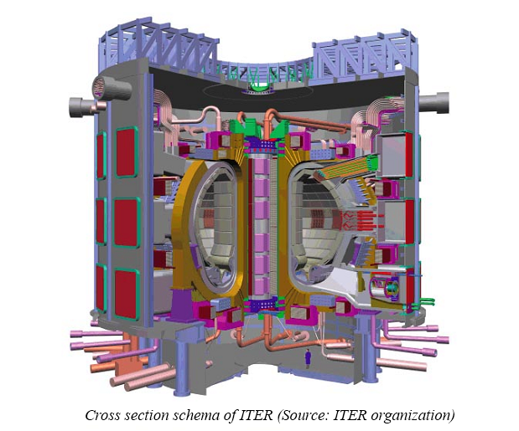

From Phd of Andrew Thornton (jan 2011), working on the MAST tokamak, Culham, page 14 :

The consequences of disruptions in the next generation of tokamaks are severe, the consequences of a disruption in a power plant tokamak would be catastrophic.

Few people know the basic principles of the machines which, starting from the first ITER machine, are supposed to result in electricity generation using fusion as an energy source.

The image above represents a thermal energy generator which, after 60 years of Research and Development, should result in a nuclear electricity generator using energy given off by the fusion of two isotopes of hydrogen; deuterium and tritium. The schema of this fusion is as follows

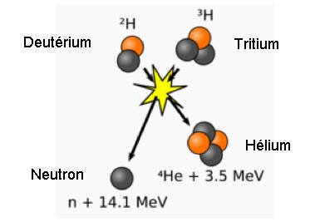

In order for this nuclear reaction to take place, temperatures of 100 million degrees have to be reached, which means that the thermal agitation speed of the hydrogen isotope nuclei must reach 1000 Km/s. An environment brought to such a temperature could not be contained in a material wall. Because of this, from the 50s onwards, magnetic confinement using a magnetic field was envisaged for the completely ionised plasma, a mixture of free electrons and hydrogen ions.

The “magnetic bottle” containing the fusion plasma was imagined in 1950 by the Russian Andrei Sakharov and was called a tokamak. This machine consists of a chamber in the shape of a torus filled with a mixture of deuterium and tritium at low pressure. Deuterium is inoffensive and is found in unlimited quantities in nature, in water. Tritium is radiotoxic and decomposes by beta radioactivity in 12.3 years. It almost does not exist in nature therefore.
In 1997 the British managed to obtain energy production by fusion for one second, using the reactor in the JET machine (Joint European Torus).

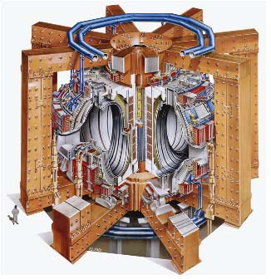
The British JET machine. The small figure gives the scale.

We can see eight enormous steel beams around the machine. Why such enormous sections? Because the magnetic field created by the machine, 3.85 Teslas, creates considerable forces which would tend to explode the solenoids that create them and which must be held solidly in check.
Later we will see how these machines work. In the JET, the magnetic field is supplied by non-superconducting solenoids. The field cannot therefore be maintained for more than a few seconds because of the heat emission resulting from the Joule effect.

The French built a similar machine in which the magnetic field reaches the same value but can be maintained without a time limitation as it is produced by superconducting solenoids. To do so it suffices to cool them to a very low temperature by means of liquid helium. As with the JET, this machine, Tore-Supra, must also be held tightly by a system of steel beams. The general look of Tore-Supra is similar to that of the JET but smaller. There is an image below.

From fission to fusion

Before developing this theme of energy production by fusion, it is interesting to present a few images which will suffice to illustrate the depth of complexity separating fission technology from so-called ‘controlled’ fusion. Before the Second World War scientists realised the possibility of creating a chain reaction using atoms such as Uranium 235. Subsequently it was shown to be possible to use this operation for the creation of bombs using plutonium 239, which does not exist in nature, it having a too short life, 24,000 years compared with one and a half billion years for uranium 235.

In 1942 the Italian Enrico Fermi had the first nuclear reactor built in an old squash court underneath the terraces of the Chicago university stadium. The construction was very simple, it just required putting bars containing uranium within graphite blocks which played the role of moderator, a neutron retarder. By slowing the neutrons emitted during the fission reactions we increase the chances of creating new fission in the nearby uranium 235 atoms.

To download the comic book : Yours energetically

http://www.savoir-sans-frontieres.com/JPP/telechargeables/English/energetiquement_eng/energetiquement_eng.htm
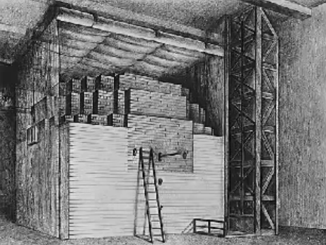

The first nuclear reactor, built in Chicago by Fermi in 1942

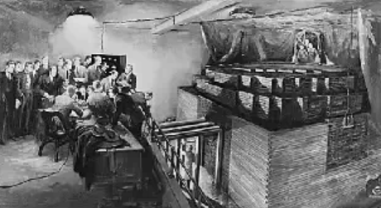

Control of the reactor with cadmium bars.
As also explained here, a nuclear reactor is completed with bars of cadmium, a neutron absorber, allowing a control of the fission rhythm or even stopping the reactor.

By making these ‘atomic batteries’, as they were called at the time, scientists were not trying to produce energy in the form of heat but to produce plutonium 239 by bombarding uranium 238 with neutrons, with the continuing aim of creating bombs. See the album cited earlier on this subject.

This first reactor did not require a cooling system because it only emitted 240 watts of heat. Nevertheless all the phenomena were sufficiently understood and mastered at the time for the Hanford site to move on to a reactor emitting a million times more energy. In this case the 240 megawatts of thermal energy were evacuated by a water circuit released into the Colombia river.

It was not until much later that people thought of using nuclear reactors to produce heat and then turn it into electricity by means of an ensemble steam turbine + alternator. We can see that if this had been the main idea it would only have taken a few months to create a power station producing hundreds of megawatts of electricity.

Fusion is infinitely more complex. In fact it would have required half a century for a reactor, the British JET, to produce energy during just one second.

How does a tokamak work?

A fusion mix at low pressure is introduced into a toroidal chamber. A magnetic field called ‘toroidal’ is created by a primary group of coils. In an industrial reactor these coils would be made of superconducting elements.

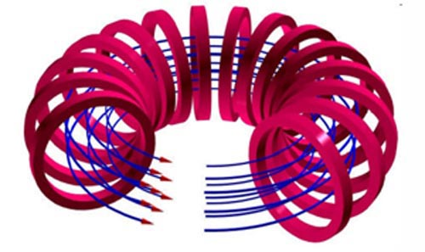

The superconducting coils are in red.
The toroidal magnetic field is in blue.

Then the toroidal chamber’s contents are ionised using hyper frequencies. Finally a plasma current is created by induction, which increases the magnetic field created by a solenoid aligned according to the axis of the machine.

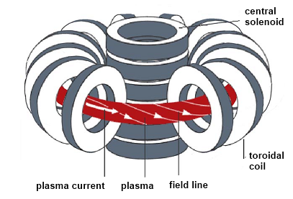

The plasma is shown in red. This plasma current creates its own magnetic field and composes with that produced by the coils, giving field lines disposed in spirals.

When the plasma temperature reaches 10 million degrees the electrons move so rapidly in the not very dense medium that they pass by the ions without interacting. The Joule effect that results from collisions between electrons and ions disappears. We could then suppose that the medium becomes superconducting. In fact it is necessary to maintain the plasma current by means of waves, analogous with those used in particle accelerators. The impulses given to the electrons compensate for the losses which, in the absence of this current drive, would cause the value of the plasma current to drop to zero in a millisecond.

A detail: We do not know how to model these losses.

An additional system of solenoids, whose current is piloted by computer, allows the position of the plasma to be controlled in the direction top-bottom. The complete schema of the tokamak is shown in the figure below (from Thornton’ thesis, page 3):

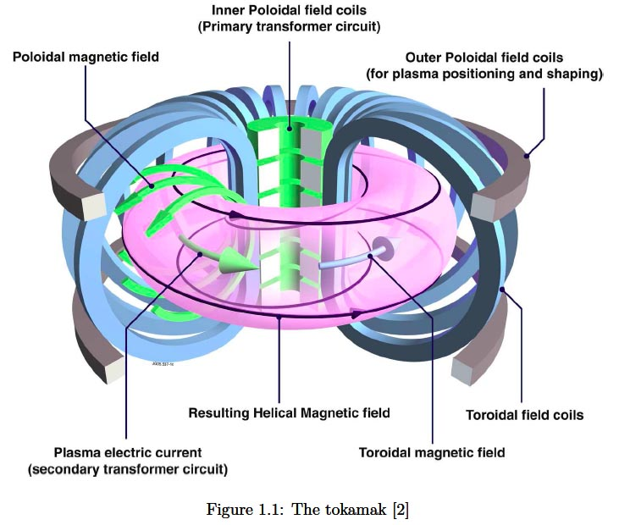

This system does not allow the minimal temperature of 100 million degrees, necessary to provoke the establishment of auto-maintained fusion reactions, to be obtained. Additional methods of heating are therefore used: hyperfrequencies and neutral particles injection. Fusion reactions were obtained during one second in the JET machine by this method. Firstly a deuterium-deuterium mix is used, raising the temperature to 150 million degrees. A few experiments were done with a deuterium-tritium mix, but very few. In effect, tritium, radiotoxic, has the property of infiltrating everywhere which would render impossible any inspection of the chamber by technicians, it having become radioactive.

Experimental data.

The experiments undertaken on the JET were very short and did not allow data to be obtained about the behaviour of the material forming the primary wall, that facing the plasma. A carbon lining analogous to that used on the space shuttle was tested in the French Tore-Supra machine. It sublimes at 2500°C and offers good thermal conductivity. Pressurised water systems to collect calories, placed on the other side of the elements, were also tested.

An unforeseen phenomenon was observed, called sputtering. The shocks of hydrogen ions against the walls and photo-abrasion caused numerous atoms to invade the experimental chamber. In combination with hydrogen they formed carbides that were subsequently redeposited on the covering, reducing the calorific conductivity. But even worse, if the machine had been operating with tritium the carbon plates would quickly have been turned into radioactive waste. For this reason carbon was abandoned.

Tritigenic cells

Tritium does not exist in a natural state given its short life, so the use of Canadian stocks, made for special types of nuclear reactor, the CANDU reactors, was envisaged. But using this to feed ITER (and its successors) is excluded. It is planned that the machine recreate its own fuel from lithium with the reaction:

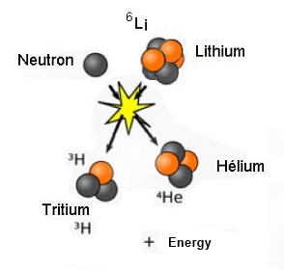
The reaction allowing tritium regeneration

It should be noted that to recreate a tritium atom, which would then be reclaimed and reinjected into the chamber, a neutron emitted from the fusion reaction presented above is required.

⁶Li (lithium) + n (neutron) → ³H (tritium) + ⁴He (helium) + energy

In order for the reactor to function, tritigenic modules (tritium creators) covering the walls are required and must be capable of capturing all the emitted neutrons, which is impossible. These tritigenic cells do not cover the entire wall.

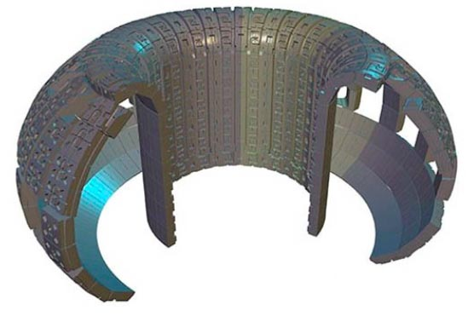

Placement of the tritium regenerating elements on the wall of ITER.

The lower part corresponds to the site of the divertor, or pumping system, the different windows to the orifices through which energy is injected or which allow measurements to be made.

Lots of neutrons will fix themselves into the wall therefore, rendering the material radioactive and producing waste.

To ensure tritium regeneration, a substance playing the role of a neutron multiplier must be used. This could be lead. Banana shaped tritigenic modules were considered where a mixture of lithium and lead in a liquid state circulated in tubing near a second circuit of water under a pressure of 75 bars to collect calories.

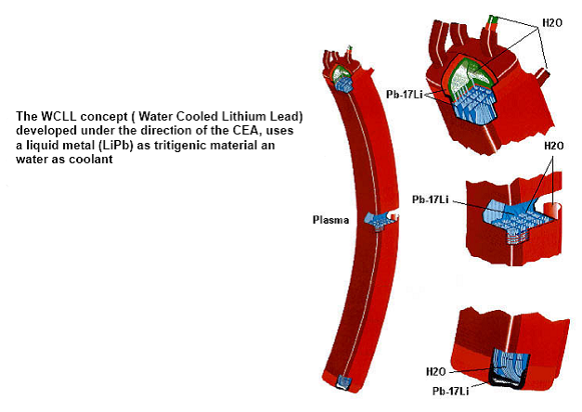

Tritigenic modules studied by the french Atomic Energy Commission

Using this formula is extremely dangerous, as we shall see below. In the event of a serious incident the lithium would explode in contact with the water (like sodium).

A second formula consists of holding the lithium in a ceramic. In this case the modules have to be covered with a body acting as a neutron doubler, beryllium, which serves as a primary wall and melts at 1280°C. The neutron multiplication reaction is as follows:

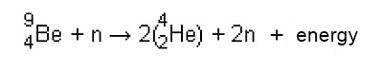
A neutron hitting a beryllium atom gives two neutrons, two helium nuclei and energy. Helium cannot link to any body. These helium atoms behave thus, everywhere that they are created by transmutation like impurities, they finish by fragilising the structures. In ITER the choice was made to use a primary wall made of beryllium, one centimetre thick.

The problem of plasma pollution.

This is constantly contaminated by the shearing off of atoms. The plasma loses energy by what is called braking radiation (in German: bremsstrahlung).

When an electron passes near an ion, positively charged, its trajectory is deviated and it emits a photon, that is to say, a radiation quantum. This loss is proportional to the square of the electric charge Z carried by the ion. For hydrogen ions, Z=1.

Carbon is interesting because it only carries four electric charges. All the elements in contact with the plasma are possible causes of pollution due to the highly charged ions, causing radiative losses likely to bring about the extincton of the reactor.

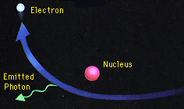

Loss by bremsstrahlung radiation

To ensure the operation of a tokamak where the continuous operation of fusion reactions is intended, the “ash”, that is to say helium, must be evacuated, which is an as yet unresolved problem. In Tore-Supra a device called a “limiter” was installed, below which pumping took place. This device, protruding into the chamber, is the most exposed to particles.

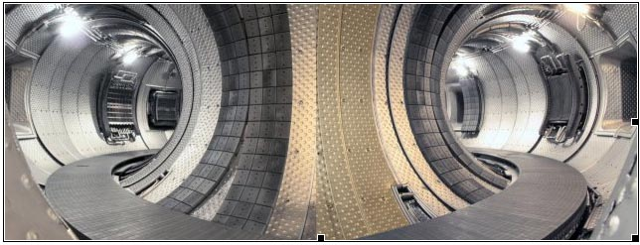

The Tore Supra limiter covered with carbon plates

In the JET, and in the ITER project, the designers chose a system called “divertor”. This system is associated with a local modification of the magnetic geometry to favour the entrapment of heavy ions. But this part of the chamber is then exposed to a very high heat flow. It was therefore decided to cover it, as in the JET, with tungsten, which has a fusion temperature of 3000°C. The filaments of incandescent lamps are made of this material.

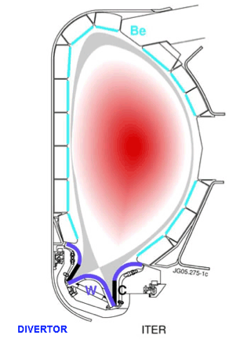
Cross section of the ITER chamber.
The tungsten covering is in violet. The carbon plates are in black.

This presence of tungsten in the covering is problematic because the tungsten ions attached to the wall can carry 60 electric charges. Thus a tungsten ion will bring about a loss equivalent to 3600 hydrogen ions through bremsstrahlung radiation. It was intended that a pilot installation named IFMIF (International Fusion Material Irradiation Facility) would be built in Japan, which would have allowed the material to be exposed to neutron irradiation with an energy near to that of fusion neutrons (14 MeV). Currently no plans exist for such an installation in which a film of liquid lithium would be bombarded with deuterium ions accelerated in two linear accelerators. Available artists’ drawings show an installation 240 metres long and it is estimated that its cost would be a third of that of ITER and that it would take 5 years to build. Logically, before designing the plans for ITER, research should have been undertaken on materials that could support neutron irradiation with a level of energy seven times that emitted by fission (2 MeV). This was not done but Motojima, the current director of the project, said:

- It is not because we do not have a magic material that we are not going to launch the project…

Let us add that no data is available concerning the resistance of beryllium to photo-abrasion and abrasion by impact. The ITER designers reply:

- The reactor will serve as test bed for the materials (…)

The state of theoretical knowledge of tokamaks

A PhD thesis was published in France on the 4th November 2010 by the researcher Cédric Reux of the IRFM, the Institute for Research on Fusion by Magnetic Confinement, which is dependent on the French Commissariat for Atomic Energy (CEA). The elements figuring in the thesis benefit therefore from the backing of French institutions such as the ITER ORGANIZATION, which participates in the management of the ITER project in Cadarache in the south of France. The thesis can be downloaded here:

http://pastel.archives-ouvertes.fr/pastel-00599210/en/
and :

http://www-fusion-magnetique.cea.fr/en_savoir_plus/articles/disruptions/these_c_reux.pdf

Asecond one was published in England on January 2011 by the researcher Andrew Thornton, working on the MAST (Mega Ampere Spherical Tokamak), at Culham. This document can be downloaded at :

http://etheses.whiterose.ac.uk/1509/1/AT_thesis_FINAL.pdf

There are direct access to these documents on

http://www.savoir-sans-frontieres.com

(“Knowledge without border” website ). The two thesis contain a point on the current state of knowledge of so-called controlled fusion. It has been known since the beginning of research on this question, in 1950, that high temperature plasmas that we try to confine using magnetic fields are seen to be highly unstable, subject to “MHD instabilities”. In fact they are just dissipative mechanisms via which a system attempts to eject out the energy it contains, to facilitate its transport.

In plasmas the problem become terribly complex because the distant regions become instantly coupled by the electromagnetic field. In fluid mechanics, when turbulence is created near a part of a plane it isn’t automatically propagated to the rest of the machine’s gaseous environment.

The global character of the phenomena appearing in tokamaks make it necessary to take into account the entire mass of plasma, which represents 10²⁰ to 10²² particles according to the size of the machine.

In addition, for each particle, six parameters also have to be taken into account, three for the position and three for the speed. These articles “live in a six dimensional space” therefore. The system must be described by a system of Boltzmann integro-differential equations coupled by the electromagnetic field. A real horror on a mathematical level but one which I know well and to which I contributed in my thesis of 1972.

The idea of using numerical simulations was considered but it was immediately seen that the possibility of making such a high number of particles interact with each other was completely unrealistic. Theoreticians then tried to schematise the milieu. All attempts failed completely. When experimenters witness phenomena, through measures difficult to put in place, theoreticians do not know how to interpret them. No fully trustworthy theoretical operating model exists for a tokamak, in particular those that would allow for extrapolations.

In short, experiments undertaken with tokamaks are born of pure empiricism.

To confirm this, French speakers can refer to the following:

http://www-fusion-magnetique.cea.fr/fusion/physique/une_journee_ordinaire.htm

How could the ITER project have been conceived?

For many people this remains a mystery. Even now, ITER has no real scientific direction. It is a headless body. Its public relation service is extremely active and speaking in every public space of :

- The Sun in a test tube
- Unlimited energy
- The “ultimate machine”
- Etc.

The comparison with the Sun makes sense to some extent.

- The temperature attained in tokamaks (150 million degrees in the JET) exceeds by a factor of ten that of the small central boiler of the star.
- The power in watts per square metre radiated on the surface of the Sun and on the internal face of the ITER enclosure are at a similar level.
- The two components of the “fusion fuel”, deuterium and lithium (which serves to create tritium for the thermonucelar reaction) are very abundant in nature.

On numerous Internet sites synthetic images show a pinkish plasma held solidly by the magnetic field of the equipment. This is completely false. Read the account of the experiment done with Tore-Supra. Via the web link above, click on the link on the page that opens to see the plasma oscillations in the JET just before a disruption occurred.

http://www-fusion-magnetique.cea.fr/fusion/physique/equilibremagnetique.htm#disruption

Everything began in 1985 following a meeting between Reagan and Gorbatchev who sought a research theme to develop wherein the atom was associated with peace. These brilliant physicists decided that research into energy using controlled fusion answered their question.

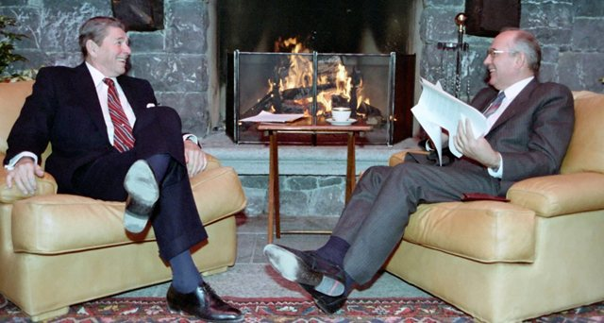

Reagan and Gorbatchev in Geneva in 1985

Atom physicists began work to make this fantasy a reality, despite the fact that since their first appearance in 1950, tokamaks were always capricious and problematic machines. Progress on one side with fusion being obtained for one second and on the other, the demonstration by the French of the possibility of creating a magnetic field of several teslas in a 25 cubic metre volume, masked the interminable list of non-resolved techno-scientific problems.

Who brought up the idea that things could be miraculously worked out by building an even bigger machine?

This idea is part of a new fantasy because heating plasma is costly in energy: produce more energy than is injected. In the JET, the British managed to restore, in the form of thermal energy, 65% of the injected energy. The ratio thermal power produced/power injected is designated by the letter Q. So, for the JET:
Q=0.65

Very schematically we could say that a machine of this type produces energy proportional to its volume while its losses, transmitted via the surface, increase proportionally to this surface.

When calculating the ratio volume/surface we obtain the scale factor. By doubling the size of the machine we could hope to double the value of Q. The ITER designers announce a value situated between 5 and 10.

Let us suppose that ITER is built and that comparable trials to those of JET are effected.

- Deuterium tritium fusion will be obtained.
- The machine will produce more energy than it consumes.

So what ?

The idea that the problem of the behaviour of the materials used will be resolved is a simple act of faith. But there is an even more serious problem described by Cédric Reux and Andrew Thornton in their thesis. A problem that is not new because tokamaks have shown themselves to be very unstable since the first trials in 1950.

The severe problem of disruption.

You will never find this word mentioned in documents describing the project, which are pure propaganda, whereas these problems are well known to all tokamak specialists. All tokamaks have problems that are called disruptions.

What are they?

When a tokamak is brought to its operating regime, a plasma current (1 million amperes in MAST, 1.5 million amperes in Tore-Supra and 4.8 in the JET) coils on itself, the current lines are laid out in circles with the machine’s symmetry as their axis.

When a disruption occurs, the plasma temperature drops extremely rapidly, in a few thousandths of a second, by a factor of 10,000, going from 100 million degrees to a few tens of thousands of degrees. The energy is dissipated by turbulent thermal conduction on the wall and by radiation.

Thornton, page 12 :

A disruption in a tokamak is a sudden, uncontrolled loss of plasma confinement. The causes of disruptions are many and varied, often consisting of a sequence of events, such as increased density, mode growth or plant failures, which ultimately lead to a disruption.

Thornton, page 13 :

The main motivation for studying disruptions and their mitigation is the damaging effect they can have on tokamak components.

The loss of confinement during a disruption causes all of the energy stored in the plasma, both thermal and magnetic, to be lost.

Typically, the energy is deposited onto the divertor and first wall of the tokamak which can lead to high energy fluxes on these surfaces which could lead to melting or vapourisation.

The magnitude of the heat fluxes and a comparison to the melting/vapourisation onset of the divertor material on ITER can be made using the convention defined in [23] of the power divided by a product of the divertor wetted area and the timescale over which the energy is deposited.

The expected energy load for ITER is between 144 MJ m⁻² s−^{0.5} and 446 MJ m⁻² s^{−0.5} ([23], table 6) depending on the actual duration of the energy deposition.

The limits for melting or vapourisation for the various divertor and first wall materials are significantly lower than this; for carbon and tungsten the limit is 40-60 MJ m⁻² s^{−0.5} ([23], table 5) and beryllium is 15 MJ m⁻² s^{−0.5} [23].

The stored energy in a tokamak plasma has been seen to scale as R⁵ [24], where R is the major plasma radius.

It is clear from this scaling, that the divertor energy loading on DEMO and future commercial reactors will pose a significant challenge.

The loss of confinement leads to a rapid loss of the plasma current. The rapid current quench causes currents to be induced in the vacuum vessel of the tokamak.

The interaction of these currents and the toroidal magnetic field (which is externally generated, and as a result does not change) produces large forces which act on the vacuum vessel. In addition to inducing current in the tokamak vessel, if there is contact between the plasma and the vessel walls, then the current flowing in the plasma will complete via the conducting vessel walls.

The currents flowing in the walls, known as halo currents, interact with the toroidal field and give rise to structural stresses. The speed of the current quench in ITER [23] is projected to be 35 milliseconds, giving quench rates in excess of 400 MA⁻²s⁻¹ for a plasma current of 15 MA.

Finally, the rapid current quench generates a large electromotive force which can act to accelerate electrons in the plasma to relativistic energies [25]. These high energy electrons, known as runaway electrons, can lead to the production of X-rays when the runaway electron (RE) beam interacts with components inside the
tokamak.

These X-rays can damage radiation sensitive diagnostics, in addition to the localised heating damage produced by the interaction of the RE beam and the tokamak.

In ITER [23] it is projected that around 70% of the initial plasma current could be converted into REs, this would amount to a runaway electron current of around 11 MA.

Thornton, page 14 :

The consequences of disruptions in the next generation of tokamaks are severe, the consequences of a disruption in a power plant tokamak would be catastrophic.

Clearly, a means of mitigating a disruption is required which can ameliorate the damaging effects. One such method is the injection of a large quantity (approximately 10-100 times the original plasma inventory, see chapter 2) of neutral particles, typically high Z (electric charge of ions) noble gases are used due their ability to radiate away energy via line radiation.

Below are the curves shown in the thesis of Cédric Reux, which illustrate the violence of the phenomenon:

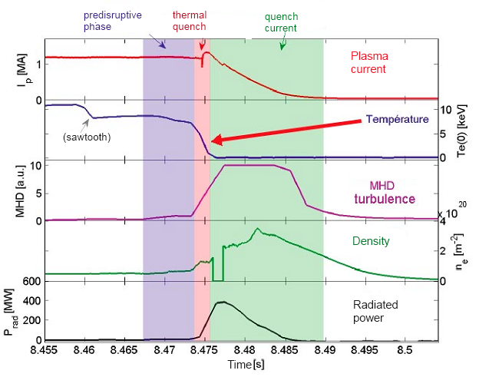

The progress of a disruption

No-one today can explain this phenomenon, predict it with certainty or master it. No one understands the mechanism of this thermal quench.

The phenomenon induces a drastic change of regime. Whereas a few milliseconds earlier the machine’s geometry presented a perfect regularity in which the magnetic field lines formed harmonius spirals, the plasma was confined in a smooth torus shaped volume and held at a distance from the walls by a powerful magnetic field.

All this order is instantly destroyed. The field is no longer able to confine, to keep the plasma in check, its structure becomes totally chaotic. Due to such low temperature, the plasma becosmes resistive. Joule effect reappears. Then the electric current circulating in the plasma, in collapsing, becomes a source of powerful induced currents circulating in all the structures of the machine which, when combined with the ambient magnetic field, engender forces counted in hundreds of tons capable of twisting and deforming the wall structures of current machine like wisps of straw.

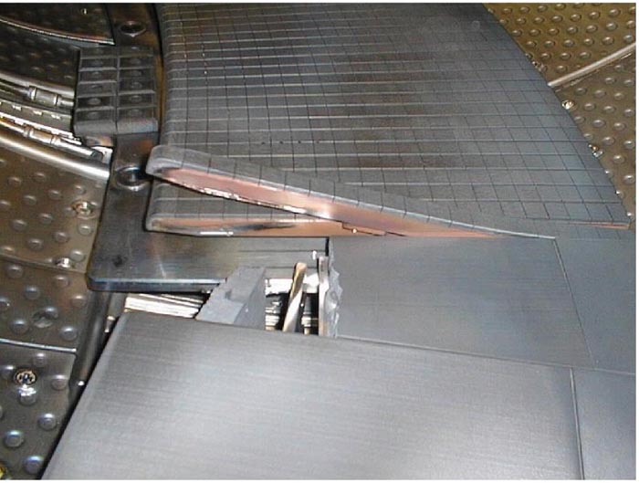

Laplace forces have twisted this element of the Tore-Supra limiter and torn off it carbon covering

A jet of high energy (from 10 to 30 MeV relativist electrons) is created whose intensity is of a similar order to that of the plasma current, equivalent to a lightning strike which hits any region of the internal face of the empty enclosure, volatising the material hit.

Thornton, page 27 :

The cross section of the runaway beam is found to be small, around 10cm [50], which leads to significant damage to the plasma facing components or diagnostics which the beam may interact with.

The estimated power load to due to runaway interaction on ITER is between 15 and 65 MJ m⁻² with the threshold for ablation in graphite being around 35 MJ m⁻² [23].

See these photos from Reux’s thesis concerning Tore-Supra and the British JET machine show.

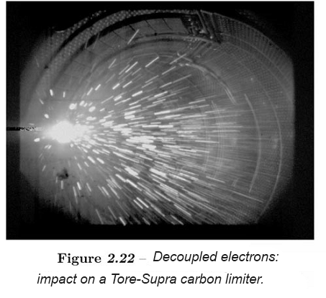

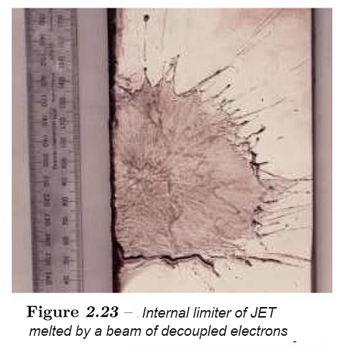

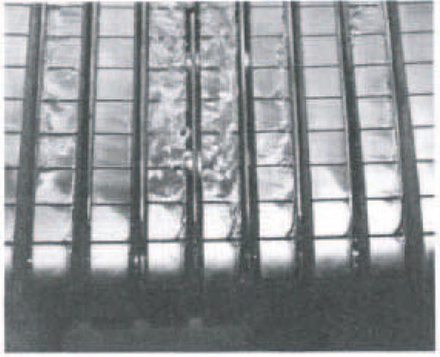

Beryllium covering on the British JET machine damaged by a disruption

As Cédric Reux notes, and we tend to agree, what was manageable until now in tokamaks such as Tore-Supra and JET will not be so in a machine such as ITER, which will contain a thousand times more energy (and even more in its descendants).

The machine’s designers themselves expect that the “lightning strikes” that will ineveitably be produced will reach 11 million amperes (and 100 million in its successor, DEMO).

Impacts of this force will perforate the vacuum enclosure. The beryllium layer, one centimeter thick, making up the first wall, that which is “facing the plasma”, will be volatised and disperse the material of which it is made, a highly toxic and cancerigenic pollutant, as well as the tritium contained in the chamber.

If the tritigenic modules (tritium regenerators), situated immediately behind the first beryllium wall, are designed on the basis of the circulation of a water cooled lithium-lead mix in a liquid state (CEA solution), toxic lead and tritium vapours will be emitted. As lithium is inflammable and explodes in contact with water, these substances could add to the pollutants cited above and the combustion of lithium, impossible to extinguish, could lead to the total destruction of the machine.

The Laplace forces, which would be measured in thousands of tonnes, could deform the machine’s structures, necessitating their replacement or even the total repair of the installation.

The most important consequence concerns any future commercial use of this type of machine. No-one could envisage basing the production of electricty on generators which, without fail and in an unforeseen manner, might be out of service for many months, even years.

The problematic piloting of a tokamak.

This aspect is clear in the account of the Tore-Supra trials, which can be consulted via the link on page 18, drawn from the official site of the CEA.

As no-one understands how a tokamak works and no one can establish with complete certainty the viability of its operating field, the empirical solution has been to record the evolution of the parameter values which led to the disruption in the memory of the control computer. These elements constitute a database allowing control of the machine.

When this type of scenario appears in a trial, the computer stops the trial automatically. The halting of an experiment is not simply a question of cutting off the power supply as a too brutal descent of the plasma current would generate induction effects equivalent to a disruption.

The behaviour of a tokamak is controlled by a certain number of measuring instruments whose response is often too slow and, as Reux notes, when it is decided to intervene (or the computer decides on the halt), it is already too late. The solution currently recommended is to drown the chamber by injecting a cold gas under pressure using tubes (Reux’s thesis). But this use of an “extinguisher” may not be sufficiently rapid. Another solution consists in injecting ice cubes with a blowpipe (which is also the solution envisaged to feed the apparatus with fresh carburant).

Using an image we could say that the plasma of a tokamak could be compared to a serpentine dragon circling at high speed while solidly holding the end of its tail in its jaws. If it lets go, it would become mad, move in all directions and bite the first element of the wall that presented itself to its mouth. Like all dragons, it exhales burning breath. The shape of its wide open mouth evokes the gradient of the magnetic field that accelerates the electrons of the disruptive discharge at a speed reaching 99% that of light. These electrons, having such energy, could not only damage the interior face of its prison but also what is beyond it.

Concerning the control of a tokamak, imagine a boiler operator confronted with the hearth of his machine. Ash and pollutant extraction is difficult. To feed the hearth he has a blowpipe with which he can fire ice-cubes of millimetric size. He watches the different dials showing the measures made in his boiler. If the parameters reach red, he puts out the fire as quickly as he can with a fire hose.

And it is with this type of machine that it is hoped we will one day be able to generate electricity by means of fusion energy.

Let us add that these problems increase according to the machine’s size. The image below shows a comparison of machines from Tore-Supra to DEMO.

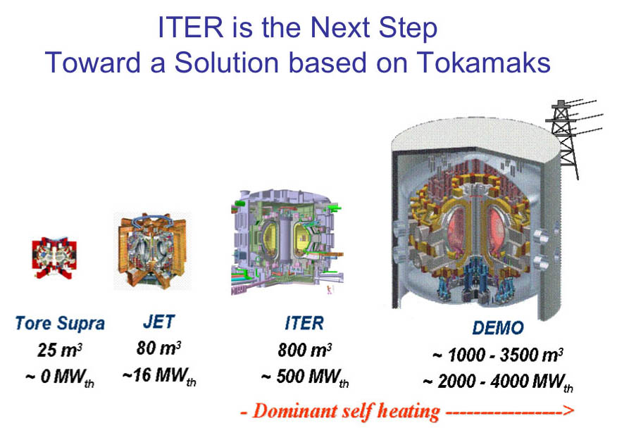

The enormous DEMO will only supply 700 megawatts of electricity.

An unmanageable industrial risk.

ITER is not a machine destined for fundamental research. It is seen as a prefiguration of a family of machines, bigger and bigger, the last being PROTO, which represents the model for future generators “exploiting this unlimited energy by putting the Sun in a box”.

We can see that on small scales (Tore-Supra, the JET and their various cousins installed in different countries) the control of these machines is already extremely problematic. At such scales incidents cause little breakage, material damage that puts the apparatus out of use for months. At the scale of machines such as ITER the disruptions, unforeseen and uncontrollable, are very important and could require the complete reconstruction of the machine. As we do not know the mechanisms, do not know how to describe them, any extrapolation, any “scaling”, is impossible. Below is an extract from the conclusion of Reux’s thesis.

Begining of the conclusion of Reux’PhD

In order to operate future tokamaks under good conditions of viability, safety, security and performance, it appears to be increasingly necessary to master plasma disruptions. These violent phenomena, corresponding to a loss of plasma confinement, are the origin of three types of negative effect. The electromagnetic effects, comprising induced currents, halo currents and the Laplace forces which result, can damage the vacuum enclosure of the tokamak and elements of the structure. The thermal effects brought about by the loss of the energy contained in the plasma are likely to irreversibly damage elements of the wall that are in contact with the plasma. Finally the relativist electron beams, accelerated during the disruption, can perforate the vacuum enclosure.
Even though the disruptions have been studied since the early years of tokamaks in the 50s, until recently they only represented a minor problem for the machine’s operation. It was only when much larger tokamaks arrived that the dangers began to be more and more present. As the energetic content of future tokamaks and reactors is of several orders of magnitude superior to those of current machines, the consequences of disruptions will be that much more serious. The need to avoid them or master them becomes indispensable, it is not always possible to avoid them.

The more powerful the machines, the more they will be unstable and the more rapid, unmanageable, violent and destructive the phenomena will be.

Why are these problems insolvable?

Tokamaks are machines that function in a contra-natural way where we attempt to operate equipment using a fluid, a plasma, while trying to overcome all dissipative phenomena. The instabilities set off in the tokamaks are simply MHD turbulence phenomena.

Turbulence is everywhere in nature. It is that that animates our meteorology. It ensures combustion in automobile cylinders, cooks our food in saucepans. To try to operate a tokamak without turbulence is equivalent to trying to heat from below while trying to stop all ascending currents, synonymous with convection.

A stable tokamak has an atmosphere without ascendance, without wind, without clouds.

The promoters of ITER ceaselessly compare their machine to the “Sun in a test tube”. We have seen that this image is without foundation. The Sun is a “saucepan with spherical symmetry”. Energy is produced at its centre in a small boiler at which the temperature is just fifteen million degrees. Convection phenomena are manifested which favour the ascendance of the thermal energy. This turbulence is visible on the Sun’s surface, which is at 600°C, and appears on photos as “rice grains”.

At that stage, the manifestation of turbulence, helping the energy to reach the surface, does not seem to be worrying. A god, having unlimited means who has decided to feed heat in a democratic manner to all the planets of the solar system instead of letting the inhabitants of Mercury get fried on the spot and the those of Pluto freeze, could decide to shut the Sun in a shell placed at a reasonable distance from the surface of the star and which would then radiate no more energy per square meter than the JET.

He would just need to have tubing filled with pressurised water using pumps of… astronomical size, to dispatch calories throughout the solar system. That would be a good subject for students of thermodynamics.

But with the first solar eruption, the envelope would be blown to pieces.

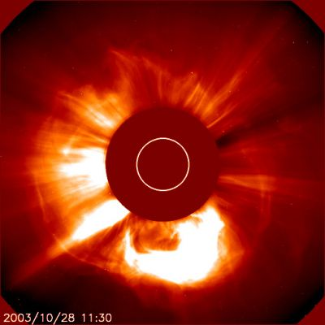

The environment of the Sun, itself hidden by a coronographic disc.

Next link, a movie of a large solar eruption :

http://www.spaceweather.com/images2011/22oct11/cme_c2.gif?PHPSESSID=03262a82v19dq6g9u4oat16hh1om/images2011/22oct11/cme_c2.gif?PHPSESSID=03262a82v19dq6g9u4oat16hh1

Solar eruptions are the manifestation of MHD instabilities comparable to the disruptions in tokamaks. They begin, like disruptions, by sorts of “hernias”. They are regions near the Sun’s surface where the magnetic pressure is not able to counterbalance the pressure of the plasma.

If you have ever blown up a bicycle innertube you will know that if you push things a little too far, in a part of the tube, the rubber of which it is made can no longer contain the pressure. A hernia will form and, if you insist, it will explode.

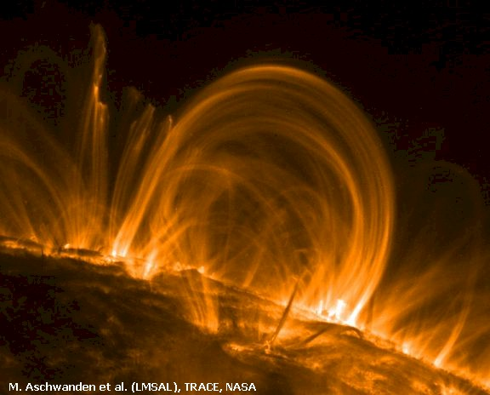

Solar eruption

When the plasma arches break they behave as natural charged particle accelerators and expel puffs of very hot plasma far from the Sun, solar wind. This is nothing other than a different form of a dissipative phenomenon which tends to send energy at a great distance, to dissipate it.

Similar phenomena create disruptions in tokamaks, manifested by the emission of jets of energy of phenomenal power. The desire to stabilise a tokamak is like hoping to observe the Sun for a day and see no solar eruptions.

A conjecture concerning thermal collapse.

This phenomenon is the starting point of disruptions and no-one know the cause. I intend to offer a hypothesis here. In 2006 my colleague and friend Malcolm Haines explained an abnormal resistivity phenomenon in Z machine plasma filaments.

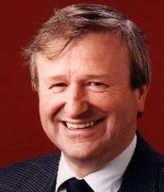

Malcolm Haines, Imperial College, London

The temperatures obtained were too high. It was impossible to invoke the Joule effect to justify this contribution of energy, the electrons circulating too rapidly in the dense plasma.

As noted above, when the electron speed reaches a certain level they pass by ions so rapidly that they no longer interact with these electrically charged “targets”. This is what happens when the plasma temperature in a tokamak goes beyond ten million degrees. The Joule effect becomes negligeable.

Haines showed that MHD turbulence could create sorts of lumps similar to ions, making what we call an “auto confined plasmoid” (confined by its own magnetic field) that the Russians call spheromaks. These objects of one micron diameter are observed in pinch discharges and are called “hot spots”. In a Z-machine filament the “targets “ encountered by the electrons are no longer isolated ions but clusters of ions, endowed with a very high electric charge. Thus the increase in the interaction between “electron gas’ and “ion gas” and the manifestation of abnormal resistivity.

The shape of the temperature curve corresponds to the evolution of the phenomenon.

- In an early stage, the start of ion cluster formation procures a temperature excess on the ion gas through the Joule effect.

- But as the ion agglomerations increase in size, the dominant effect will be the haemorrhage of energy by braking radiation.

To conclude, if MHD micro-instabilities allow dense plasma temperatures to be increased, they condemn the use of tokamaks as generators of electricity.

What is good for one is bad for the other

So does a solution exist?

For tokamaks I can’t imagine any. I believe that the ITER project will end up in complete failure and maybe with a fire in the apparatus thus causing a major ecological disaster.

In 2006, in the MHD compressor of the Z-machine installed at Sandia, a temperature of three thousand million degrees was reached in a dense plasma cord of the size of a pencil lead. It was obtained by injecting a current of 18 million amperes into a cage made of 240 metal wires having the thickness of a hair. The regularity of the compression was able to be obtained because of the brevity of the discharge, 100 nanoseconds, which is an essential element of the experiment. In effect, an electric discharge with an ascent speed (quasi-linear) of 100 nanoseconds is equivalent to an impulse of 10 megahertz.

However we know that high frequency currents do not circulate inside conductors but only penetrate to a certain depth. Because of that the wires, each carrying 70,000 amperes, are not instantly volatilised, thus preserving the axisymmetry and hindering the MHD instabilities from developing and distorting completeley what has become a plasma curtain.

See the papers of Malcom Haines :

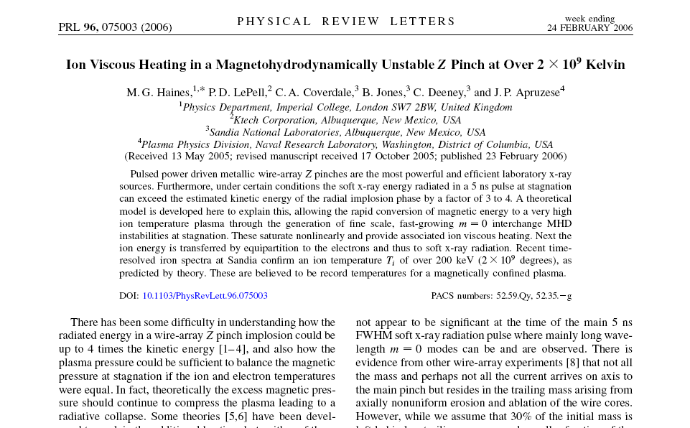

To learn more about Z-machine :

http://www.jp-petit.org/Site_Anglais/Z_machine/Z_machine.htm

In short :

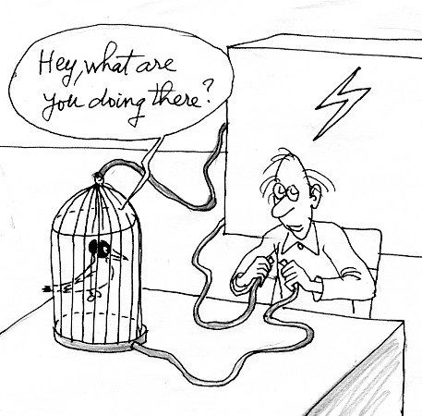

Sandia Lab : Gerold Yonas at work on the Z-machine

In 2009 the Sandia machine’s intensity was brought to 26 million degrees and the theory (well mastered in this case) predicts that the temperature obtained should be around 7 thousand million degrees.

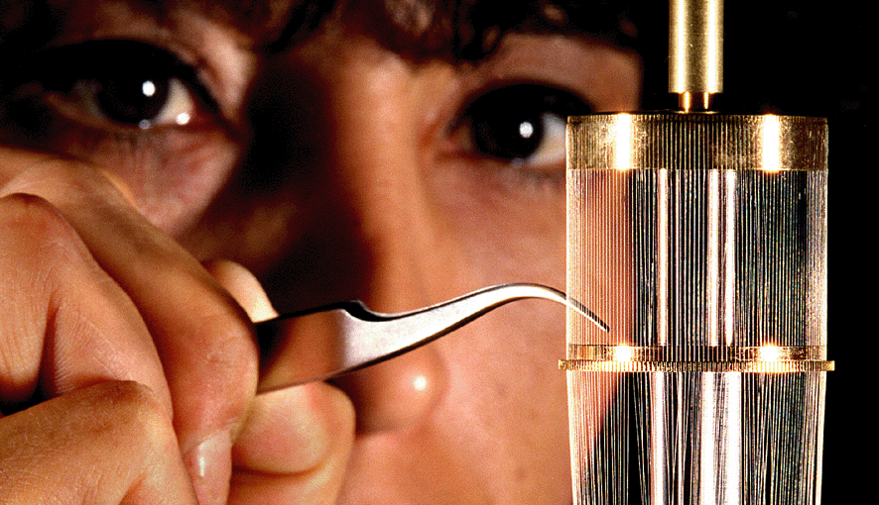

Sandia Z-machine : wires array “cylindrical liner”

Smirnov, in Russia, the inventor of this “wire cage” that specialists call a wire liner, oversaw the construction of a Z-machine capable of producing 50 million amperes with an ascent time of 150 nanoseconds.

Performance was improved by the invention by Zakharov, a collaborator of Smirnov, of a liner in which the wires were laid out according to the meridians of a sphere, thus producing a stronger concentration of kinetic energy at the geometric centre of the system.

Behind these experiments is the possibility of obtaining fusion by MHD. As the temperatures far exceeds a thousand million degrees (which a tokamak would never be able to do), aneutronic fusion then becomes possible.

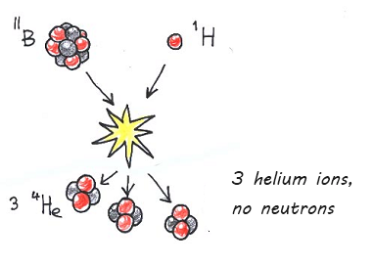

¹¹Boron + ¹Hydrogen → 3 ⁴He

If the “Lawson conditions” are present in such a hyperdense milieu then fusion will produce energy, carried uniquely by the electrically charged helium nuclei and not by neutrons. It then becomes possible to get this energy back “by direct conversion” by ensuring that the plasma expansion takes place within a magnetic field. Then, in the spires creating the field, an induced current appears allowing energy to be recovered with a yield of 70%.

This is not new. In the 50s, under the leadership of Andrei Sakharov, the Russians managed to detonate an explosive charge doped with caesium, the most easily ionisable substance in the Mendeleiev table. By effecting this expansion in a magnetic field creating coil, the induced current produced the direct conversion sought, with this yield.

Here we can perceive the appearance of the theme “two-stroke fusion”. It requires storing part of the energy in a “flap” which is then… a condensator, less complicated than it might appear insofar as this energy is in fact stored in its dielectric. With a liquid dielectric (such as the water of the Sandia Z-machine) an extremely rapid charge-discharge time is obtained.

But as Kipling would have said, that’s another story, that I’ll relate in another dossier consecrated to these MHD machines.

_______________________________________

Allen Boozer in an international meeting.

In november 2011, Allen Boozer, from Colombia University, a master in the field of hot plasmas and tokamaks presents a paper.

Reference :

Bulletin of the American Physical Society

53rd Annual Meeting of the APS Division of Plasma Physics
Volume 56, Number 16

Physics of Tokamak Disruption Simulations

Abstract :

Disruption simulations address two fundamental questions:

(1) When is a tokamak operating in a metastable state in which loss of control is credible (avoidance question)?

(2) What is the worst credible level of destructive effects when plasma control lost and how can these effects be mitigated (effects question)? T

he success of ITER and the future of tokamaks as fusion systems depend on the precision with which these questions can be answered.

Existing capabilities are far from those desired.

Nevertheless, physical constraints on the answers can be given and further important constraints could be obtained through a relatively limited theoretical effort interacting with ongoing experiments.

The nature of the physical constraints and procedures for deriving further constraints will be discussed. Throughout a disruption, the plasma evolves through force-balance equilibria.
The fastest time scale, roughly a millisecond, is about a thousand times longer than an Alfven time, and the longest is of order a second.

Disruption effects include forces and heat loads on surrounding structures and the production of relativistic electrons, which can burn holes through structures.

Although the spatially averaged force that can be exerted by a disruption can be easily estimated, the determination of the localization and duration of force and heat loads is far more subtle.

The physics and critical issues in constraining these loads will be discussed.

The danger posed by relativistic electrons depends on the quality of the magnetic surfaces when large voltages arise in the disruption evolution. Issues and mitigation methods for relativistic electrons will be discussed.

UFOs in tokamaks?

At the end of Reux’s thesis there is a surrealistic table which lists all the possible causes for disruptions. They are… countless.
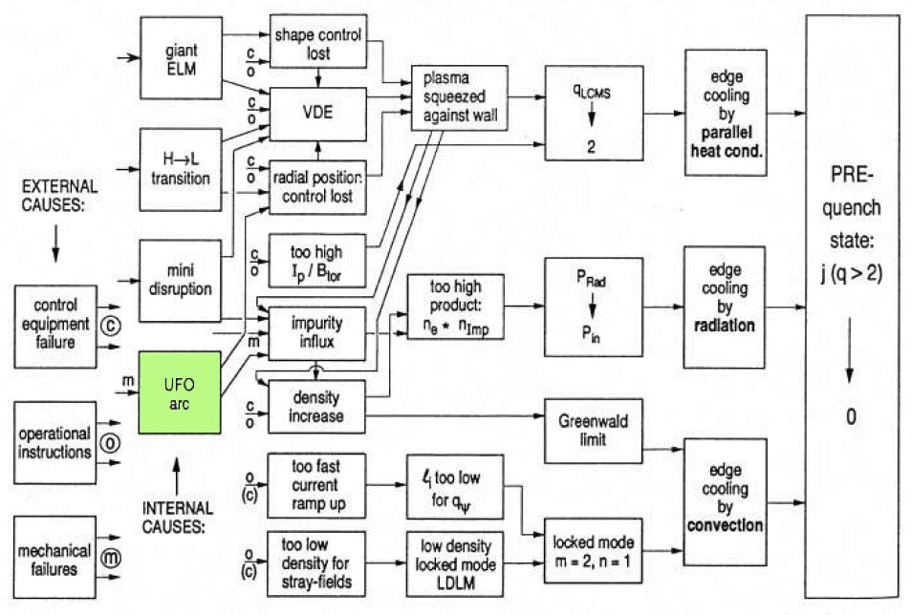

Schema of possible causes of disruptions

In this flowchart there is a strange entry named “UFO”. It is the term used to indicate unidentified objects circulating in the tokamak chamber which relate to various debris torn off from the walls through uncontrolled contact between these walls and the plasma. It is mentioned in the account of the experiment provided via the link on page 17 pointing to the CEA site.

Here is the exact image taken from the page of the CEA site:

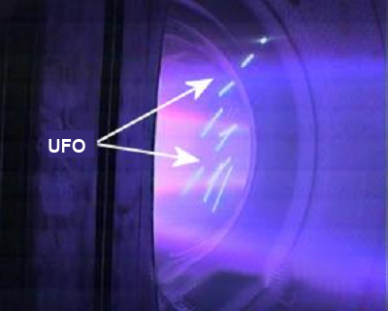

and its commentary, from the CEA webasite :
At the next shock, increase of impurities at 16 seconds: disruption. A UFO, as they are called in Tore-Supra jargon, has passed in front of the visible cameras. Spectroscopes detected iron, nickel and copper in the plasma… not good news! Probably the overheating of a component facing the plasma. The plasma is pressed against the primary internal wall: the infrared camera detected no problem with the carbon bricks but does not see the entire chamber. The aerial protectors are also strongly solicited, but there again, the infrared surveillance cameras detected nothing abnormal. Discussions to decide the next step in the programme. In the meantime cleaning discharges will be used to salvage the disruption. Finally, with the agreement of the director, we pulled out all the stops: to save the FCI antennae we used 2 of the 3 at a time, alternating them every 4 seconds, highly acrobatic… In addition, we added modulation to the vertical position of the plasma in order to move the impact point of the plasma on the wall and avoid excessive heating.

The burning plasma problem.

In ITER people expect to get Q from 5 to 10. That means that the thermal energy produced by fusion will fairly excess the injected energy (microwaves, neutral beams injection).

The energy injectors surround the chamber. When Q < 1 they control the temperature field. This will no longer be the case if Q >>1, when fusion will be self-sustained. Then the plasma in the chamber will run its own life, without any possible control.

All exothermic reactions in gases are fairly turbulent. Then we can expect fusion turbulence, with local increases of plasma temperature and fusion reaction rate.

The confinement depends on the balance of plasma pressure by magnetic pressure. If some region gets hotter, the local pressure rises, and the plasma escapes its magnetic prison, getting in contact with the wall.

An additional problem.

Some consider the problem of disruptions as the main one. It is linked to the existence of the plasma current, necessary to ensure the stability of the plasma.

Another solution is the so called Stellerator, which does not require plasma electric current.

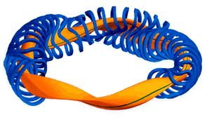

Stellerator

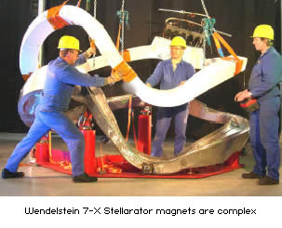

So, people say : “ no plasma current, no disruptions “

Yes, but what about fusion turbulence ?

To summarize

- Tokamaks do not seem to be a good way to produce electricity, even in a distant future. It would be reasonable to give up immediately that crazy and costly project named ITER.

- Instead, we suggest setting up a center devoted to the study of large scale renewable energy plants.

- Just besides it: a Z-machine exclusively devoted to civilian research, and electricity production. The cost: two orders of magnitude smaller than ITER’s one.

- Very reliable. A new field of research, with reversed non-equilibrium conditions: the ion temperature is 100 times higher than the electron temperature.

- But this is a big problem, for such “pure fusion” provides smart thermonuclear bombs, which can be scaled down. Such gadgets do not need a A-bomb to be fired.

- If Boron hydrogen mixture is used, it becomes a Green Bomb.

- Then a question arises:

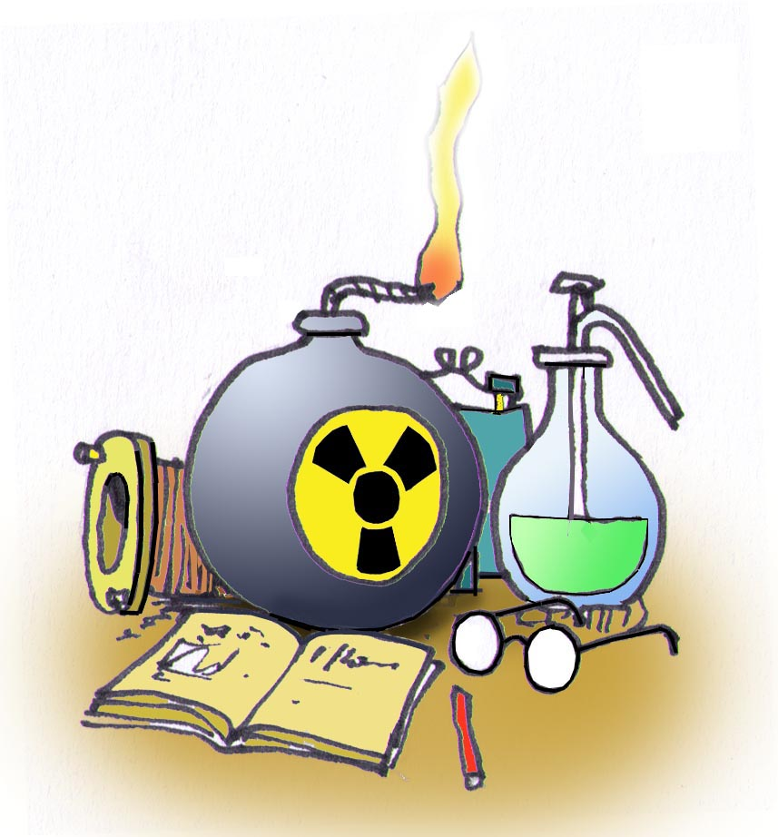

Do we want energy, or bombs?

http://www-fusion-magnetique.cea.fr/cea/next/couvertures/blk.htm
For that kind of stuff, see The Mathematical Theory of Non Uniforme Gases, fro S .chapman and T.G.Cowling, Cambridge Mathematical Library.

